Castello di Torre in Pietra
Initially the village was a "castrum" surrounded by towers and surrounding walls.
In 1254 the castle was owned by the Normanni family who united in a single property some neighboring estates such as Pruniano (Leprignana) and Castel Lombardo, then probably passed by inheritance to the Anguillara who, in 1457, by the hand of Lorenzo and Felice Anguillara, for 3000 gold ducats they sold it to Massimo di Lello di Cecco dei Massimo, then it passed to the Peretti family.
In 1639 it was sold to the Falconieri princes. Ferdinando Fuga built the church and the staircase on the main floor of the castle, then Pier Leone Ghezzi built the interiors, mostly the frescoes relating to the Jubilee year 1725. The castle thus appeared to be at the end of the 18th century the center of an estate with of over 1900 rubles equal to 3460 hectares.
The castle we admire today is essentially the one that the Falconieri family left us.
The frescoes are perfectly preserved: we can relive the glories of the jubilee year 1725, when Ghezzi is called by Alessandro Falconieri to decorate the main floor with scenes celebrating the visit to the castle of Pope Benedict XIII.
Inside the octagonal church, the frescoes on the side altars are further evidence of his work.
Finally, in the second half of the nineteenth century, the falconers died out and Torre in Pietra experienced a period of decline.
In 1926 it passed to Senator Luigi Albertini who reclaimed the land according to modern techniques and made it one of the most prestigious Italian livestock companies.
In 1941 it passed to his daughter Elena Albertini, married to Count Nicolò Carandini, whose heirs are still owners of the castle.
The chapel, with a single nave, is in Baroque style with an octagonal plan.
The door ends at the top in a round arch surmounted by a triangular pediment and flanked by 4 pilaster pilasters (2 on each side). On the altar there is a painting of a Madonna and Child.

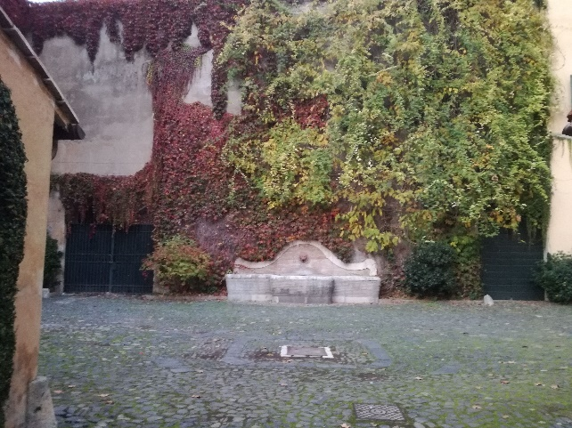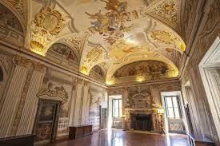

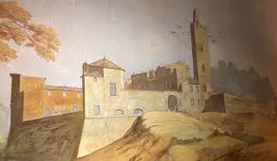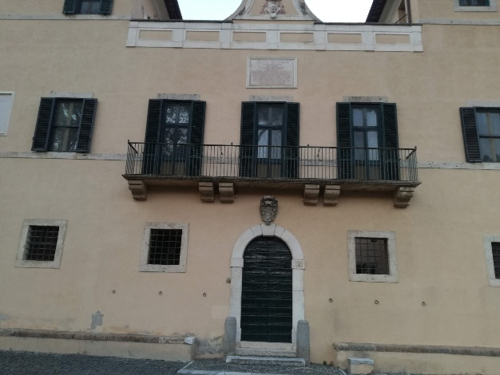
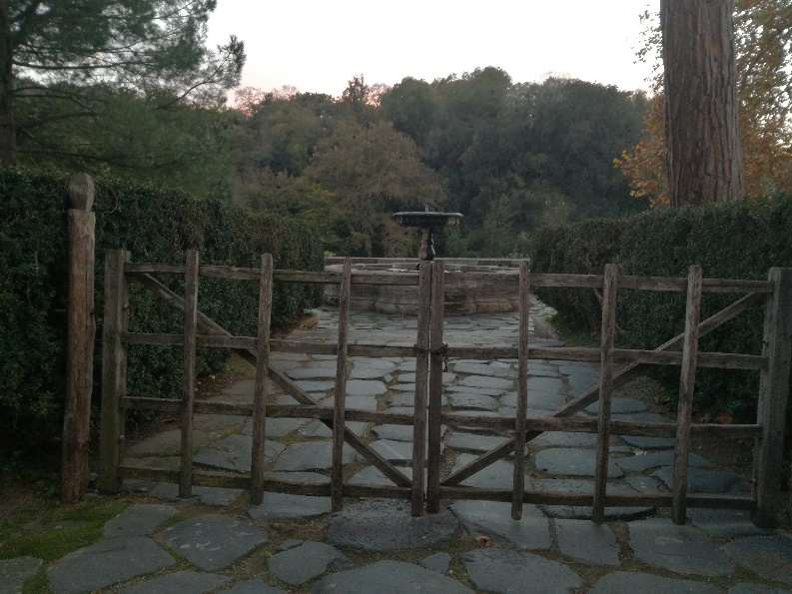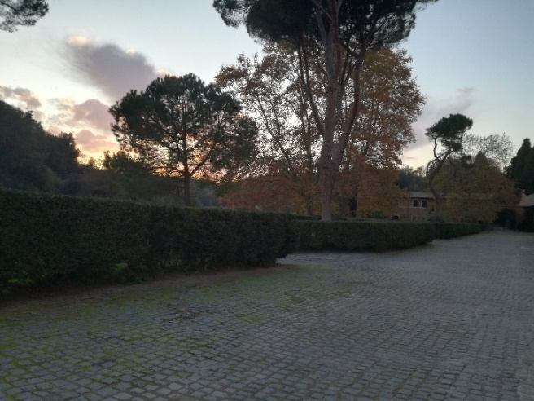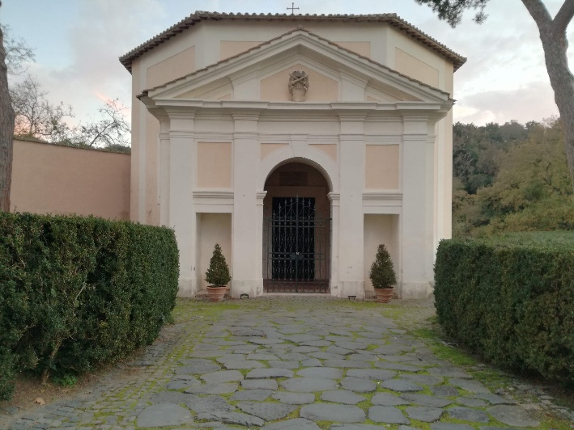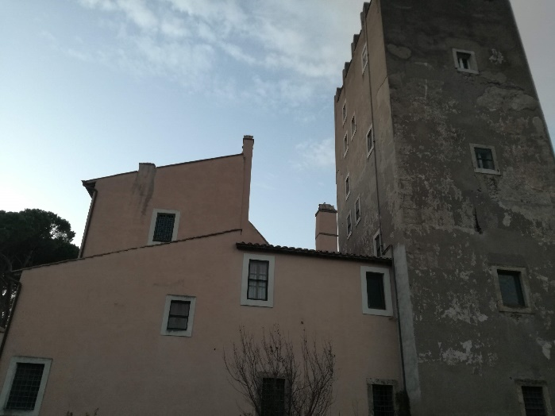

Mileto Marta 3a

