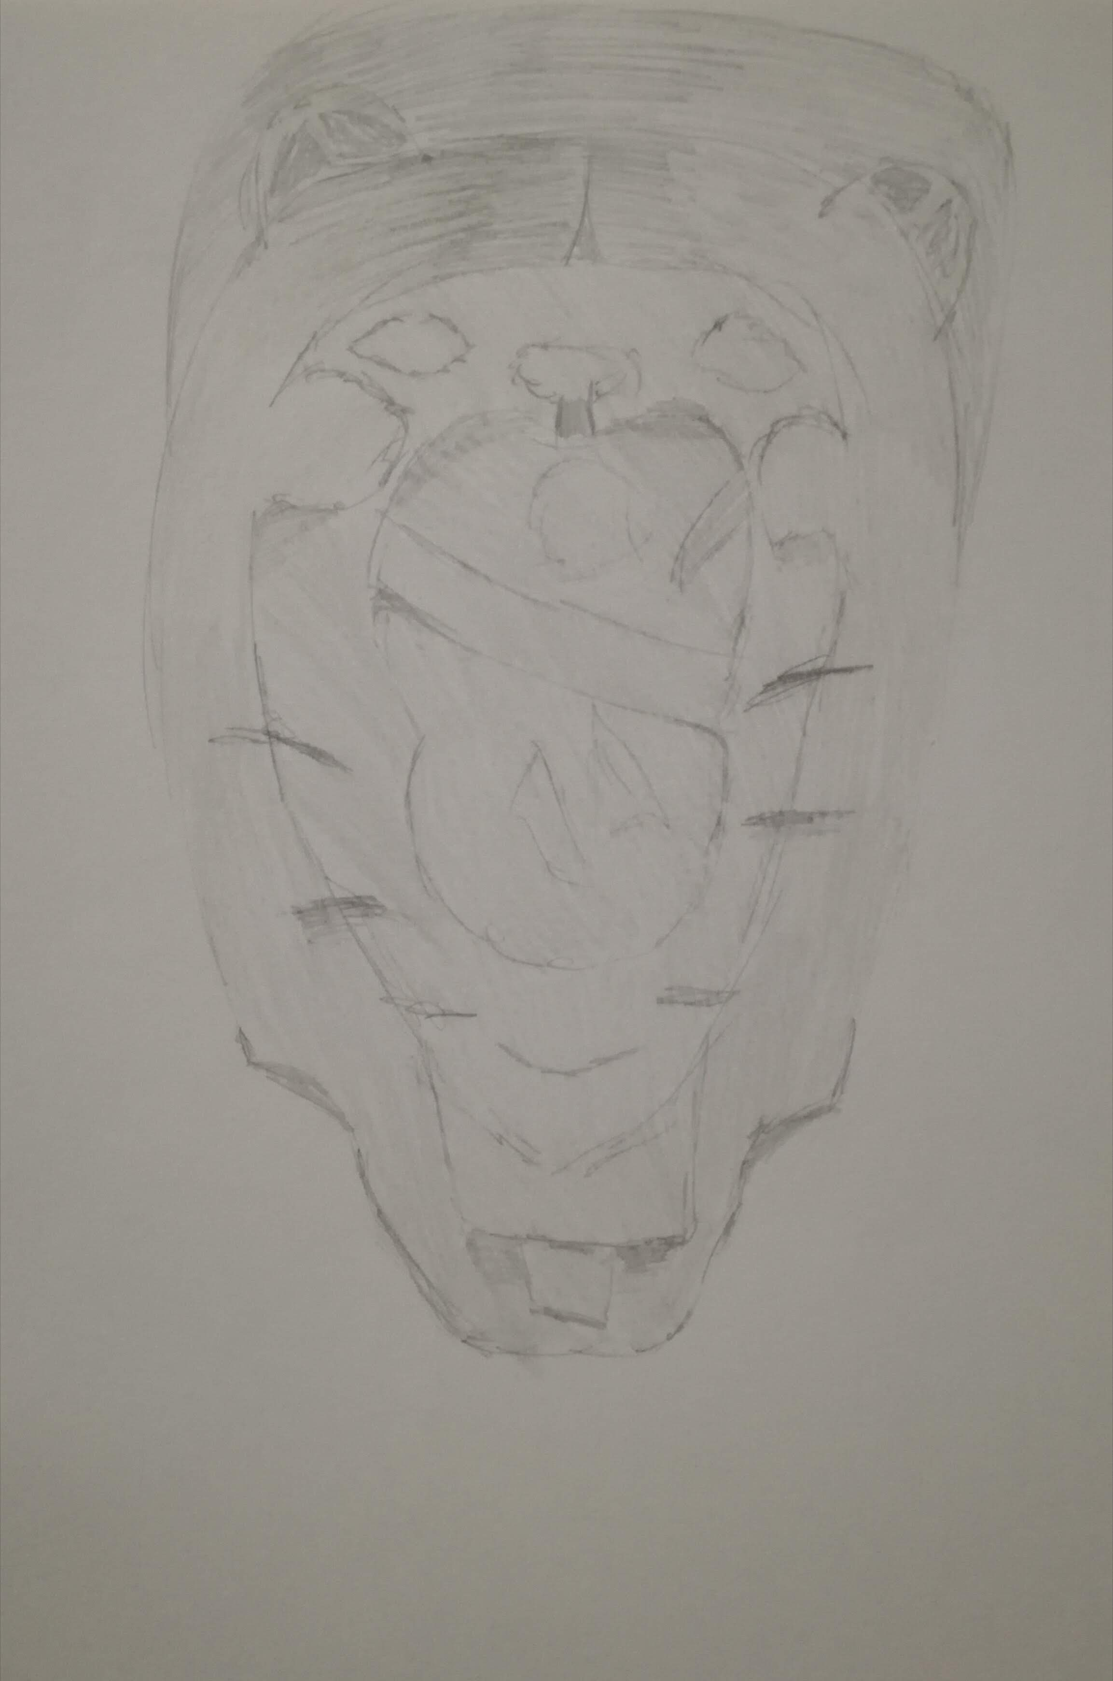

Stone relief depicting a lion's head with wide open jaws.
Pier Leone Ghezzi (1674-1755)

MARTA MILETO 3^A Moda

