Aromatic Flowers

Lilac
(Syringa x 'Declaration')
Star-shaped reddish purple flowers appear in large dramatic clusters in early spring. The scent is spicy sweet—the essence of spring. The deciduous shrub reaches 6 to 8 feet tall and 5 to 6 feet wide; it takes full sun, or light shade in the hottest climates.
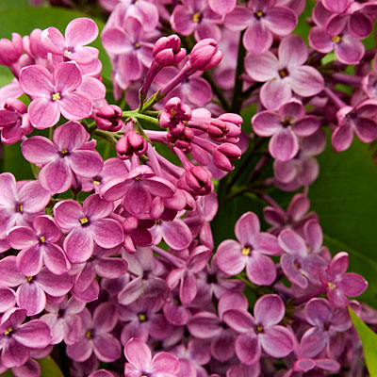

'Scarlet Pineapple' sage
(Salvia elegans)
This shrubby perennial reaches 4 feet tall, and has bright red flowers and foliage that smells like ripe pineapple
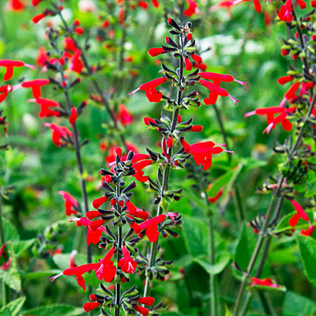

Lemon verbena
(Aloysia triphylla)
A tall, lanky deciduous shrub, it has lemon-scented leaves and lilac or white flowers.

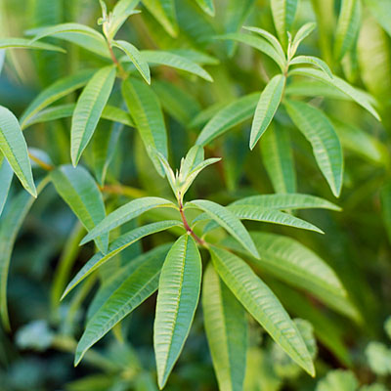

Angelwing jasmine
(Jasminum laurifolium nitidum)
This semi-evergreen vine has glossy green leaves and pinwheel-shaped white flowers. .

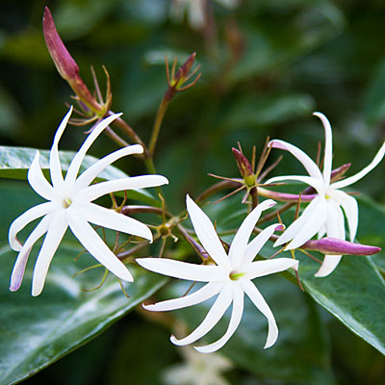

Heliotrope
(Heliotropium arborescens)
Though the purple varieties are more common, the white-flowered form is the most fragrant.

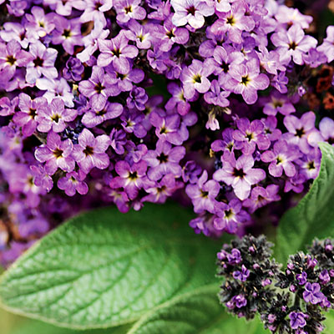

Roses
Many old types--including Bourbon, China, and damask--are fragrant, and more and more modern varieties, such as 'Yves Piaget', are too.

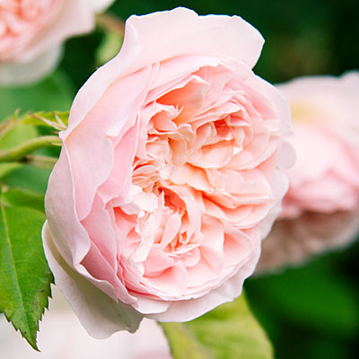

Lemon-scented geraniums
Look for the variety 'Prince Rupert' or 'Mabel Gray'.

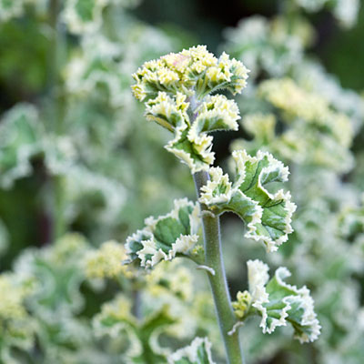

Mock orange
(Philadelphus coronarius)
White four-petaled flowers cover this tall shrub.

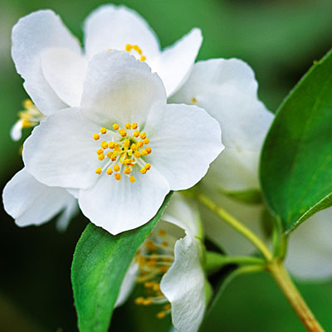

Angel's trumpet
(Brugmansia)
A woody shrub, it has pendant flowers in a range of colors. Most varieties are fragrant, but 'Charles Grimaldi' is the best.

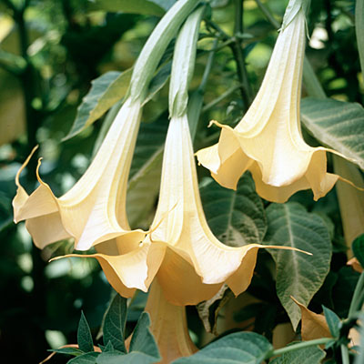

Tuberose
(Polianthes tuberosa)
This perennial has a fountain of grassy leaves and glistening white tubular flowers.

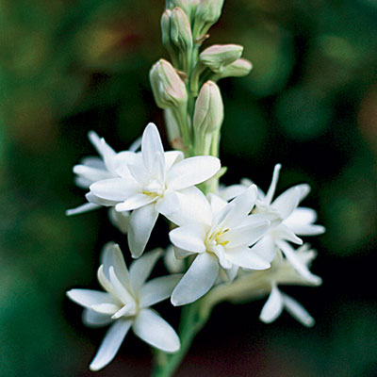

Flowering plum
(Prunus cerasifera)
Single white to light pink flowers open in clusters from pinkish buds before leaves appear (in March in the Northwest, earlier in warmer climes), releasing a honey scent, especially on warm, sunny days. The tree, 20 to 30 feet tall and wide, likes full sun. ‘Thundercloud’ has purplish brown leaves.

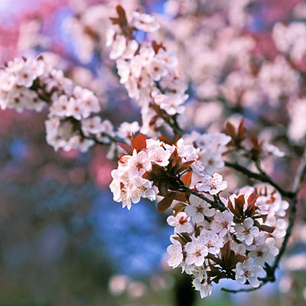

Star magnolia
(Magnolia stellata 'Royal Star')
Pink buds open to white star-shaped flowers in early spring. The scent is subtly sweet with a hint of citrus. The slow-growing deciduous shrub or small tree (to 20 feet tall) blossoms in early spring before the plant leafs out. It likes sun or part shade.

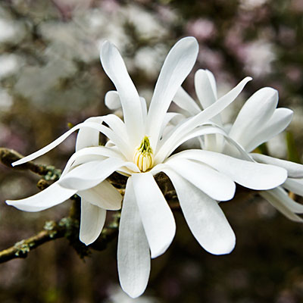

Polyanthus jasmine
(Jasminum polyanthum)
Small rose-colored flowers are white inside and grow in dense clusters in late winter to early spring. The scent is sweet and floral, like a warm Hawaiian night. A climbing vine reaching 20 feet tall, it’s sometimes grown in big pots and hanging baskets, or used as a groundcover. This jasmine takes full sun or light shade.

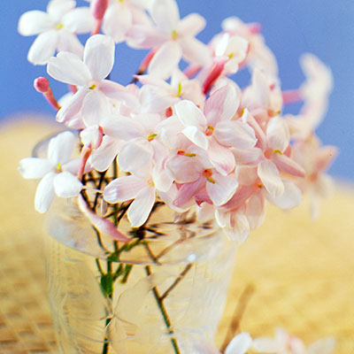

Citrus
Creamy white blossoms of ‘Washington’ navel orange have a rich, fruity perfume that seems to float in the warm spring air. ‘Eureka’ lemon has at least some flowers nearly all year. Grow both in sun.
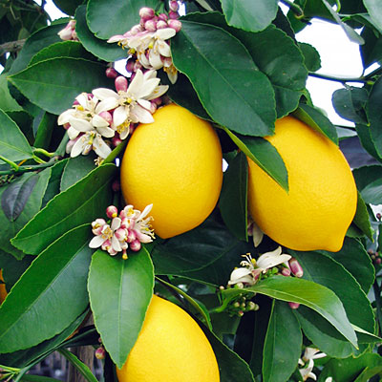

Mexican orange
(Choisya ternata)
Small white flowers smell like orange blossoms with a hint of gardenia. The evergreen shrub (not a true citrus) reaches 6 to 8 feet tall, and takes sun in cooler climates but part shade elsewhere.

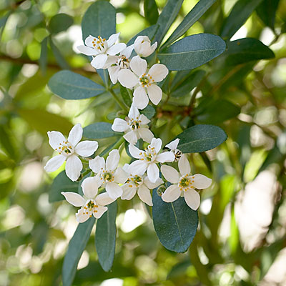
Münevver Çakır Ertekin
Kutlukent 80. Yıl İlkokulu-Samsun

