Easter
At Easter, in Romania, red eggs are broken, which symbolizes the blood of Jesus and they eat PASCĂ, a kind of pie with sweet cheese, all this happens at 12 at night.
There is no Easter meal without a “pască” (Easter cake) with cheese and raisins, sour cream or
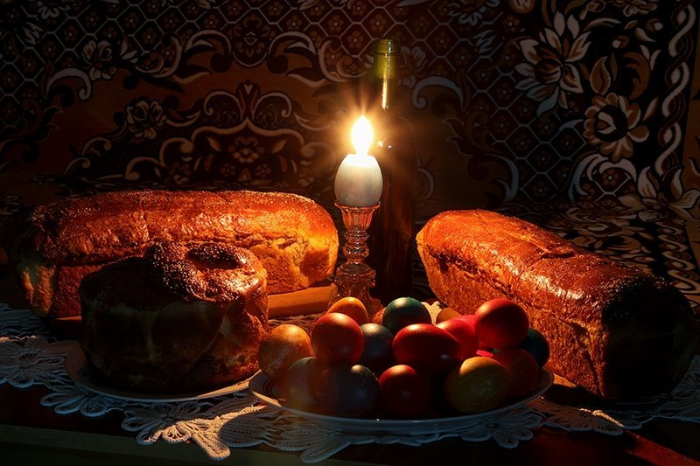
chocolate.
The Christians borrowed the custom of preparing “pască” for Easter from the Jews.
The pieces of “pasca” and the poured wine symbolise Jesus Christ’s sacrifice.
The Easter cheese cake is prepared on the eve of Resurrection. The true “pasca” is cut into small
pieces, put in small packages which are taken to church to be blessed. The pieces of “pasca” are
brought back home and kept to be shared with the God’s believers, having the power to protect
us from the diseases and troubles.
