Hello i'm Sıla. I live in Marmaris. I am 18 years old and I am studying accommodation at Halit Narin Vocational and Technical High School.
I'll tell you about the traditions and customs of Turkey.
Fırst I will talk about folk dances. It is unclear where and when the folk dances appeared. however, they have continued from the past to the present.
Folk dances are local dances performed at weddings, holidays, military festivities, engagements, henna night and other occasions.
LOCAL DANCES AND THEİR PLACES;
Zeybek belongs to Aegean region. It is played Aydın, İzmir, Muğla, Denizli, Bilecik, Eskişehir, Kütahya, Çanakkale, Kastamonu, Uşak, Manisa, Balıkesir, Burdur.
HALAY is played Bitlis, Bingöl, Diyarbakır, Elazığ, Malatya, Kahramanmaraş, Gaziantep, Erzurum, Erzincan, Sivas, Mardin, Muş, Yozgat, Çorum, Adana, Ankara, Siirt, Hatay, Tokat, Şanlıurfa.
HORON belongs to Eastern Black sea regin. It is played Trabzon, Samsun, Artvin, Ordu, Rize. It is danced to the song played by kemençe or drum.
BAR belongs to thrance and It is played Trakya. Edirne, Kırklareli, Tekirdağ, Çanakkale
KAŞIK It is played Eskişehir, Afyon, Kütahya, Bilecik, Kırşehir, Konya, Mersin, Antalya, Bolu, Bursa. People keep wooden spoons in their hands as rhythm tools.
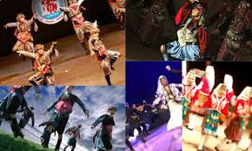
BENGİ it is played Balıkesir, Manisa, Bursa, Çanakkale
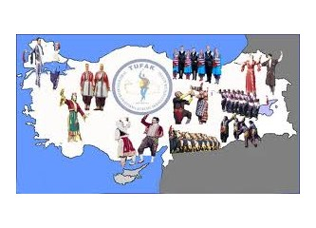 Sıla KAYALAR

