EASTER TRADITIONS IN ITALY:

Taralli di Pasqua

This sort of doughnuts is a typical Apulian recipe: the rings of dough are not baked but boiled in water and then glazed once they are dry.
They are definitely something to try!

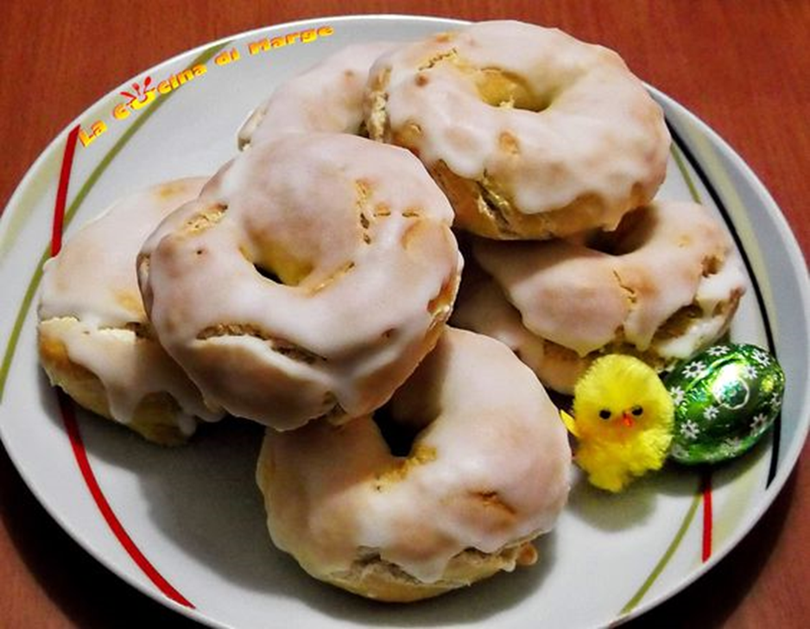

SCARCELLE:
This is the most typical Easter sweet od the Apulian traditions! It is a sort of big cookie that can have different shapes and it is usaully decorated with sprinkles and little chocoalte eggs. It is also a customary to place a hard-boiled egg at the centre of the cookie. The egg is a very symbolic element connected with Easter: it represents the birth and new life.

