Here the most famous tourist attractions!
If you visit Apulia, you can’t skip them!

Salento: a charming land with a unique history and traditions, among masserie

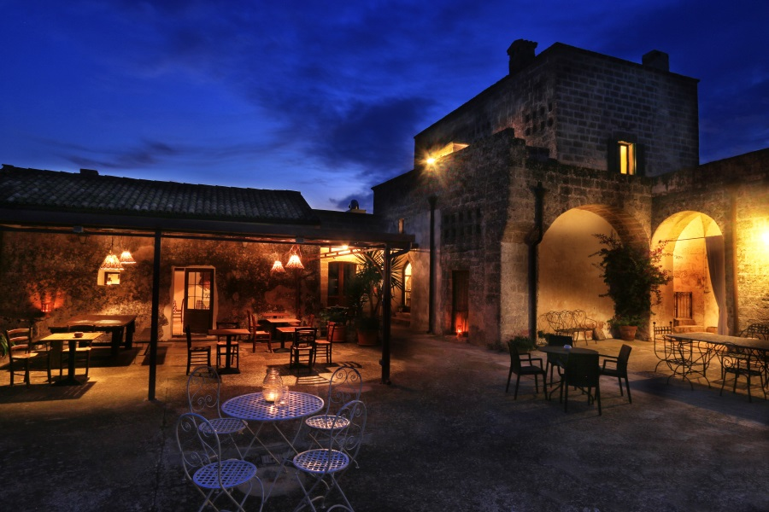

and white sand beaches with crystal-clear waters (no coincidence called “the Maldives of Italy”) 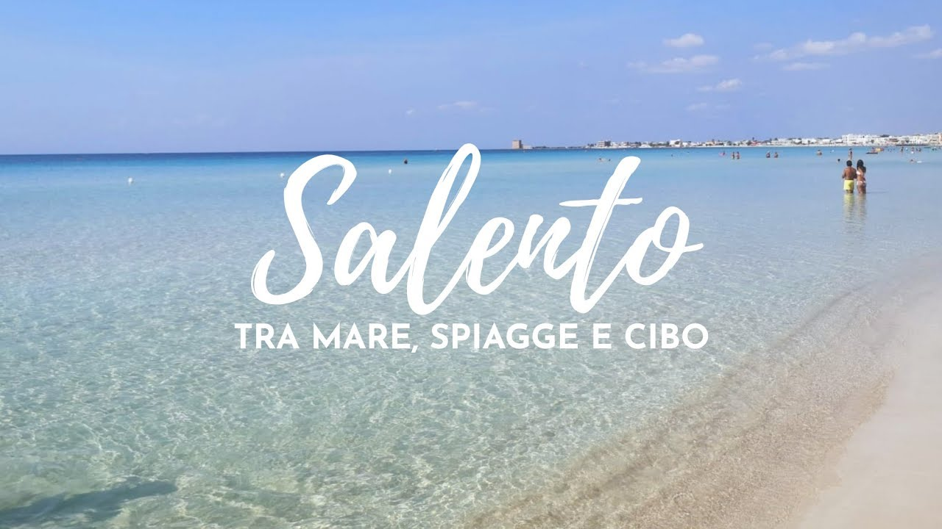
Figura 1 SALENTO: SEA, SANDY BEACHES AND FOOD

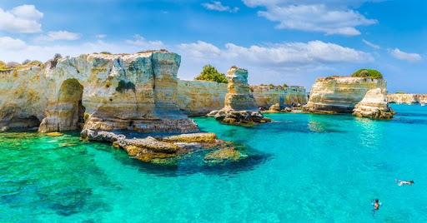
Figura 2 Salento: natural cliffs

If you think of Apulia first of all you think of trulli, the typical dry stone huts with conical roof of the Apulia’s countryside you find scattered all over the central and southern part of the region. Trulli are widespread in the Itria Valley and in the Murge and especially in Alberobello, whose entire historic center is made up of trulli: since 1996 the Trulli of Alberobello are Unesco’s World Heritage Site

ALBEROBELLO
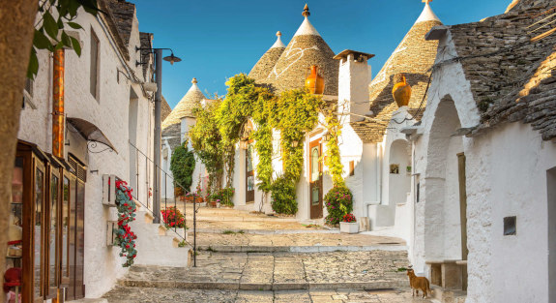

CASTEL DEL MONTE
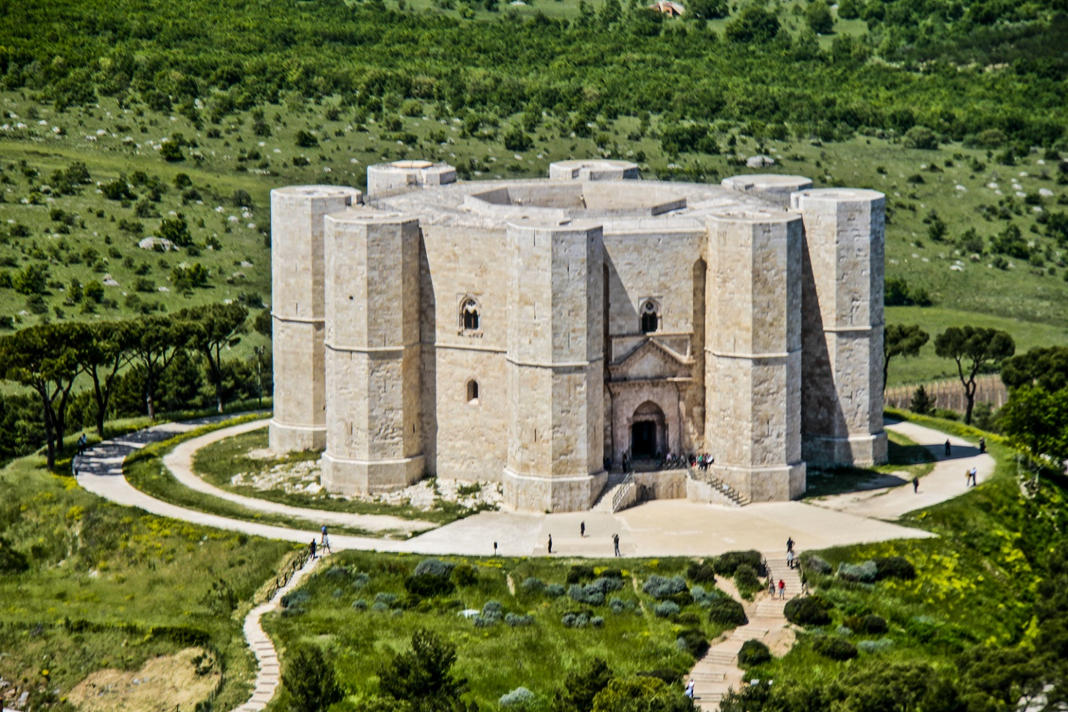

Another emblematic place of Apulia is Castel Del Monte, a XIII century fortress not far from Andria, also enlisted in the Unesco's world heritage patrimony.
It was built by the Emperor Frederick II in the XIII century, is internationally renowned because of its peculiar octagonal plan and is the region’s most visited monument

LECCE
An art city and Baroque jewel, a real open air museum scattered with outstanding masterpieces and landmarks

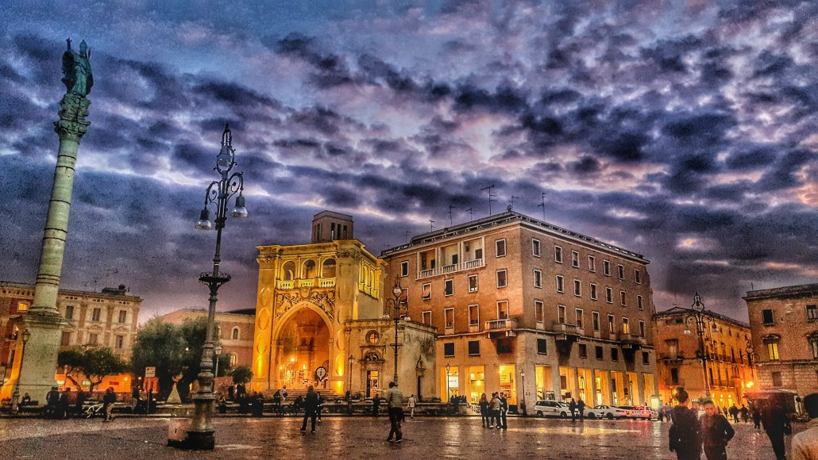

POLIGNANO A MARE
The Apulian jewel: ,
Clinging on a rocky cliff overlooking the Adriatic Sea, it is a holiday resort much appreciated also for its sea caves and Roman remains.

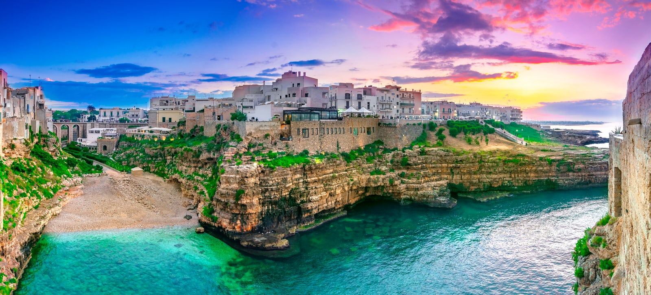

OSTUNI: THE WHITE CITY

it’s called “White City” due to its historical center of whitewashed houses, a true sight for the eyes -

