Easter

Easter is a Christian festival and cultural holiday that commemorates the resurrection of Jesus from the dead. It is described in the New Testament as having occurred on the third day after his burial following his crucifixion by the Romans. It is the culmination of the Passion of Jesus, preceded by lent, a 40-day period of fasting,prayer and penance. Most Christians refer to the week before Easter as Holy week,, which contains the days of the Easter Triduum, including Maundy Thursday, commemorating the Maundy and Last Supper as well as Good Friday,commemorating the crucifixion and death of Jesus.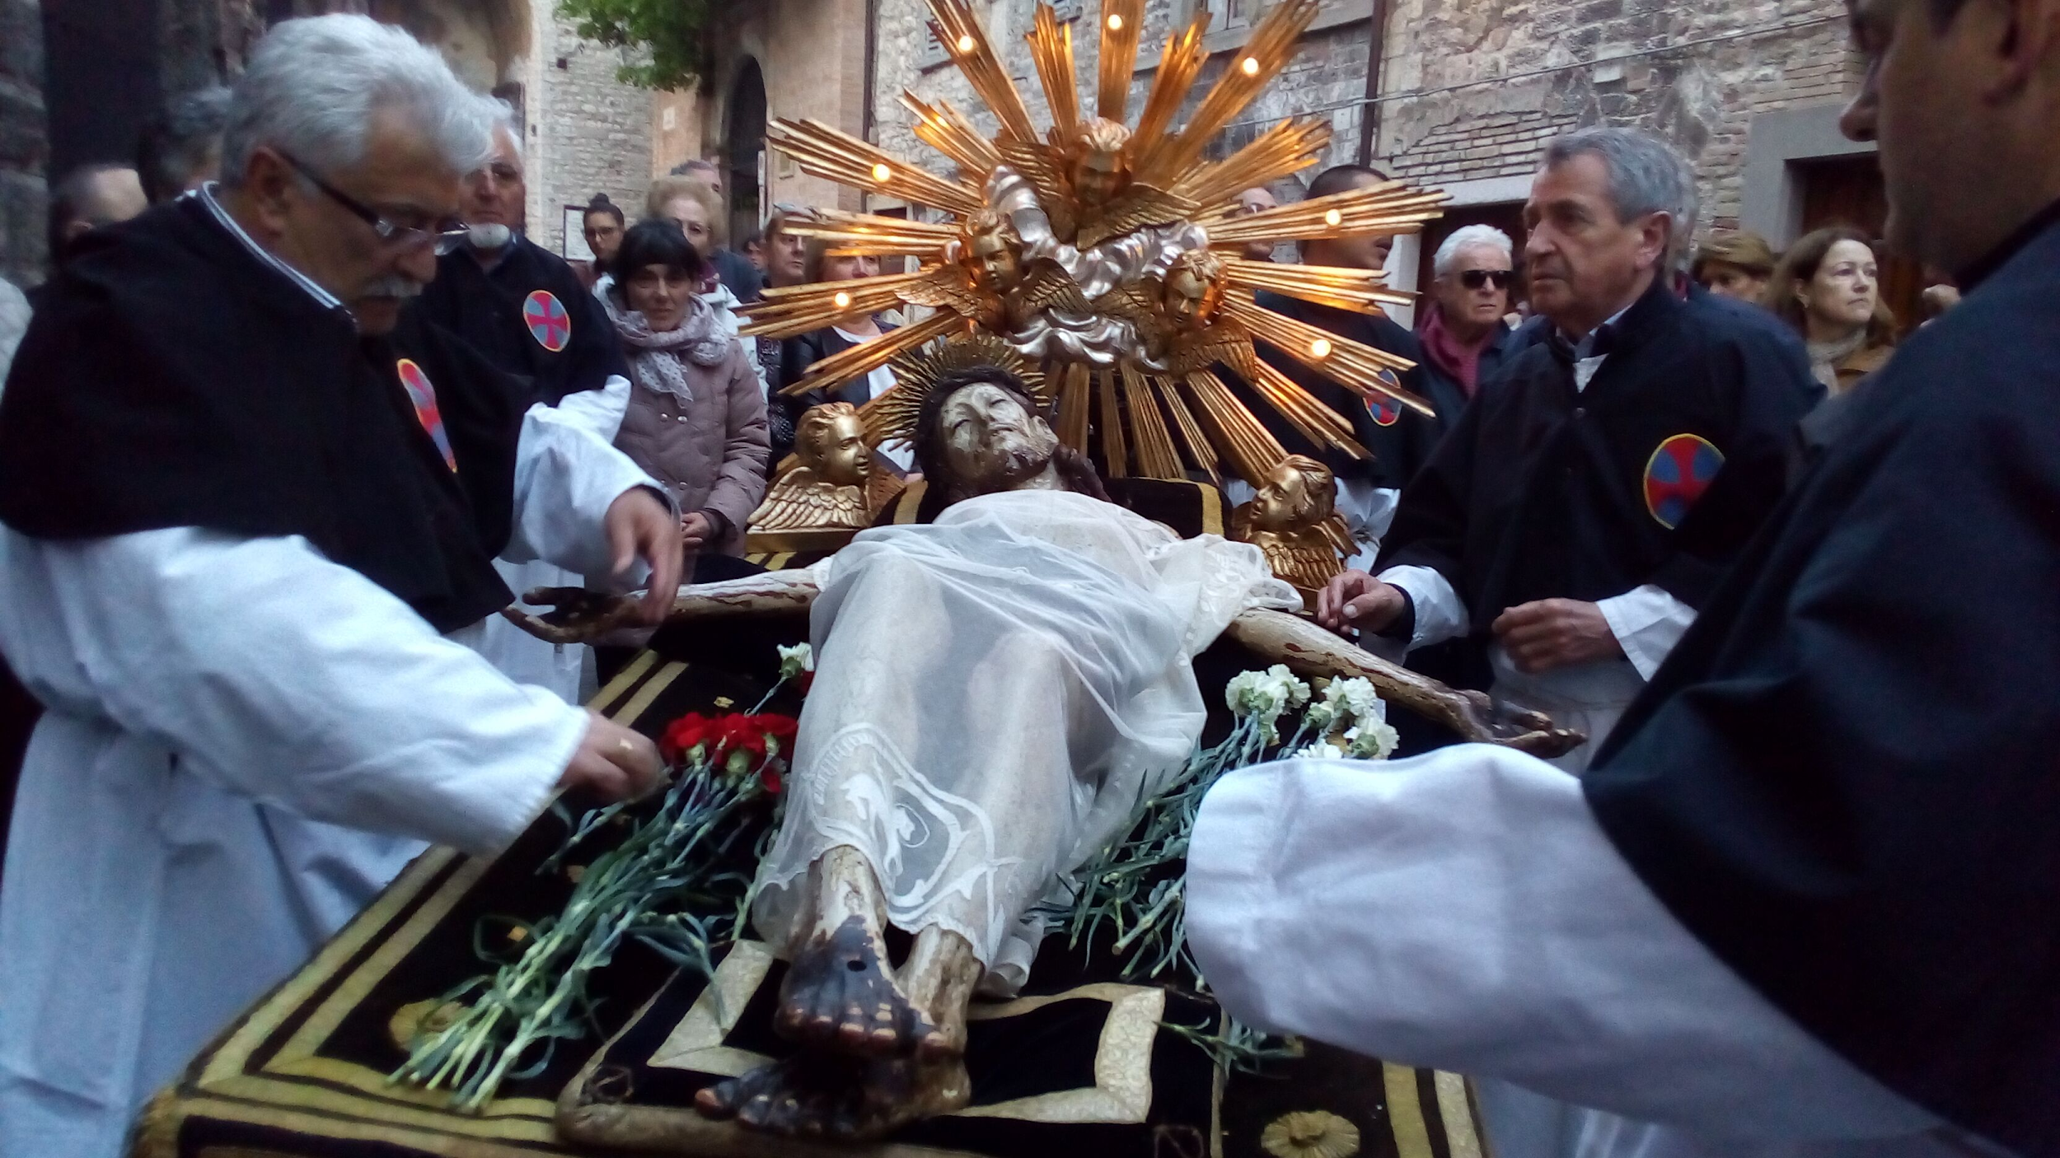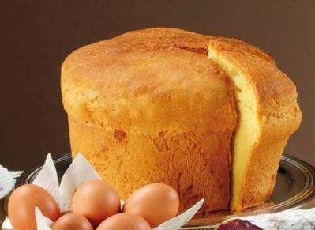

Infiorate di Spello

Infiorate di spello is a manifestation which takes place every year in the small Umbrian town of Spello in Umbria Italy on the occasion of the Corpus Domini feast, on the ninth Sunday after easter. On that night, almost a thousand people work incessantly to create carpets and pictures made of flowers along the town’s narrow streets. Floral creations cover streets throughout the historical centre in preparation for the passage of the Blessed Sacrament carried in procession by the bishop on Sunday morning. The result is a unique, one mile-long path of beautiful floral creations with an explosion of colors and scents.
