Gnocchi Festival in Narni

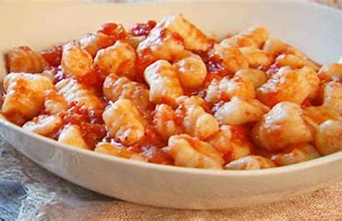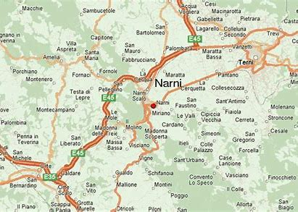

From 8 to 17 July in Narni in the province of Terni, the gnocchi festival is held.
Every evening, from 7 pm onwards, at the covered food stand it will be possible to taste the dumplings seasoned with various sauces, from ragout to butter and sage.
The music will accompany the evening and after dinner it will be possible to have fun on the track, dancing to the rhythm of music. During the party there will be the "Corri sul Nera" running race, which will be held on Sunday 3 July at 6.30 pm.

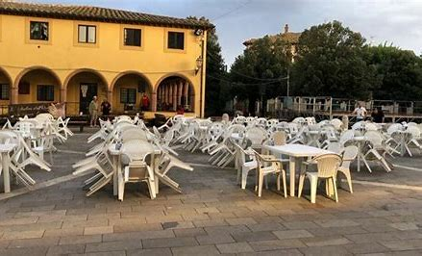

The Wild Boar Festival

From 7 to 16 July it will be Vitellino Castiglione del lago in the province of Perugia, to host the festival.
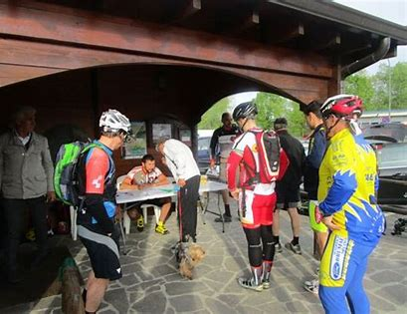
Every evening it will be possible to taste, outdoors, wild boar dishes, such as pappardelle and stewed wild boar. There will be live music during the evenings.
