The infiorate of Spello
the infiorate of Spello are an event that take place every year in the umbrian town during corpus domini that is the nine sunday after easter. The infioritori work all year round to create rugs and floral paintings.
these flower carpets honor the passage of the body of christ which is carried in procession by the bishop.
Is a traditions celebration born in 1600 in which men make colored paintings with flower petals
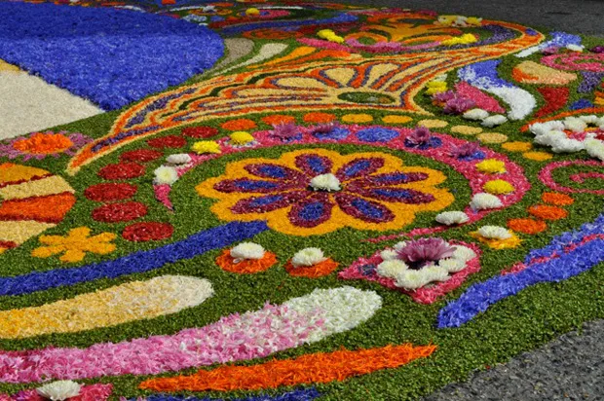
La festa dei ceri
The feast of the candles takes place in gubbio on may 15 of each year and consists of the transport in running of three candles crowned by statues of saints. It is one of the oldest italian folklore events .
this event is repeated every year and is very important for the city of Gubbio lived with great attachment by all citizens.
the three candles have represented the symbol of the region and the statues that are carried in the race are the statue of sant’ubaldo, patron of gubbio,the statue of san giorgio and the statue of sant’antonio
