Carri di maggio: Cantamaggio
On the distant night of April 30, 1896, in Terni a group of friends went to the countryside with the intent of renewing the ancient customs.
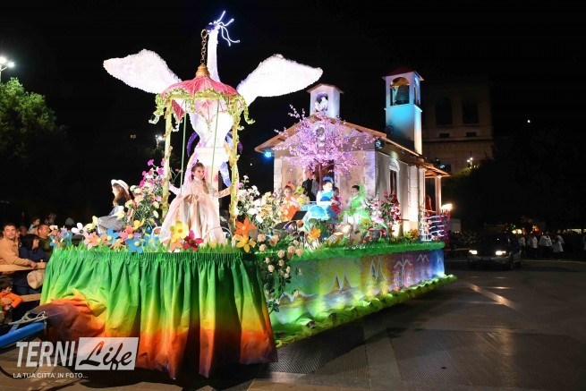
With them, a flowered branch lit by lanterns to be planted in the farmyard of country cottages, around which to sing.
I MAGGIAIOLI:
This was the name of the boys who wore the "May", then the Spring, represented by a branch with yellow flowers and a hanging lantern.
THE EVOLUTION:
The maggiaioli over the years have grown more and more in number, that illuminated branch was placed on a wagon and moved to the city.
The May Floats, set up in the various areas of Terni, began to parade to win the beauty contest, and progress has made them increasingly sophisticated.
THE MAY WAGONS TODAY:
Today, during that special night Terni dresses to party.
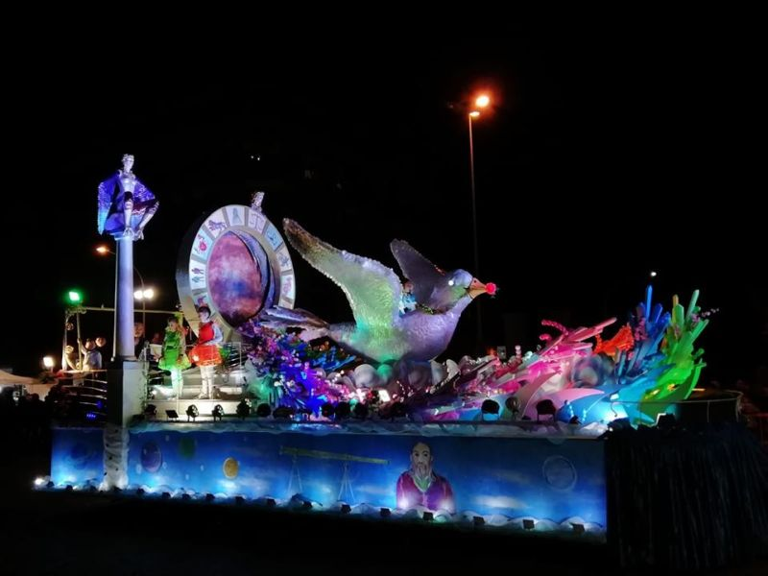
All ternani meet there, to admire them, to applaud them, to sing the various stunners that cheer their passage.
All seasoned by the inevitable sellers of peanuts, candy, balloons and everything that makes you think of a great party.
THE LEGEND:
It draws its origins in the rites of fertility and rebirth, the blossoming of nature after winter.
Legend has it that those who follow the allegorical floats that parade through the city meet the soul mate, for a night or maybe forever.

