BRUSSELS IN WINTER
The months that go from October to March are usually quite cold, with maximum temperatures that hover between 4 and 7 degrees. In autumn the days tend to be gray although the temperatures are not too cold.
During the months of December, January and February, the days are shorter and the temperatures can fall several degrees below zero at night.
BRUSSELS IN SUMMER
June, July and August are the hottest months of the year although, with an average temperature of 20 degrees, at no time does it become an oppressive heat. In Brussels it rains almost all year round and summer is no exception

BELGIAN INDUSTRY

Historically, coal is the main mining resource, but its extraction has been exhausted and production fell considerably in the late 1980s. The industry extracted 5.6 million tons of coal in 1986, but production was reduced to 634,000. t in 1991 and only 147,000 in 2003. Many mines have had to close in the coal regions of the south, around Mons, Charleroi, Liège and Namur; the Campine basin, to the north, produces almost all the coal that remains to be extracted. Because of this, coal must be imported for steel mills and other industries. The importation of crude oil is also highlighted
Belgium is one of the most industrialized European countries, mainly due to its geographical location and transport infrastructure. Industrial production increased rapidly after World War II, but declined in the 1950s. However, the establishment of the European Economic Community (now the European Union) in 1957 and the introduction by the government of an incentive program the investment supposed an industrial resurgence. Belgium is among the largest producers of iron and steel, and more than half of the production is exported. Around 10.5 million tons of raw steel were produced annually in the early 1990s.
The textile industry, dating from the middle ages, produces cotton, wool, linen and synthetic fabrics. With the exception of linen, the rest of the materials are also imported. The centers of the textile industry are Bruges, Brussels, Limburg, Ghent, Liege, Kortrijk and Mechelen. At the beginning of the 1990s, 46,000 tons of cotton fabrics, 32,000 tons of woolen fabrics and 38,000 tons of rayon and acetate fabrics were produced annually.
HOW TO MOVE FOR BRUSSELS

Public transport:
On the surface, the signal indicating the subway stops is a white "M" on a blue background. Many stations display works by local artists and the subway seats are soft and comfortable.
The tram and bus stops are marked in red and white respectively. The route and destination number is displayed on the front of the vehicle and all stops must be requested. The yellow and blue trams run through the center of the city and outlying neighborhoods. The trams reach their highest speed in the subsoil.
Tickets can be purchased at subway stations or in press stores. Bus and tram tickets can be purchased before or during transport (you must bring the exact amount if you buy it on the bus). Once purchased, the ticket is valid for any means of transport, even to transfer.
Taxis:
Their vehicles take a yellow and blue plate and make trips from the Brussels airport to any point in the city. In the center of Brussels there are numerous taxi ranks. You can also ask for taxis by phone. Tipping is optional.
By car:
Although traffic can be dense in the periphery of Brussels during peak hours.
Projects are constantly approved to reduce traffic in the city center, such as the pedestrianization of zones or the application of different traffic management schemes.
Rent a car:
To rent a car you must be over 23 years old, be in possession of a passport or identity card as well as a valid national driver's license of one year old. All major companies have an office at the Brussels airport.
Bicycle rental:
The company Pro Vélo, Rue de Londres, rents bicycles by day or for the entire weekend. It also organizes thematic tours.

Population:

Belgium population clock
11 577 772 Current population
5 676 346 Current male population (49.0%)
5 901 426 Current female population (51.0%)
21 655 Births this year
355 Births today
18 311 Deaths this year
300 deaths today
9 081 Net migration this year
149 Net migration today
12 425 Population growth this year
204 Population growth today

Farms:
Happy cows give more milk and less problems to their owners. In fact, betting on animal welfare can make a farm up to 30% profitable. This aspect was evident in the technical workshop of the dairy sector held yesterday in Mazaricos, where he talked about aspects as important for farmers as the design of their facilities or the importance of maximizing the cost of feeding the herd, a section on that the producers of the zone already allocate more than half of what it costs them to produce each liter of milk.

In this sense, especially noteworthy was the lecture given by the veterinarian Juan Manuel García Castro, who under the title Apuntes sobre instalacioness, made a didactic tour of how the design of the ideal farm should be, both from the point of view of comfort of animals as well as people who must work in it.
"As cows are xustas and end up returning us all the comforts that we give them", sentenced Manolo de Albeitaneria, as is known in the area, while noting the importance of animals having enough space -minimum 10 square meters for res- , have easy access to food and water throughout the day or have adequate light and temperature conditions.

Processing of corn
Full of advice was also the conference given by Javier López, responsible for Spain and Portugal of Kemin, which dealt with the convenience of making an optimal processing of corn -the main food used in the farms of the region- to make the most of your nutrients He advised the attendees to cut the highest plant and plan the harvest so they can wait three or four months after silage to serve the grain to the cows. "Isto allows the quality of starch digestion, or that can affect an increase of two liters per cow per day."

No less profitable is the correct maintenance of the mixer trailer with which the daily ration of dairy cows is prepared in practically all farms. Pedro Sedano, head of the Qualivet firm for northwestern Spain, spoke about this and shared his long experience auditing the feeding services of hundreds of farms.
He stressed the need to establish an adequate order when adding food to the mixture, in a correct cleaning of the machinery or in ensuring the good condition of the cutting blades.

Highlights
In addition to its educational aspect, the technical seminar of Mazaricos has become a meeting point for all those professionals linked to dairy production, where the issues that currently affect or concern the sector are brought together.
Price of milk
It is, traditionally, one of the issues that most concern the sector since it conditions the activity of the entire chain. In this sense, the professionals complain about the scarce evolution that the price of the raw material in origin has registered up to now. Today, farmers in the region receive 31.4 cents for each liter delivered to the industry, one cent less than a year ago.

Outstanding collections of the CAP
Although in recent days some producers received a money advance, coming from Brussels, which corresponds to the Common Agricultural Policy, many others are still waiting.
Morphing of slurry
A Picota also spoke of the extension that allows farmers to spread the slurry using dish systems as they had been doing.

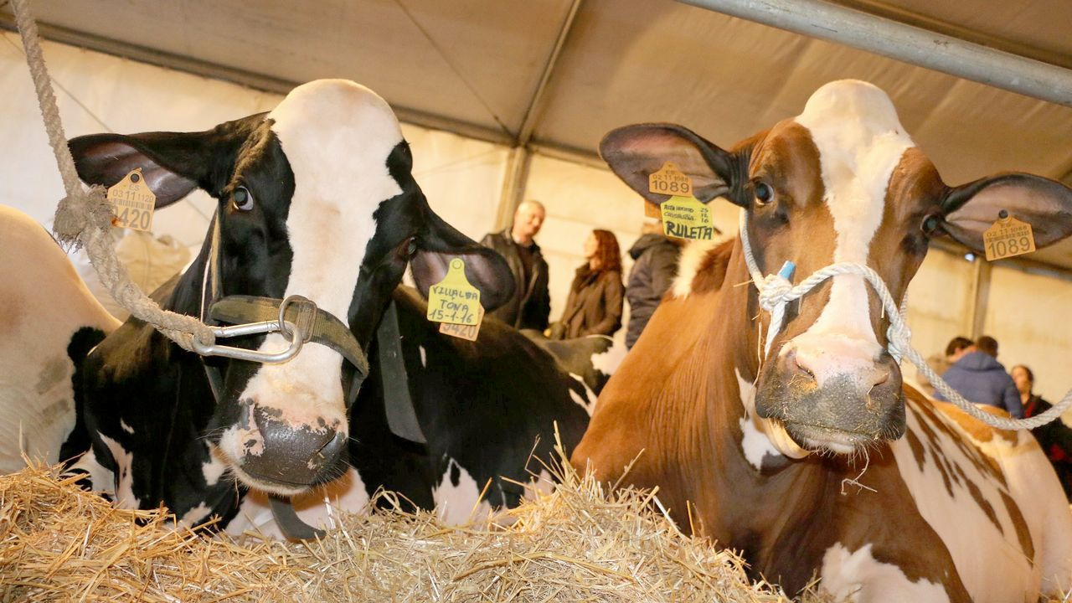

Economy:

