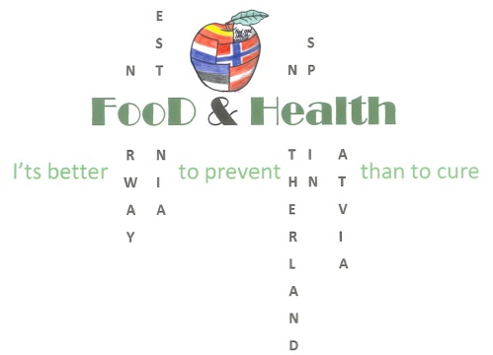
Erasmus+project 2016-2018: Food and Health- It’s better to prevent than to cure

4thGeneral meeting/ Students Exchange
In lyganuse Secondary School , Estonia , from 12th of February to 16th of February 2018

Sunday 11th February | - Arrival at Tallinn airport  - Norway, The Netherlands and Latvia transfer to Lyganuse at about 17.30 (18.00)  - Spain at about 23.00  - Students meet their host families at school, and they go to their host families
MONDAY 12TH February | - 08.00 Arrival at school  - 8.00- 9.00 Welcoming ceremony, Presentations ( school canteen survey )  - 9.00- 10.00 a tour around the school, visiting the local shop (tasting carrot and beetroot chips)  - 10.00-11.30 Lunch at school  - 11.30- 12.00 a bus trip to Narva  - 12.00- 15.00 visiting Narva Castle. Admiring Russia across the border.  - 15.00- 16.30 Travelling back to Lyganuse.  - Students go to their host families
TUESDAY 13Th  February | - 08.00 Arrival at school  - 8.00- 8.30 Presentations (video about preparing one healthy dish and a short presentation)  - 8.30- 10.30- Preparing healthy salads, presenting, degustating  - Teachers` first meeting, Exchange of best practices T&L  - 10.30- 11.00 Lunch at school  - 11.00 Going to watch a Waterfall of Valaste  - 12.30- 15.30 Shrove Tuesday at a farm of Tagavälja.(Estonian farm animals, making Estonian bread, having a sleigh ride)  - Students go to their host families
WEDNESDAY 14 TH  February | - 8.00 Arrival at school  - A bus trip to Tartu  - A tour around the town, visiting Science Centre Ahhaa, visiting Upside down house, shopping  - ±19.00 back at school  - Students go to their host families
THURSDAY 15 TH  February | - 08:30 Arrival at school  - 08.30 – 12.00 Sports lessons ( different sports games, playing floor hockey  - Teachers` second meeting  - 12.00- 13.00 Lunch at school. A bus trip to Estonian Mining Museum  - 13.00 - 16.00 visiting Estonian Mining Museum  - About 17.00 back at school  - Students go to their host families
FRIDAY 16 th February | - 8.00 arrival at school  - 8.00- 8.30 seminar about healthy lifestyle  - 8.30- 10.00 Making posters about healthy lifestyle (mixed groups)  - 10.00-12.00 Preparing healthy snacks  - Teachers` third meeting (evaluation)  - 12.00 lunch at school  - 12.30- 15.00 A surprise activity (depends on the weather, warm clothes needed)  - 15.00 Students go to their host families  - 18.00 a concert ( The Republic of Estonia 100),a Farewell party with host families  - After the party transfer to Tallinn (Norway and Spain)
SATURDAY 17th February | At about 11.00 Transfer to Tallinn ( Latvia and The Netherlands)  Departure

