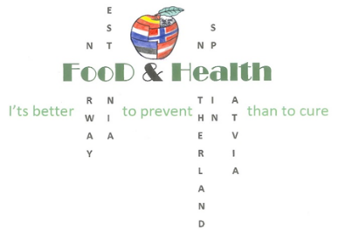
Erasmus+project 2016-2018: Food and Health- It’s better to prevent than to cure
in Auce, Latvia, between the 14th and 20th of May 2017.
Sunday,14.05.17. | Arrivals
Monday,15.05.17. | All students attend 1st and 2nd lessons.  Teachers have a meeting.  Presentations in the school hall:  - Homework about collaboration with regional /national organizations-presentations,  - Homework about different work-outs –videos,presentations.  After presenting homework all students attend last lessons.  Teachers have a planning meeting.  Lunch  All students go home with their hosts after all lessons.  Water aerobics for teachers.
Tuesday,16.05.17. | All students attend 1st lesson.  Baking bread workshop”Bake your own loaf of bread!” at the bakery “Lāči” .  Lunch at the seaside(depends on the weather), sightseeing in Riga.  Healthy dinner at our collegue’s home
Wednesday, 17.05.17. | All students attend 1st lesson.  Workshop of healthy cakes and snacks.  Picnic.  Zumba for teachers.
Thursday, 18.05.17. | All students attend 1st lesson.  Sports activities for students.  Teachers have a planning meeting, best practise in ICT in Auce secondary school.  Mother’s Day Concert  Festive dinner-host families, students, teachers at school.
Friday, 19.05.17. | All students attend 1st lesson.  A day of succadas in Auce (local manufacturers)  Lunch  Garden - Museum of Grower and Selectionist Peteris Upitis in Dobele – degustation of succadas and healthy snacks, excursion in the lilac garden.
Saturday, 20.05.17. | Departure

