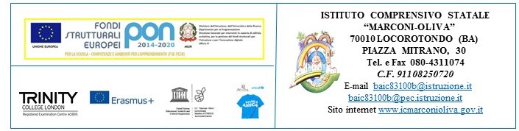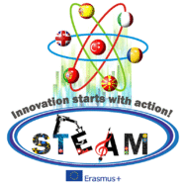
Innovation starts with Action! STEAM 2016/2017
2016 – I – TR01 – KA219 – 034227_7
Teachers | Subject | Activity | Final Output
Mirabile Vittorio  Masciulli Paola | Digital Competences  Foreign Language Competences  (Speaking, Writing, Reading, Listening) | Historical data are converted into a 3D housing Guide by using a 3D English based app  (Planner 5D)  Translation of all data and reports into English for the making of a 3D Guide | Housing model in 3D app and 3D GUIDE  Audio 3D Guide in English
Zocche Maurizia  Serinelli Giovanni | Arte | Geometry and Art  Perspective around us  The making of the project logos  Christmas cards for the Partners  Lanterns and welcoming cards | Drawings of Geometrical shapes  Works of Art related to Perspective  2 Logos for the Competition  Cards for the card exchange activity  Orienteering lanterns for the Erasmus Day event
Cisternino Vita | Technology | The making of housing models of Locorotondo | Pop-up 3D Housing Models on a scale calculated town base
Grossi Davide  Netti Apollonia | Maths | Engineering, Coding and Robotic activities  (Scratch, Arduino, | Videos of Coding, robot making, Paper Curtains in the classroom
Caramia Margherita | Physical Education | Orienteering activities | Orienteering performance during Erasmus Day Events
Caramia Sante, Caramia Evita and Punzi Paola | Music | Music and Lyrics of the STEAM song | Erasmus Day public performance (06.05.2017)

The Italian Coordinator
Paola Masciulli

