AMAZING WATER

Experiments with second and 4th graders.

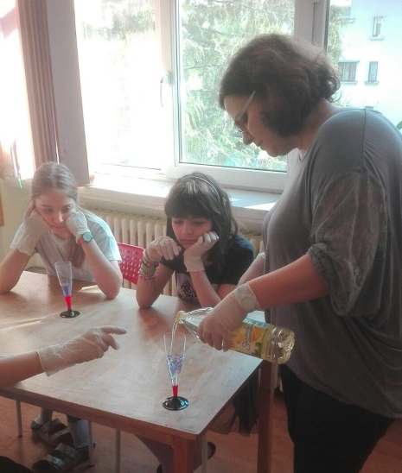
EXPERIMENT 1 - Density of water (water, oil, honey, alcohol)
Every liquid has a different density. Each of these items is made of molecules and each of the molecules is packed differently.
Oil has wide space in between their molecules making it less dense than water. Water molecules are tightly packed, liquid detergent molecules mix with water. Honey is water and dissolved sugar.
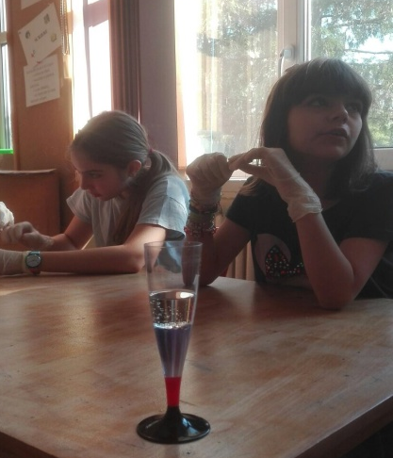
Oxygen is heavier and smaller than carbon, so a volume of water molecules is heavier than the same volume of oil molecules. This makes water more dense than oil. Also, water molecules are very attracted to each other and pack very close together. This is another reason why water is more dense than oil.
Alcohol is less dense than oil. Alcohol molecules are mostly carbon and hydrogen atoms so they are similar to oil. But they also contain an oxygen atom, which makes them a little heavy. For this reason, you might think that alcohol would be more dense than oil. But alcohol molecules do not pack very tightly together. Because of their shape and size, alcohol molecules do not pack as efficiently as oil molecules, making alcohol less dense than oil.

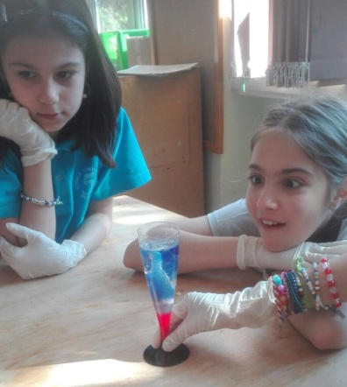
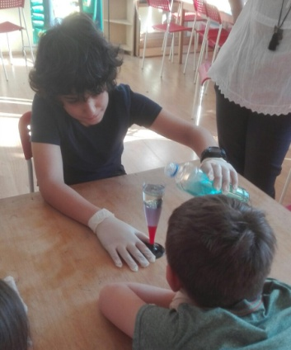
EXPERIMENT 2 - Volcano in a glass
Transform the glass from first experiment in a volcano, just adding a Alka-Seltzer (or other tablets that fizz) and some drops of ink or food coloring.

EXPERIMENT 3 - Colour mixing
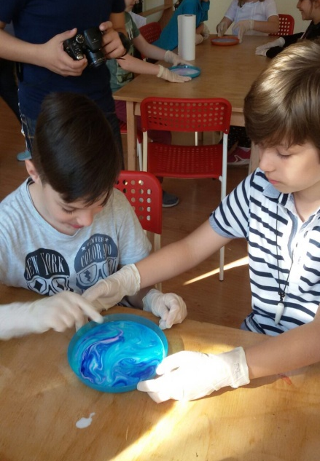
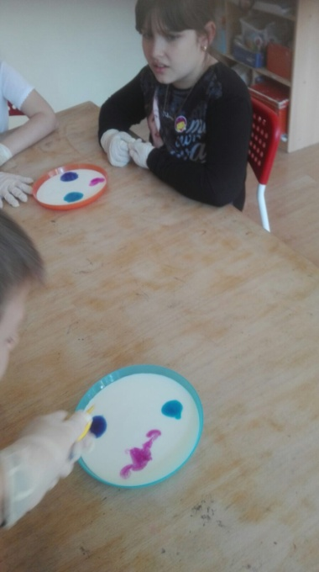
Add one drop of each of the four colors of food coloring—red, yellow, green, and blue—to the milk. Keep the drop. Find a clean cotton swab for the next part of the experiment. Predict what will happen when you touch the tip of the cotton swab to the center of the milk. It’s important not to stir the mix—just touch it with the tip of the cotton swab. Go ahead and try it close together in the center of the plate of milk.
Mix the color and enjoy your art piece

EXPERIMENT 4 - Secret power of soap
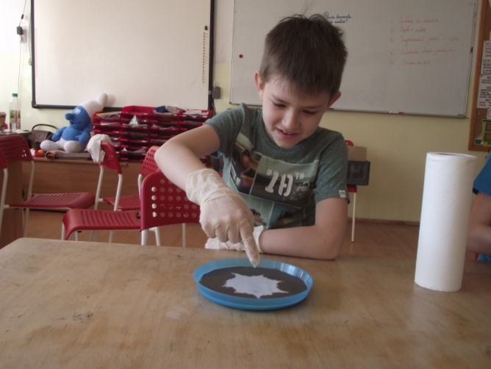
Based on the previous experiments.
Now place a drop of liquid dish soap on the other end of the cotton swab. Place the soapy end of the cotton swab back in the middle of the milk and hold it there for 10 to 15 seconds. Look at that burst of color! It’s like the Fourth of July in a plate of milk.
Watch the colours swirl around. Why is it so?
The fat and protein molecules in the milk are altered by the soap. This causes them to roll around. Once the soap molecules have mixed evenly with the fat and protein molecules in the milk the motion will stop. So keep adding drops of dishwashing liquid when the action slows down.
Add pepper into the plate and repeat the experiment.

EXPERIMENT 5 - Diapers battle with liquids
The secret inside disposable diapers since the mid-80s has been Super Absorbent Polymer (SAP). These tiny crystals are carefully sprinkled inside the layers of the absorbent core of a diaper, being utilized for their incredible ability to absorb and trap fluid. SAP is claimed to absorb up to 300x its weight in water and retain it.
Based on his ability, we test how much water can a very small SAP quantity will absorb.
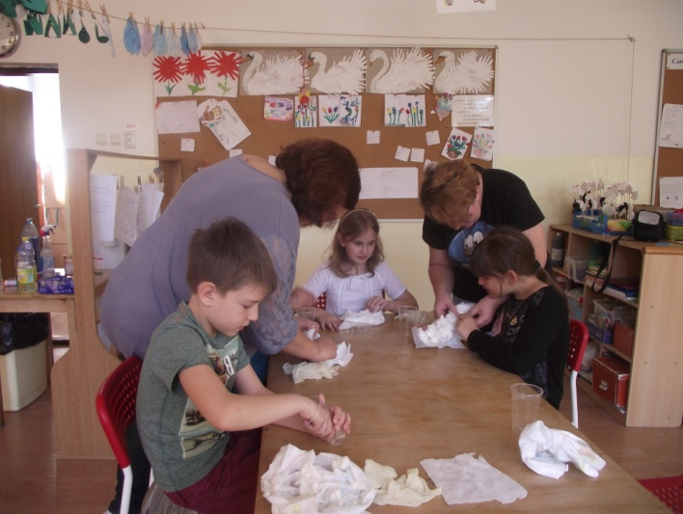

EXPERIMENT 6 – Funny colors
We mixed shaving foam and honey in a transparent glass. After two minutes the children noticed that honey was deposited at the bottom of the glass and the shaving foam came to the surface without mixing. Then we added tempera colors and the children have drawn on paper with the mixture formed.
