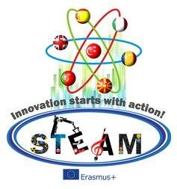

Innovation statrs with action!
STEAM Lesson Plan
This is an example lesson plan
School & Country | Mersin Bilim ve Sanat Merkezi
Teacher | Yıldız Kanlıöz –Primary school teacher
Class age of students | 10-12
Lessons | Mathematic – Art- Robotic-History-Nature science- Dijital Story telling
Themes | Geometry around us
Time duration | 2 month (November-December)
What will be learn? Which methodology are used for these activities? | Students will be learn geometry in their real life.  Learning by doing  Exploring  Disscusion  Demonstration
- Materials | Geometrical shapes, leaves, phones or tablets, computers,  Lego EV3 Robot set, patatoes, colours,
- Art | Working with Potato printing or/ and leaf printing about the theme geometry.  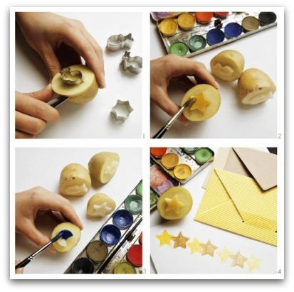
- Science | Exploring for geometry in the nature and real life. Students explore in groups the natüre and find the geometry in the natüre. They take photos and create a poster or presentation about it.
- Technology | Use paint program or 3D programs for creating geometric designs.  Let the student make a digital story or a documentary movie /or a thriller movie about the geometry in the buildings / in the nature around them.
- Engineering | Use wood or woste materials to create a castle or an other builduing with geometrical objects.
- Robotics | Students will be program their robots so that the added pencil draw a geometrical shape. For example draw a square or triangle with the robot.  https://plus.google.com/+DamienKee/posts/ZrsNx3RjZpP
- Coding and programming | Students explains their coding and programming of their robots.
- ICT and Web 2.0 | Tinkercad, scetchUp, http://www.sweethome3d.com/  Coding shapes with the https://www.khanacademy.org/ free lessons.  Agumented realty apps for example quiver apps and platonic shapes  http://www.quivervision.com/education-coloring-packs/#quivervision-platonic-solids
- Museum Activity | Find the geometrical shapes in the historical objects, how is the geometry used in the history?
- Nature Activity | Look around and find the leaves and flowers symmetry and geometry in the nature
- School Activity | Students groups make a presentation about their Works and give feedback to the other groups.  They explain the desing about the circle, sqaure or triangle to their classmates.
- How to measure these activities? | Surveys before and after the activities will be made to the students.
- How Innovative is it? | It will be innovative if the students can be take part and get their mind and creativity free.
- Creativity | Students explains their ideas in a creative way to us.
- Interdisiplinary | Geometry is integrated in different subjects cirriculum and in real life.
- Measurable | It is measurable because students fill the surveys they get different view of the theme and they use technology. So we can give points for their work and outcomes.
- Sustainability | Every school can make these activities in their school and in real life.
- Applicability | This theme is applicable with different subjects and is important for design and art.  So that can be integrate into robot programming too.
- Collobrative | It is collobrative, because the students are working in groups.
- Economic in save of time and money | All the activities can be integrated in real life and the materials are very cheep.

