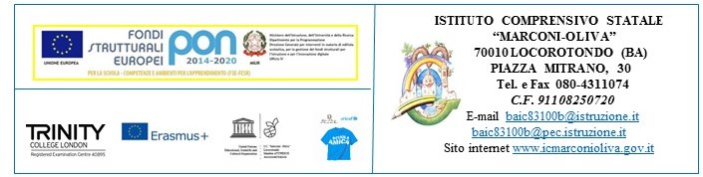

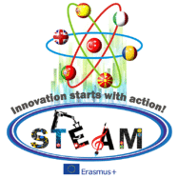
INNOVATION STARTS WITH ACTION!

STEAM

KA2 – Cooperation and Innovation for Good Practices 2016/2018
2016-1-TR01-KA219-034227_7
2nd Transnatıonal Meeting
3 – 7 May, 2017

