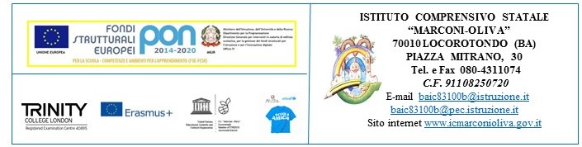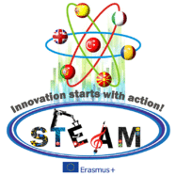
Innovation starts with Action! STEAM 2016/2017
2016 – I – TR01 – KA219 – 034227_7
Teachers | Subject | Activity | Final Output
Mirabile Vittorio  Masciulli Paola | Digital Competences  Foreign Language Competences  (Speaking, Writing, Reading, Listening) | Historical data are converted into a 3D housing Guide by using a 3D English based app  (Planner 5D)  Translation of all data and reports into English for the making of a 3D Guide. Coordination of the project, supervision of all project activities in Italy, partecipation to the project webinars and meetings. Reports and uploading of all activities carried out so far on TS and the project website. Organisation of the 2nd transnational meeting in Italy. | Housing model in 3D app and 3D GUIDE  Audio 3D Guide in English  Posters  Webinars and meetings  Skype chat with Romania  2nd TPM in Italy
Zocche Maurizia  Serinelli Giovanni | Arte | Geometry and Art  Perspective around us  The making of the project logos  Christmas cards for the Partners  Lanterns and welcoming cards | Drawings of Geometrical shapes  Works of Art related to Perspective  2 Logos for the Competition  Cards for the card exchange activity  Orienteering lanterns for the Erasmus Day event
Basile Giuseppa L’Abate Giuseppina  Decarolis Angela | History | Historical reasearch on the local housing structures  Steam welcoming cards with poems | Documents for the 3D Guide  Cards of Locorotondo with poems
Cisternino Vita | Technology | The making of housing models of Locorotondo | Pop-up 3D Housing Models on a scale calculated town base
Grossi Davide  Netti Apollonia | Maths | Engineering, Coding and Robotics, Engineering activities  Water Interdisciplinary CLIL Activities | Videos of Coding, robot making, Paper Curtains in the classroom, Solar Panel and devices made with recycled materials, CLIL on Water
Caramia Margherita | Physical Education | Orienteering activities | Orienteering performance during Erasmus Day Events
Caramia Sante Caramia Evita | Music | Music and Lyrics of the STEAM song | Erasmus Day concert  (06.05.2017)  Erasmus Song

The Italian Coordinator
Paola Masciulli

