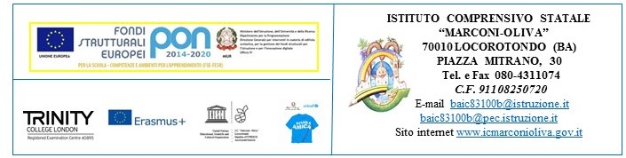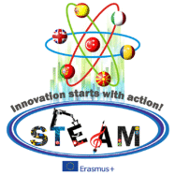

Innovation Starts with Action! STEAM
Strategic Partnerships for School Education
ERASMUS+ 2016/2018
2016-1-TR01-KA219-034227_7

2nd TRANSNATIONAL MEETING – ITALY, 3-7 May 2017

LETTER OF INVITATION
Yildiz Kanliöz
Balazs Kecskemeti
Ana Nojkovska
Irina-Elena Petcu
Edelmira Riero

Date: February 2017

Dear

It is my great pleasure to invite you to attend the 2nd Transnationsl Meeting for the period of 03rd /07th May 2017, in Locorotondo, Italy. Your visit will be supported by the ERASMUS+ Innovation Starts with Action! STEAM Strategic Partnerships for School Education.

Teacher:
1.
2.

ERASMUS+ will cover the costs of your travel, accommodation and subsistence expenses related to your visit up to the agreed amount as detailed in our application form.

ERASMUS+ does not provide insurance services, and this is a responsibility of all visitors to have a comprehensive travel insurance including the medical cover.

I very much hope that you are able to accept the invitation, and I am looking forward to welcoming you in Locorotondo, Italy.

Yours sincerely,

Mrs Grazia Convertini
Principal
IC Marconi Oliva
Locorotondo (BA), Italy

