MERRY CHRISTMAS!

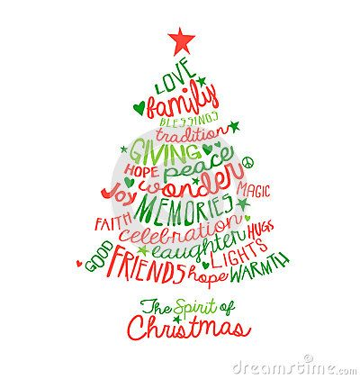

*May you and your family find the light inside yourselves and laugh together during the brightest of celebrations!*

*Best of wishes from Romania!*