MIGRATION IN ITALY

Sicily has been a land of immigration for millennia ... arrival port for those looking for luck. First the Greek colonization before our era, the mass arrival of Berber farmers following the Arab conquest, Normans ... land of refugees for other countries such as the Greek-Albanians fleeing from the Turkish conquest ... or today people from North Africa.

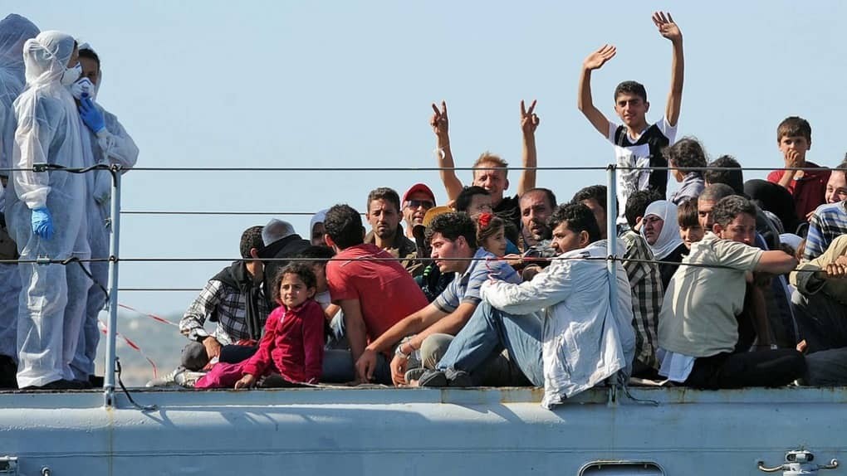

Sicily has been a land of emigrants, people that left their homes to look for a better future.

Italian emigration, from the unification of Italy to the second half of the 20th century, has been defined as the greatest exodus of a people in modern history. It is estimated at more than 5 million people who emigrated in the period between 1877 and 1900 and more than 8.5 million in the first fifteen years of the twentieth century were from Sicily. They went to North and South America and to Australia
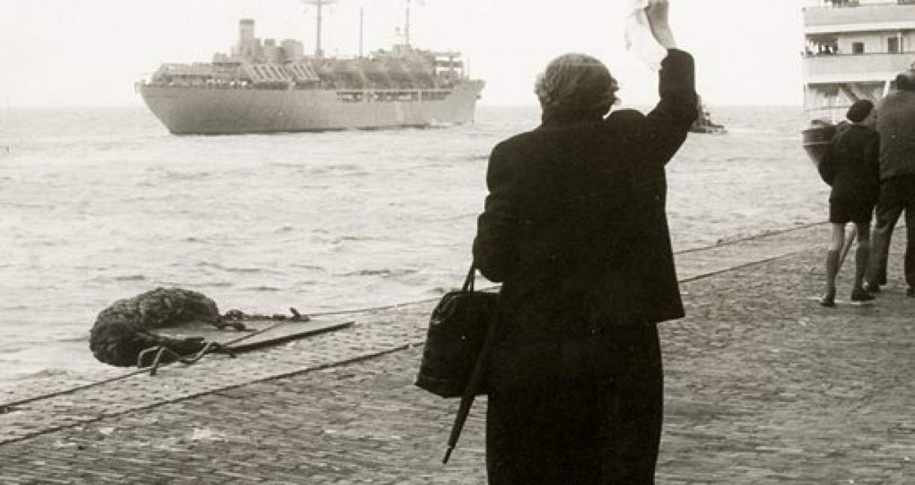

In the past Sicilian people emigrated to find a job and earn some money. Then, they went back to their own home country where they built a house and had better life conditions
Today young people from Sicily emigrate to find abroad better job opportunities. They are not keen to come back again to their home country again.
Interview to Alfio L – 93 years old
When I left Sicily I was nearly 18 and I spent my birthday on the ship that took me to Sydney . There I joined my father who had migrated to Australia some years before. We emigrated because of the great poverty that there was in Sicily that time. After a 40 days travel by ship I got the Australian coast and then, by train, I got to Cairns where I worked as a sugar cane cutter for 19 years. In 1948 we decided to come back to Italy to live there in better conditions.

