**BOOK OF STORIES**

In the first half of **November,** some of our students published in the etwinning page of the project some information and details about our ***Soul Feast*** or ***Black Night*** traditions. Surprisingly for us, they discovered that, before Americanised Halloween feast reached our country, in many places of our area, there were quite similar traditions. Unfortunately, those traditions have been lost but our students were able to find some interesting testimonies of people who still can remenber them or have studied them.

**-Josu Ozaita** and **Jaime Altuna** are two teachers and researchers who have studied this ancient costumes related to Soul Feast or *Arimen Gaua* in Basque. This is what they said to our students:

*We have received different testimonies from many towns all around the Basque Country. In Unanu (Navarre), for example, the turnips were emptied, the face of the turnips were shaped, red paper was placed inside them, and they were placed on the windows. We have received different testimonies about that and they all coincide, so, it seems that that day was quiet remarkable*

*In other parts of the Basque Country, such as Oiartzun (Gipuzkoa) we were told by old people that the pumpkin was placed as a scarecrow's head, along with a candle. They also put the children in the shape of big heads in Zegama (Gipuzkoa); also in the same province, in Zaldibia, skulls were taken from the cemetery bone and placed with candles around the cemetery.A woman aged 101 years old told us a couple of months before she died.*

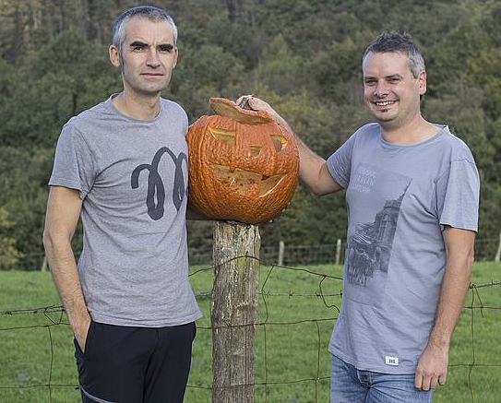

*We have also discovered that The Night of the Souls or Arimen Gaua used to be celebrated on November 2nd in some twons. They also used to perform services for the souls.*

*Today, October 31 is celebrated in many places. Although there are differences from one town to another, they have common characteristics, such as the recovery of grandparents' habits, being in Basque and the prominence of souls. In Bergara (province of Gipuzkoa), for example, a group of parents started celebrating four years ago, mainly because they saw that they were starting to celebrate an Americanised Halloween. They get together in the square and make their way to the cemetery, in a theatrical way, giving scares, and they end the route in the square, eating sweets. The day before, they do a pumpkin workshop to give it a face shape, and put it on the street the next day*

-But that wasn´t the only testimony. Amaia San Martin, a student who took part in our Roots project and went to Cyprus, made a research at her grandparent ´s town (Lekeitio, province of Biscay) and this is what **Amaia San Martin ´s** grandmother told us about it:

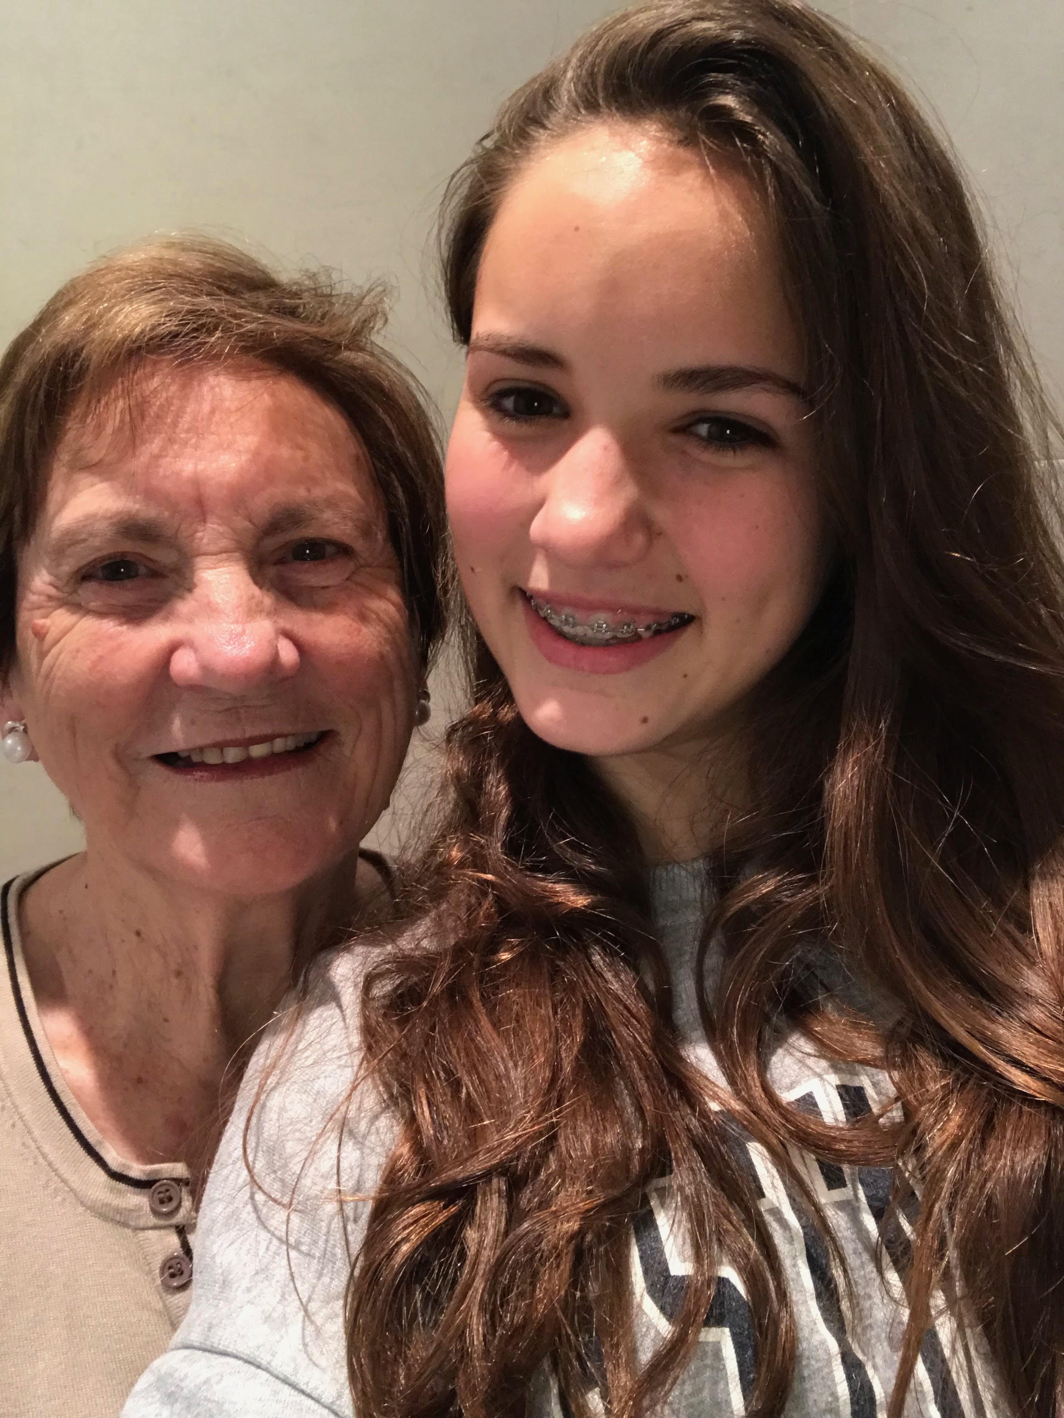*"I remenber that 60-70 years ago my granmother and grandfather told me that they used to “steal” the pumpkins from other people's gardens in a funny way, and they also had the chance to go out at night to celebrate* Arimen Jaia *or Soul Feast. Unfortunately, those tradditions disappeared during Franco´s dictatorship here in the Basque Country and I never had the chance to take part in them myself"*

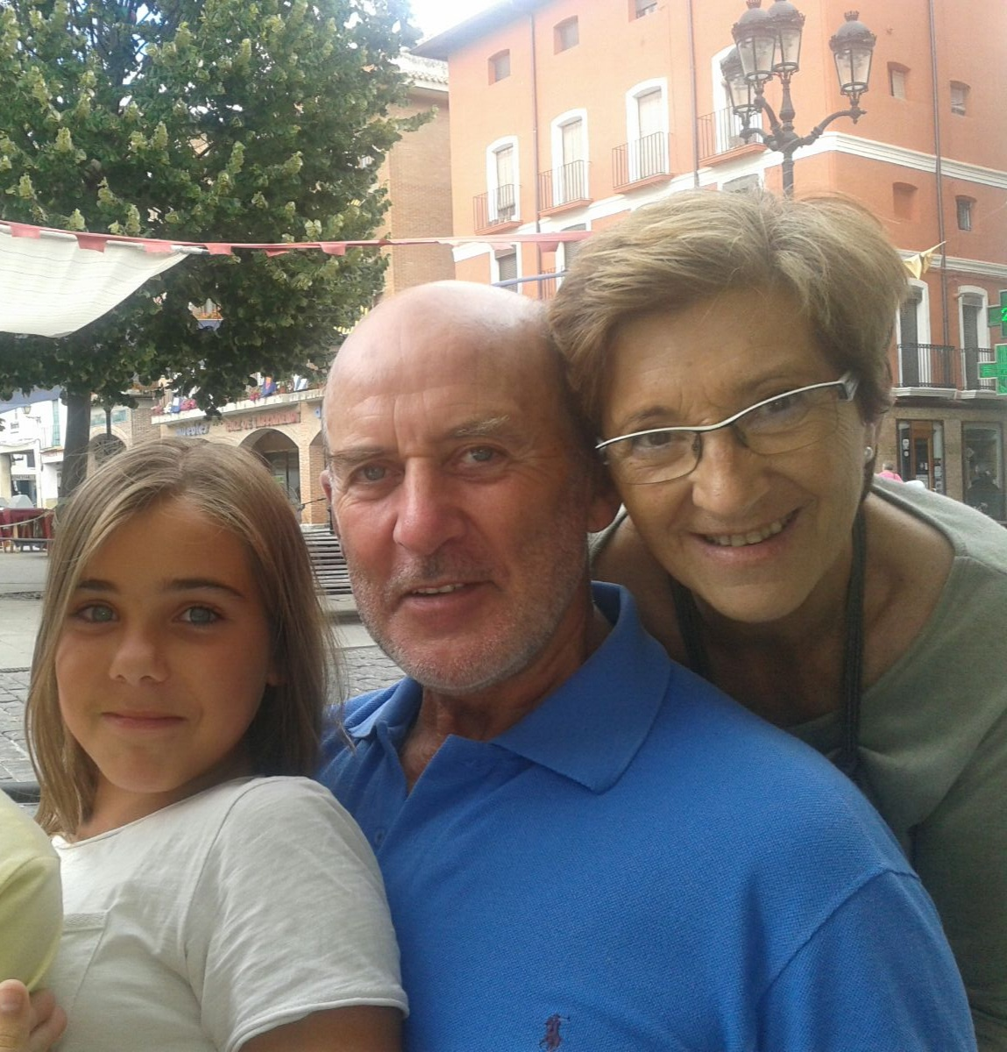**-Maddi Galdeano,** another student who also went to Cyprus, made a research at her grandparent ´s town too. In this case it was Elgeta, in the province of Gipuzkoa:

*I remenber that in Elgeta we still celebrated a Black Cat Day in the 80´s, and the people would dress up as black cats. Yor grandfather and me used to take part in it. Now this feast has gained momentum in recent years and they do a horror walk, kind of a theater which is very funny. We don ´t know for sure, but, aparently, there was something similar to the Cat Day in Elgeta at the beginning of the XXth century.*