Book of Stories, Finland

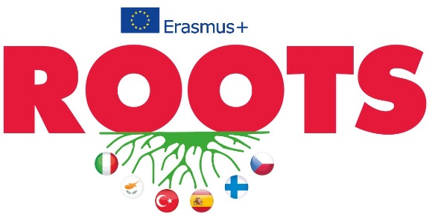

# Folk stories

**The sleepy head of Naantalin kaupunki, the City of Naantali**

**Video made by Lotta Raitanen and Karoliina Malkki**

Every summer the 27th of July we have “unikeon päivä”. So there is like the official unikeko which means the sleepy head in English. The person is always important to Naantali and the person has influence in Naantali somehow. The history of this date starts in Naantali spa where the servants woke up the customers like this: Wake up! Wake up! Wake up! (banging a cauldron with a spoon). Because they had to have their morning walk and drink “magic water”.

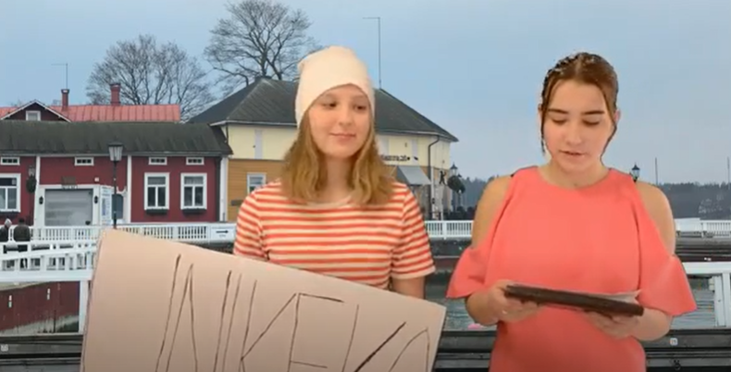

So the customers were bored because their summer just included walking and drinking water – that’s boring. So they wanted something special and that’s how the sleepy head day was born.

Nowadays the day starts at 6 a.m. when the morning walk where everyone is in their pyjamas and doing this (banging the cauldron with a spoon) and waking up the city.

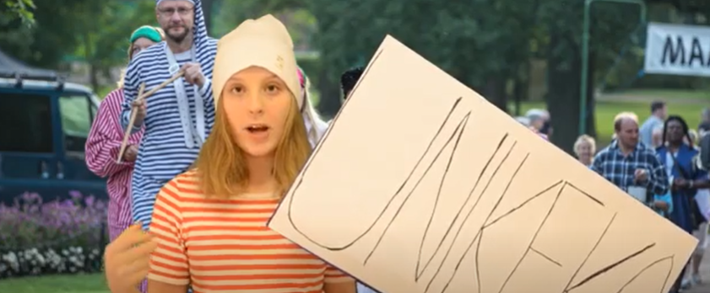But last year at 7 a.m. they dropped me (the sleepy head) to the water and the people were standing and watching me in the water and excited about that who is going to be the sleepy head of the year. And it was me. So after that, when the sleepy head has been revealed there’s a costume contest for the kids and model shows and restaurants are open and shops are open and it’s a day that you will remember.

Hi, so we are relaxing at the Naantali Spa right now. Many years ago like in the 1920s it was a well-being center outside in Nunnalahti (the Bay of nuns). And there were also these massauses who gave them massage and took care of them and the womans and mans had their own places because they couldn’t swim together because it was improper. Because it was 1920s. PRRR! Oh, the bell rings! So it’s time for our water. So the water came from Viluluoto’s fountain and people think that if you drink this water, then you are healthy and beautiful and you live longer – and that is correct.



**Kalevala, the national epic**

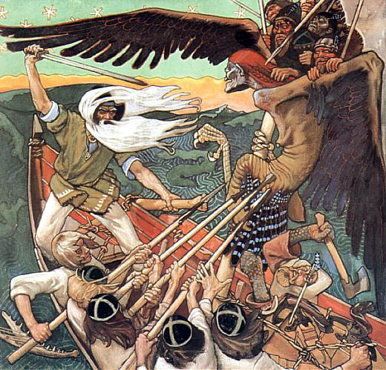

Kalevala is a Finnish folk story

-Elias Lönrot had gathered stories and poems from Finnish people from all over the country and he put it together in one piece.

-Kalevala is Finland’s national epic.

-Through the stories of Kalevala there were a lot of different versions of how the world was born.

-Many people thought that the world was born from Kalevala’s character Väinämöinen when an egg hatched on his knee.

-Some people thought that two characters from Kalevala created the world by singing.

-The stories are really fictional but they made a great start for finnish culture and inspired literature, arts and music. Kalevala was the start of Finnish identity.

# Immigration

**We asked our grandparents, parents and neighbors what they think about immigration**

**Interview made by Ella Mäntysalo and Sara Hänninen**

**Parents’ opinions: Do you think that immigration is good or bad thing**?

-it’s both good and bad!

It's good because people who have some war in their home country can have a safe life in Finland without fear.

Immigrants are themselves active people. Immigrants, for example, have many organizations, associations and companies and that's really good.

It’s a bad thing because some people who come to Finland don’t go to work and don’t respect our culture.

Everyone who’s trying to adapt to our society is very welcome here (working, studying), but it’s not okay to do nothing and live by the government’s social benefits

**Parent’s opinion: “What do you think about immigrants?”**

Immigrants bring more Multiculturalism and professional abilities to our country

**Grandparens’ opinion:** **Do you think that we should take more immigrants in Finland?**

Yes, some of them who have really bad living conditions in their country should have an opportunity to a better life and have freedom to raise their children without war.

No, because some crimes have been committed by those immigrants and some of them don’t want to follow our culture.

**A fact from my dad:** Finland’s population growth is going to be down in the future. We need more employees from the other countries.

**Grandfather’s opinion:**

I really wish that Finnish morals and ways of living wouldn’t disappear totally from the society.

**My neighbour’s opinion about asylum seekers:**

Immigration should be more limited. If an asylum seeker doesn’t get asylum from our country, there is usually a good reason for that. It means they shouldn’t stay in our country illegally.

# Food

**Voisilmäpullat**

**Video made by Tiina Peltonen and Jade Hautala**

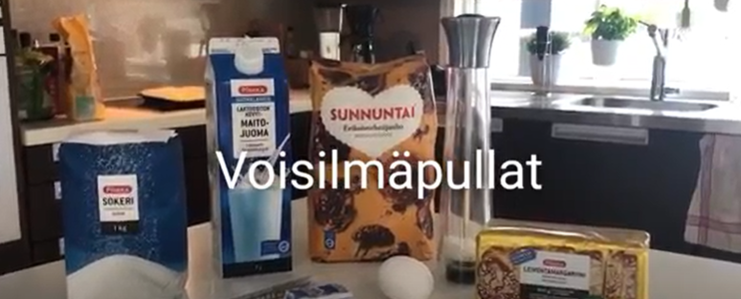



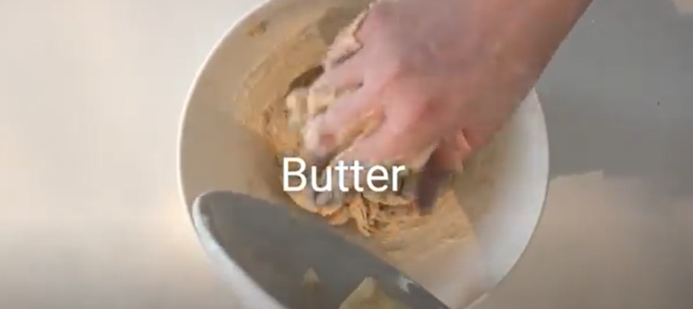

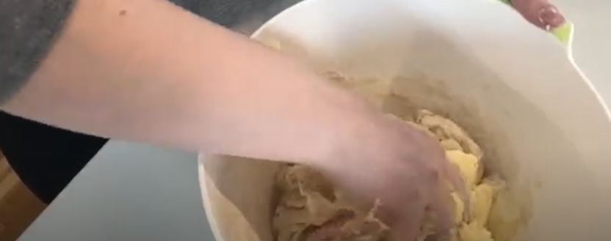

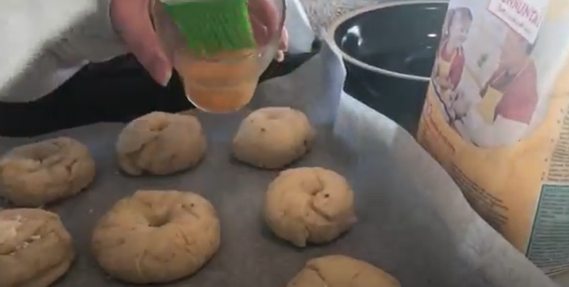

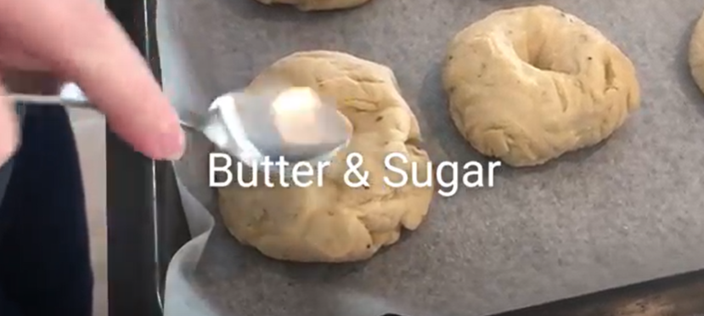

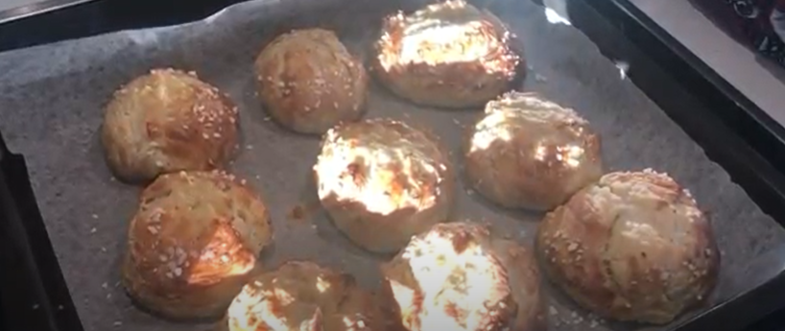

**Macaroni Casserole**

**Recipe made by Eemeli Järvi**

Ingredients

* 400g  Macaroni
* 400g  Ground beef
* 1     Onion
* ¾ tsp  Salt
* ¾ tsp  Black pepper
* ¼ tsp  Allspice
* 2  tsp basil
* 2 tsp thyme

Egg and milk mixture

* 2-3 Eggs
* 7dl Low fat milk
* 1 tsp Salt

Preparation

* Boil the macaroni and then sieve the macaroni from the water.
* Chop the onion in to a fine dice. Cook the ground beef in a pan until it’s brown. Then add the finely diced onion with the ground beef. Add the spices. Put this mixture in a 3 liter casserol dish.
* Combine The eggs, milk and salt in a big bowl. Then pour it all on to the macaroni mixture,
* Cook it in the oven in 175*°c for about 45 minutes.*
* *Enjoy!*

# Music

**Folk songs and dances in grandparents’ childhood and youth**

**Interview made by Venla Hinkkanen**

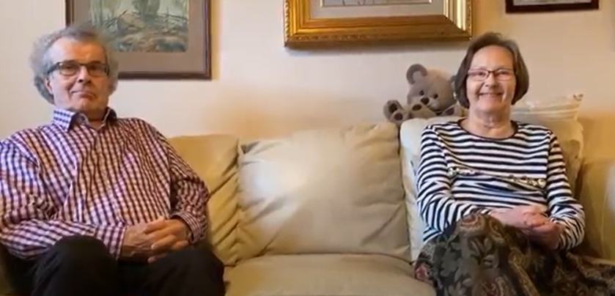

**Venla:** What kind of songs did you sing when you were children

**Grandfather:** Song that were born among people, folk songs, not made by composers, Finnish songs.

**Grandmother:** Folk songs and patriotic songs, too. Different songs for spring, summer, autumn and Christmas.

**Venla:** Which folk song do you remember?

**Grandfather:** Tuonne taakse metsämaan (Beyond forest) was often sung at school and in the choir.

**Grandmother:** Lintuselle (To the little bird).

**Venla:** Did you have a fancy ball at school for the senior students like we do?

**Grandfather and grandmother:** Yes, there was a similar one. However, the customs were different.

**Venla:** Did you go dancing in your freetime?

**Grandfather:** Yes, in the 1960s there were places in the countryside for dancing. Tango was particularly popular.

**Grandmother:** I didn’t go that often but sometimes. Tango, jenkka, polka and ring games.

**Venla:** Where did you go dancing?

**Grandfather:** In the summer in the outdoor dancing facilities, in the winter in local assembly halls.

**Grandmother:** I preferred folk dances.

**Venla:** What was it like to dance?

**Grandfather:** It was popular Finnish tango, very simple and you could take contact without knowing how to dance.

**Venla:** How did you dress?

**Grandfather:** For men it was a jacket, not jeans. In general neat clothes.

**Grandmother:** In the summer light summer dresses, in the winter clean winter clothes.

**Venla:** What kind of artists did you listen to?

**Grandfather:** Reijo Taipale, Eino Grön – Finnish artists who played tango. I also played music myself.

**Grandmother:** I listened to the radio a lot to Finnish artists.

**Venla:** What kind of music did you listen to?

**Grandfather:** In the 60s the dances usually started with a walz, followed by jenkka and then mainly tango all evening.

**Grandmother:** I listened to dance music of course but I also sang in the church choir, we sang in unison.

**Venla:** Did you play any instruments?

**Grandfather:** I played the piano, contra bass, clarinet, drums and organs in the church.

**Grandmother:** I didn’t play any instruments, I just sang in the choir.

**Venla:** Do you know any folk dances?

**Grandfather:** No, I don’t.

**Grandmother:** Yes, we had a teacher at school who was very keen to teach us: forward, backward, round and round and round.

