ERASMUS+, KA229, SCHOOL PARTNERSHIP PROJECT
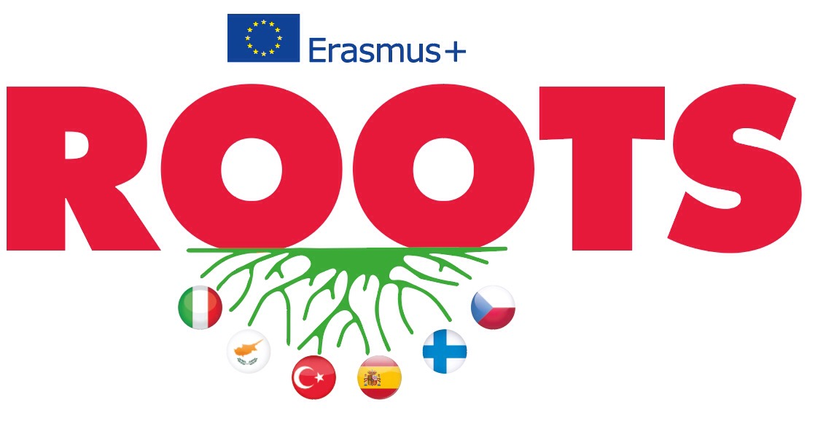
January 23-28, 2019
Limassol, Cyprus
REPORT OF QUESTIONNAIRE ABOUT IMMIGRATION BY TURKISH SCHOOL
ÖZEL FALEZ FEN BİLİMLERİ ANADOLU LİSESİ
ANTALYA / TURKEY

50 Students from our school joined this questionnaire. Here is their answers;

1.

2.

3a.

3b.

3c.

3d.

3e.

3f.

3g.

3h.

4.

5.

6.

7.
8.

9.

10.

11.

12.

13.

14.

THANK YOU FOR WATCHING

