The Easter Easter is an annual celebration celebrated by the resurrection of Jesus. The Resurrection is at the heart of Jesus and the Christian faith, and Easter is the oldest and most important celebration of Christianity since. Easter is preceded by a quiet week in many churches, the content of which is in Christ's Passion, culminating in the long Friday, the historic Jesus Crucifixion Day. The actual Easter begins on Easter Sunday when Christians celebrate Jesus' resurrection and follow the second Easter day. These days are holidays in Finland and many other countries.

The Easter tradition has been easter eggs made by hobby, jokes and dragonflies, and Easter food. In Finland, traditions have also included a viewing or presenting Easter plays, Easter travels where the public can participate in Christ's suffering story.

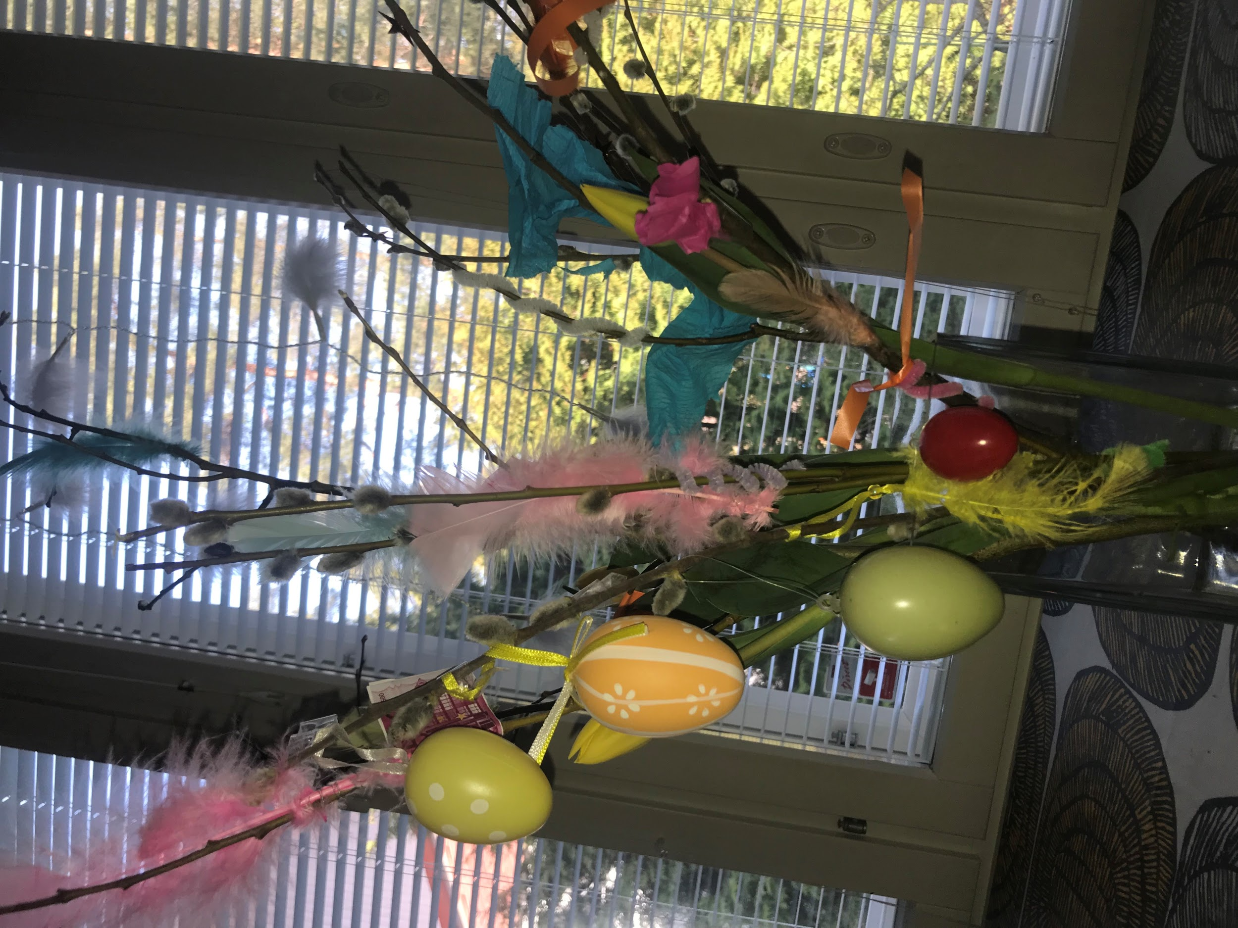
Virpominen is a tradition of palm-sun, in which the spirits are thrown away by evil spirits and wishing happiness and health by waving the decorated willows. Virpominen also refers to the saying of the palm tree, when according to the gospel Jesus rode on the ass in Jerusalem, and the people threw palm leaves before him.. Virpominen tradition also includes that the virpoja will get a salary that is usually candy. Nowadays, children are often dressed up as Easter witches.

Traditional virpomis jingle goes like this:
Virvon varvon,
tuoreeks, terveeks,
tulevaks vuodeks,
vitsa sulle, palkka mulle!

Narcissus depicts Christ's resurrection because it grows on the surface of southern Europe just at Easter. The daffodils have been decorating Easter time since the 19th century.

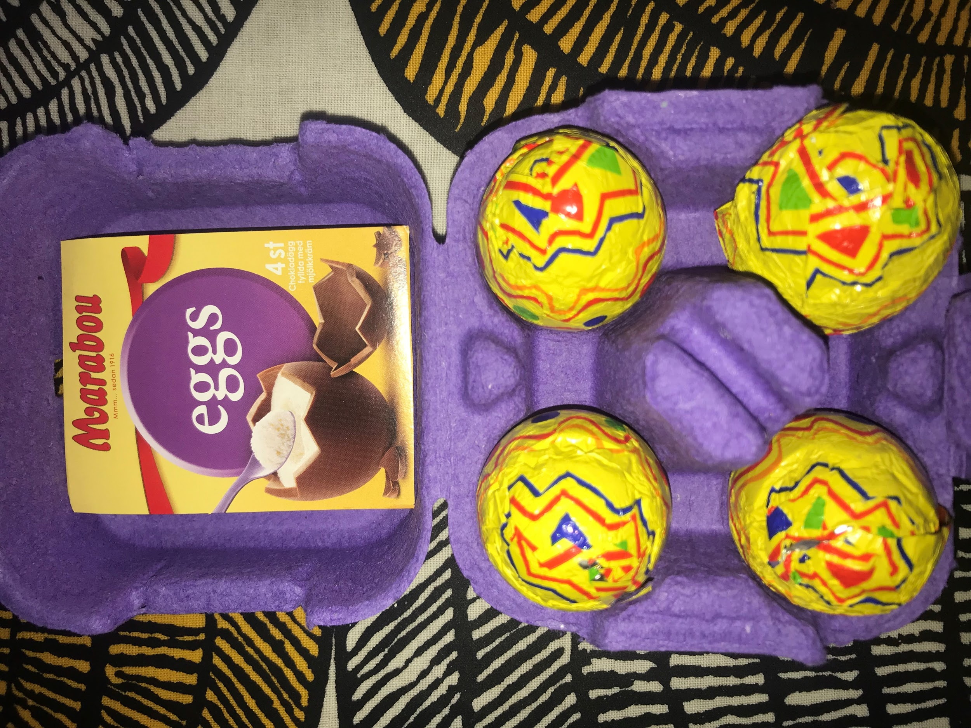

Easter Bunny is a fictional hare that brings chocolate eggs to children at Easter time in many Western European cultures and Australia.

Eggs also came to the Easter table for practical reasons. If there were chickens in the house at the time, during the Easter days and fasting, the eggs had accumulated in the store.
Nowadays, the main thing is the chocolate season in the high season. Easter consists essentially of chocolate eggs, surprising eggs

