BOOK OF STORIES BY THE CZECH STUDENTS


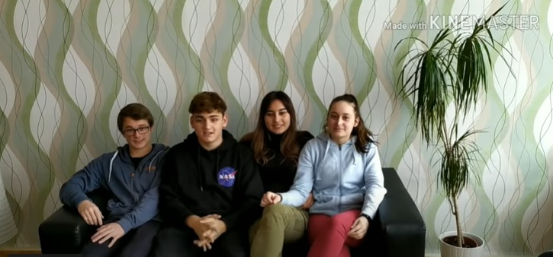
The students of Obchodní akademie s.r.o in Karviná, the Czech Republic, made some interviews with their grandparents and other people within the Erasmus+ Roots project. They talked about legends, stories, jobs, typical food, favourite music from past times to learn more about the past times and the roots of our cultures. Here are some of the stories.

INTERVIEW 1 – by Veronika Mrozková
Hallo! Excuse me, may I ask you a few questions? What did you listen to when you were young?
Well, I obviously used to listen to the Czech music – Karel Gott, I liked Věra Špinarová, yeah, and I also liked foreign music – Omega, Deep Purple, Boney M, well, this kind of music. Some other bands, too, but I do not remember.
Thank you very much
Well, and as for my hobbies, I used to go to a typing course here in the Petr Bezruč Community Centre, which was great. Then, I used to attend a sewing course but I did not enjoy it much. Of course we used to go skating or swimming, there were a lot of activities.
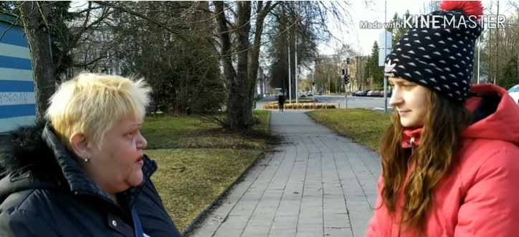
Yes, we also have typing lessons at school but not on typewriters but computers.
In my times there were no computers. But it helped me, anyway.
My mum also used typewriters, she always told me they were typing.
And we often spent time in the Community centre. I think today´s youth does not devote time to anything. It seems to me that way. Yeah… I do not know… Well, they just go to parties, take drugs and so on.
Yeah, you can see it here close to the Elan hypermarket.
Today there are few people who are decent, have some interests, really go to school. Anyway I like to remember my youth, I had friends, we had the same interests, we used to go to the library…
And did you use to go dancing somewhere?
Yes, we used to go to Stav (former Bytostav) to have some tea, but I was very guarded at home so when a party started I usually had to go home.
Oh, I see
So I said I was going to the cinema and went with my friends somewhere else. I had to wear a long skirt so I changed it for a shorter one somewhere in a basement. Well, I really had to be back home at 8 PM. And we went to buy some french fries, they sold them in…. I don´t know what it was called… in Club, yes, it was called Club. There we could buy fries.
It does not exist any longer, does it?
No, it doesn´t
And where was it? Here, somewhere in Havířov?
Yes, yes, I used to work there and they made it into a gambling room and people went to play there… Bingo, was the name. I did not like it there. I do not like gambling machines and those lottery tickets and stuff. It destroyed a lot of families and there were such rich widows and… just… Well, the present time is good at something. You can go abroad, but in some things the previous times used to be better. I think we did not have much spare time and we did not know that something like this exists… but.. I like to remember those times. We used to meet, we used to go skating or to a disco, but just within limits.
Thank you very much!
……………………………………………………………………………………………………………………………………………………………

INTERVIEW 2 – by Filip Tyc
Hallo. I would like to ask you… What music did you listen to when you were young?
Well, mainly Alphaville, the rock band Slade and folk music a lot because I used to play the guitar and listened to folk music.
Did you use to go to discos?
Of course I did. When I was young, there used to be discos where young people could go only till 9 PM. Well, then the olders could go. I think that is basically not in Havířov today.
Yes, that´s true. Well, did there use to be any balls?
Yes, there used to be balls as far as I remember.

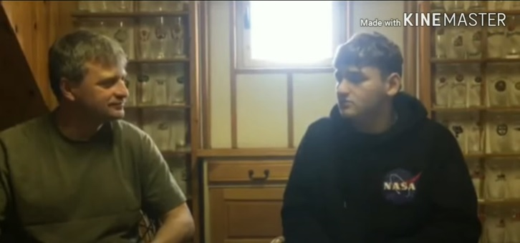
Did you use to live in a town or in a village?
I used to live in a town but we used to have a cottage where I used to go all my life every weekend so I can consider this and that.
And where did you use to feel better?
Well, it used to be better at the cottage but life is easier in a town with all the comfort and culture than in a village.
Well and what about your favourite meal in your youth?
As a child I liked omelettes for sure and also tomato sauce.
And is there any meal you used to cook and now you don´t?
My grandmother cooked for me, well, it was called „slíšky“, these are sweet semolina gnocchi with butter and sugar.
It sounds interesting. And did you use to grow any vegetable or fruit?
Yes, we used to grow everything possible in our garden… carrots, potatoes, parsley… everything you can grow we used to grow.
Thank you for the interview!
…………………………………………………………………………………………………………………………………………………………….

INTERVIEW 3 – by Katka Látová
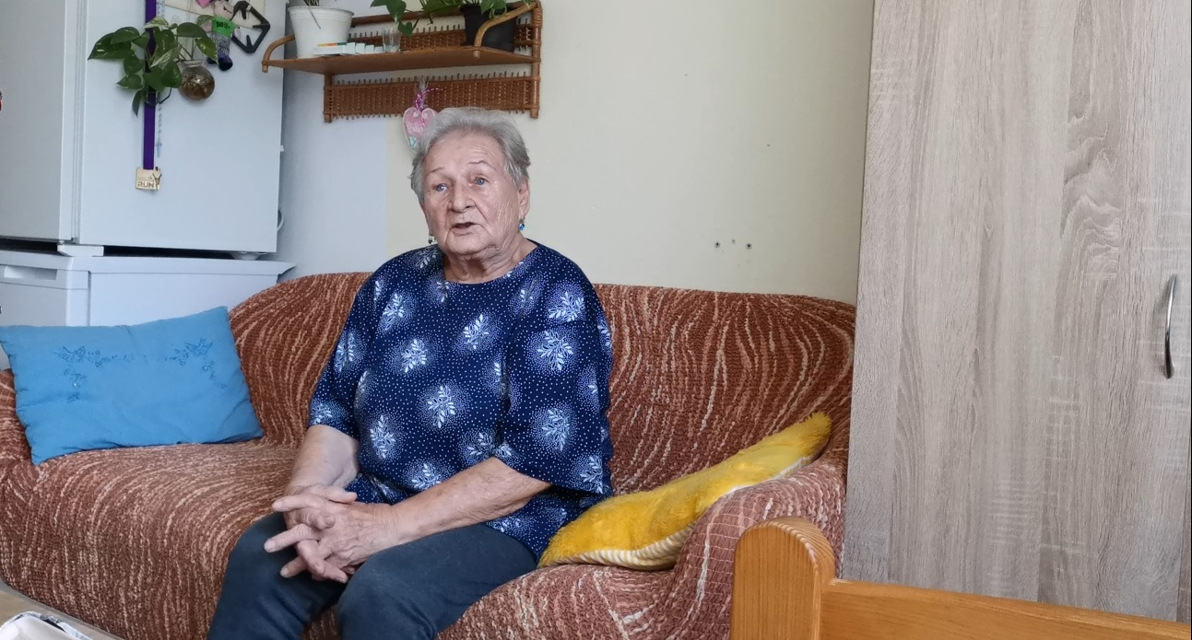

What is our family legend?
It started when a family built a Chateau here. They were called The Sailers and came from Austria. They used to have various large farms and also a brewery. The landlord was looking for some employee to the stables, some vet and a smith. But – on condition that he was married, not single. At that time my grandfather who used to live in the Highlands showed interest. He agreed with his girlfriend to get married and apply for that job. The landlord employed him and they got a flat in the mansion. For the employees there were a workroom and a forge. The Sajlers also owned two cars. My grandfather also worked as a driver so they needed another worker to ensure that the blacksmith´s workshop still worked. Then a smith from neighbouring village joined my grandfather. Whenever neede, my grandfather drove them around and even to Austria. Once the landlady said she would like to have lunch in Vienna so they asked my grandfather to wash himself, get dressed (he used to have a special uniform), start the car and drove to také the landlady for lunch in Vienna to be back at the Chateau in the evening. This is the legend of our family.
INTERVIEW 4 – by Katka Látová

What was your childhood like?
It was quite good.
How many people were there in your family?
We were 6 people at home.
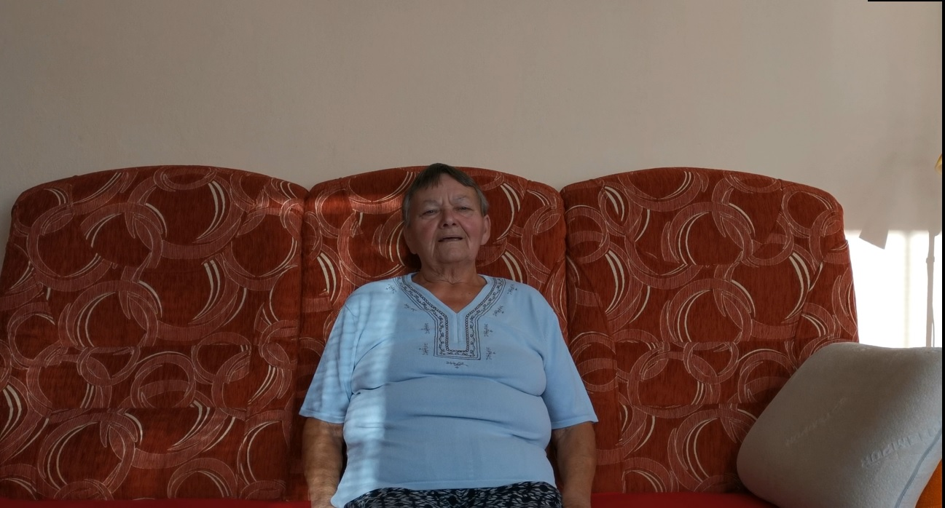
What meals did you use to cook at home?
Some sauces, dumpling, boiled meat with an egg.
What was your favourite meal when you were young?
Szeged goulash or potato goulash with a roll.
Do you remeber the recipe how to make it?
You cook potatoes, fry an onion and some sausage, add some minced sweet pepper, garlic, mix it with potatoes. Then you make roux, add it and that´s it. And I always use to eat a roll together with the goulash.
Is there any meal you have never tasted but would like to?
No, there isn´t.
Do you think people eat better that they used to?
Well, they don´t. I think it used to be better.
Why?
Because it used to be healthier.

