Logo competition results
First three most voted logos based on average percentages:
Slovenian logo 1: 69.8 %
Hungarian logo 1: 19.75%
Finnish logo 1: 9.27%

Results by countries:
Finland:
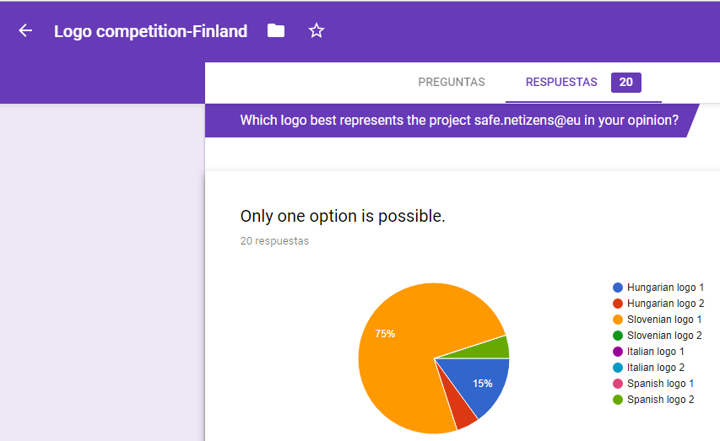

Hungary:
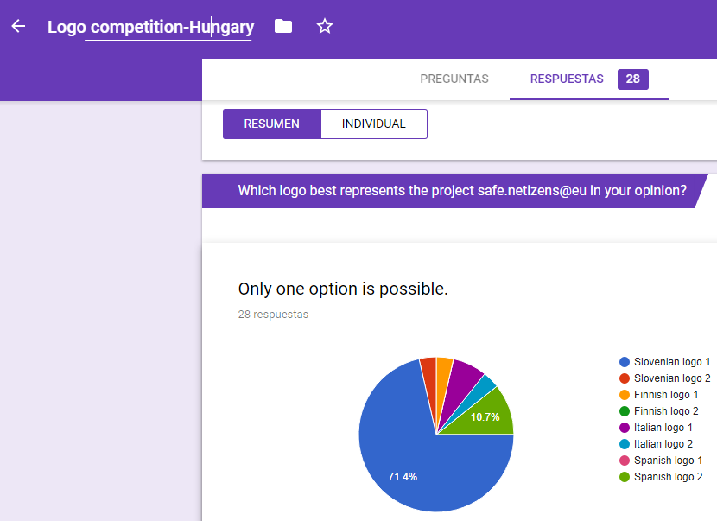
Italy:
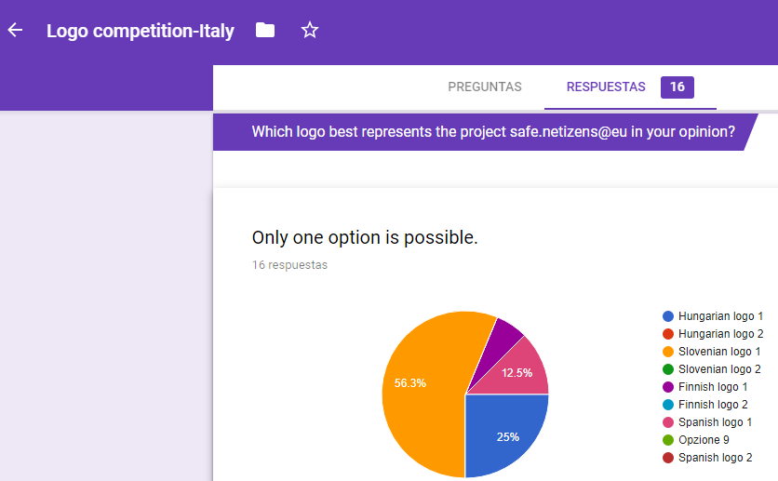

Slovenia:
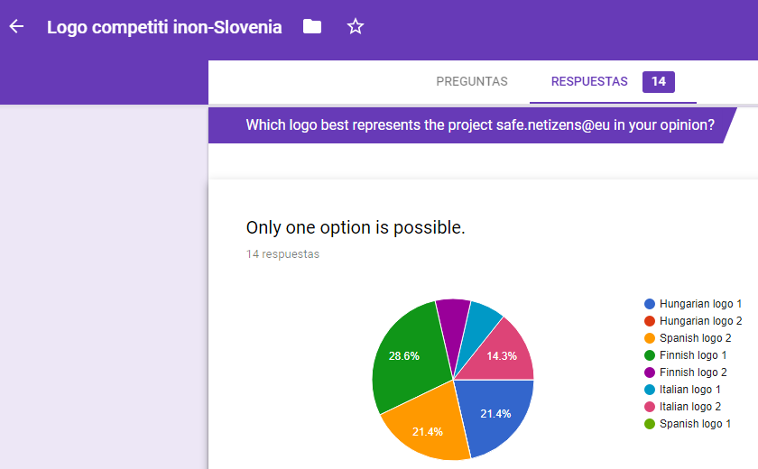
Spain:
