LESSON PLAN | Watchful European Young Environmentalists  (2019-1-IT02-KA229-062235)

Country + School: | Ylakiai Gymnasiumof the Skuodas region
Teacher(-s) | Rasa Petrulevičienė
Subject / Course: | Biology and Technologies
Topic: | The Benifit of The Bees’ Products
Age group: | 14 | Lesson/ Activity Duration: | 90

Lesson Objectives which the students acquire:
Students will learn about the benefits of the bee products and will make a candle

Summary of Tasks / Actions:
1.Team work.Using the Internet resources and the texttbook, the pupils gather information and make posters about the bee products and the medical benefit of bee products.
2. The teams present their posters in front of the class.
3. Project work: “The Beeswax Candles Production”.
Process:
Cut wax in small pieces and melt it in a bowl over the hot water.
Put a wick into a silicone molds and pour melted wax into them.
Wait for some minutes. Remove candle from mold. Once the wax has solidified and cooled, remove any rubber bands and gently pull away the mold sides.
4. Students present the candles in the class. Assess their work, explain the successes and challanges.

Materials / Equipment:
The textbook “BIOS 7”, phones/ computers/ tablets, beeswax, electric stove, the bowl/pot to melt the beeswax, silicone molds, cotton candle wick,

References/ theories/ teaching methods used:
Team work, information search, story telling, poster making

Evaluation of the objectives acquired:
- Development of initiative and creativity,comunication and digital competences, ability to learn and cognition.
- Students are able to make a candle from the beeswax waste.
- Posters:
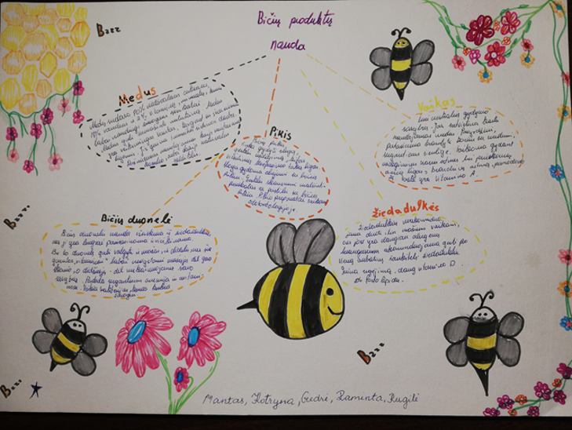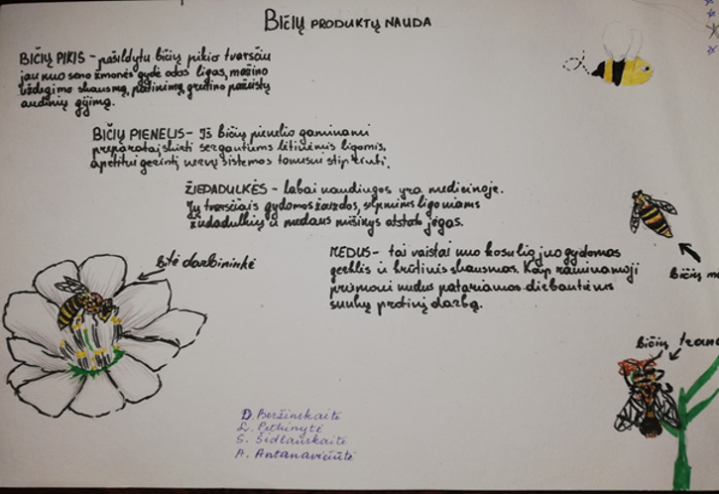
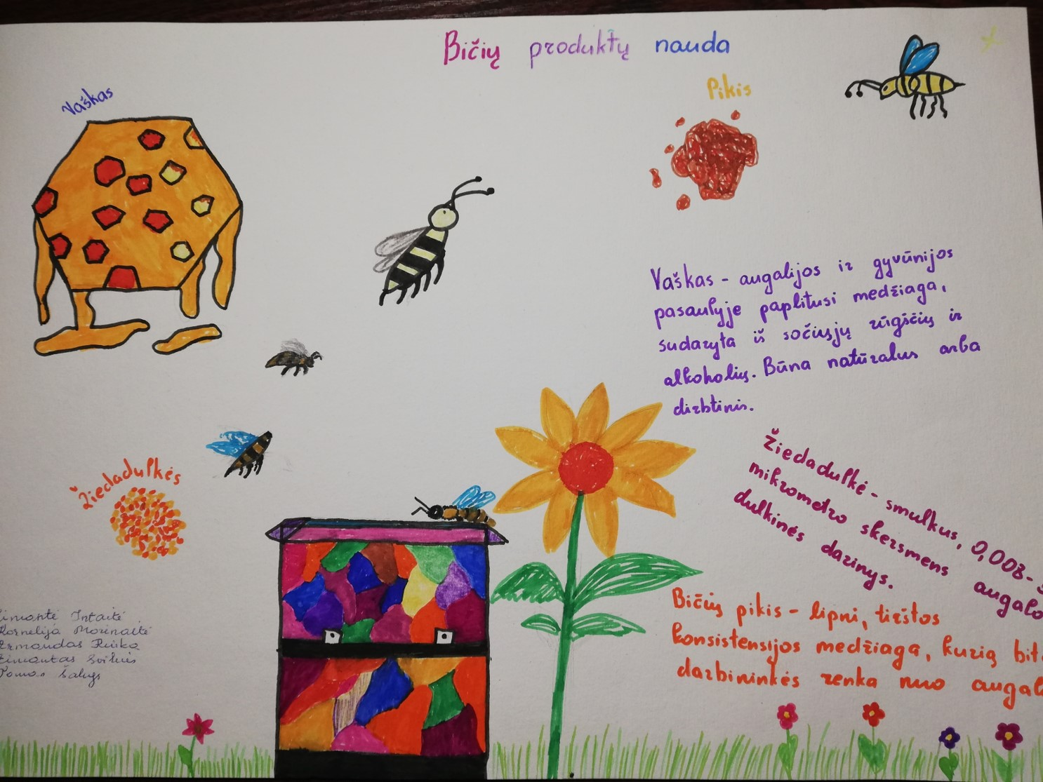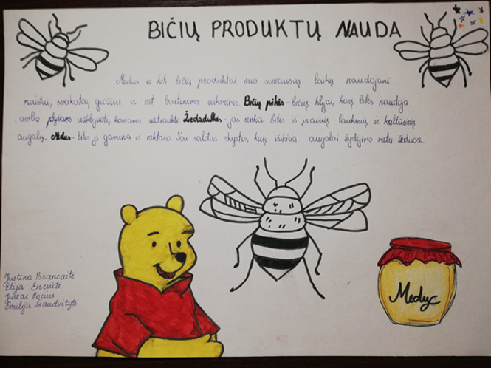

Process:
