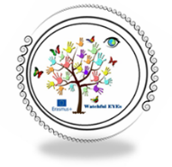
LESSON PLAN | Watchful European Young Environmentalists  (2019-1-IT02-KA229-062235)

Country + School:
Teacher(-s)
Subject / Course:
Topic:
Age group: |  | Lesson/ Activity Duration:

Lesson Objectives which the students acquire:

Summary of Tasks / Actions:

Materials / Equipment:

References/ theories/ teaching methods used:

Evaluation of the objectives acquired:
  - II

