# **A bilingual high school**



I.E.S. Huelin is a high school were you can study from eleven to eighteen years old.

It´s situated in the south of Spain in Málaga, that is a coastal city.

There are more than 800 students.



**The installations**



We´ve got a playground with two basketball courts, a football soccer field and also two of volleyball

We also have a gym, three technology classrooms, an assembly hall, a music classroom and an art one.

**HIGH SCHOOL**

**I.E.S. HUELIN**

A BILINGUAL HIGH SCHOOL

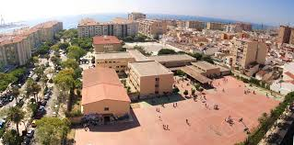

Tomás Echeverría, 2, 29002

Málaga, Spain

**Trips**

Here we have got many interesting trips or activities. In third year we´ve got a ski trip. Also in fourth year. the students travel to a foreign country.

The high school offers the possibility to travel abroad as an exchange student or in programs financed by the European Union, such as Erasmus+.

