How to make crempog - Welsh pancakes
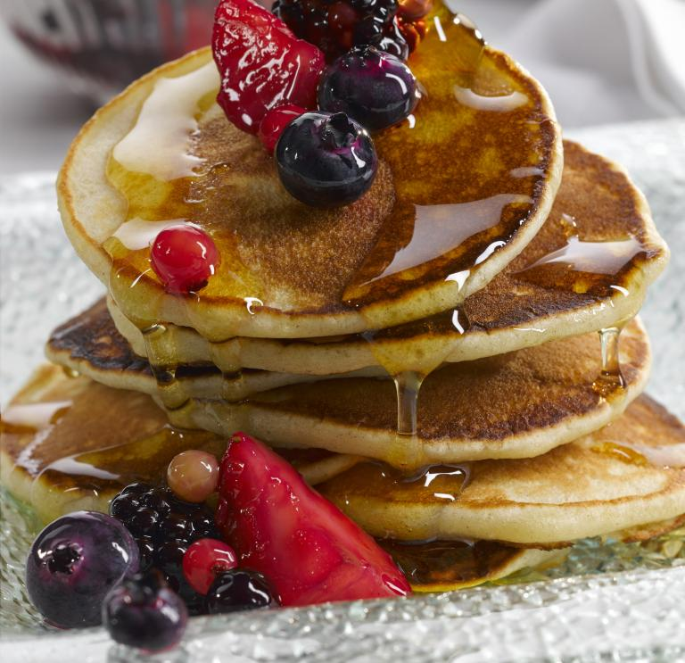

Welsh crempog recipe
Traditional Welsh crempog are thick pancakes, thicker than a crepe and bigger than a pikelet. Crempog are traditionally eaten on Shrove Tuesday, though they're great to eat all year round!

How to make crempog
- 2 oz/ 55g butter
- 15 fl oz/ 450 ml warm buttermilk
- 10 oz/ 275g all purpose/plain flour
- 3 oz/ 75g sugar
- 1 tsp bicarbonate of soda
- ½ tsp salt
- 1 tbsp vinegar
- 2 free range eggs, well beaten

Method
Stir the butter into the warmed buttermilk until melted. Gradually pour the milk and butter into the the flour and beat well. Leave the mixture to stand for at least 30 minutes (or a few hours if possible) before stirring in the sugar, bicarbonate of soda, salt and vinegar into the beaten eggs.
Pour this mixture into the flour and milk mixture and beat well to form a smooth batter. Heavily grease a griddle or hot-stone and heat, then drop the batter, a tablespoon at a time onto the heated griddle and cook over a moderate heat until golden brown on both sides. Keep the crempog warm and continue this method until all the batter is used up. Spread butter on each pancake and eat while warm. Jam, banana, syrup, currants and even a chocolate drizzle are of course optional!

