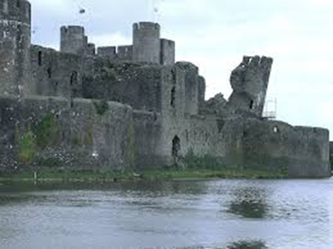
Caerphilly Castle

Use the following websites to answer the questions on Caerphilly Castle.
https://www.visitwales.com/product/1891933

- What inspired the mightiest medieval castle in Wales to be built?

- Who built Caerphilly Castle?

- How many acres does Caerphilly Castle cover?

- Describe the size of Caerphilly Castle.

- Describe the castle’s defence system.

- What happened to the castle when Llewelyn died?

- Who did the castle pass down to?

- What is said to be the best loved feature of Caerphilly Castle?

https://www.bbc.co.uk/wales/history/sites/themes/society/castles_caerphilly.shtml

- Between what years was Caerphilly Castle built?

- What happened when Edward 1 took Llewelyn’s lands?

- What was the Eastern gatehouse used as?

- What caused the famous “leaning tower”?

- Who finally took over the upkeep of the monumental Caerphilly Castle?

- In what year was Caerphilly Castle handed over to the Government?

