Erasmus+ 2019-1-UK01-KA229-062157
ONE CLASS-TOTAL INCLUSION

LODGING OPTIONS FOR VISITING TEACHERS AND STUDENTS
Albergues juveniles: 1) Carranque: https://www.inturjoven.com/albergues/malaga/albergue-inturjoven-malaga 2 KM TO MALAGA CENTRE(BEST OPTION)
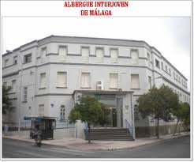
2) Torremolimos: https://www.inturjoven.com/albergues/malaga/albergue-inturjoven-torremolinos 16 KM TO MALAGA CENTRE

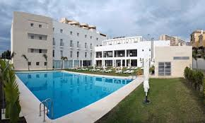

This work is licensed under the Creative Commons Attribution-NonCommercial-ShareAlike 4.0 International License. To view a copy of this license, visit http://creativecommons.org/licenses/by-nc-sa/4.0/.

