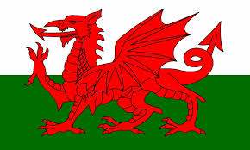

a. It is made on bakestones or griddles.

b. They are normally served piled into a stack.

c. It is traditionally served at celebrations in Wales, such as shrove Tuesday and birthdays.

Food and drink

a. It is traditionally vegetarian.

b. The main ingredients are cheese, leeks and breadcrumbs.

c. It is named after the county ‘Glamorgan’.

a. This cake is baked on a plate.

b. The name describes the cake as moist or wet.

c. It contains fruit.

a. This drink is made in a brewery.

b. It is made by Tomos Watkins

c. There are many different types named after Welsh words, such as ‘haf’ and ‘Braf’ .

a. It is similar to a fruit cake.

b. It’s meaning in English is ‘speckled bread’.

c. It is usually eaten with butter at tea time.