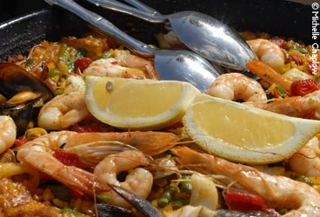

Paella with Chicken and Seafood
This is the paella best-known to visitors to Spain. The yellow rice includes bits of chicken, squid, shrimp and mussels. You can savor it at a Costa del Sol beach bar or at almost any restaurant in Andalucía. It differs from a traditional Valencia paella, which doesn't include seafood, but is made with snails, rabbit or chicken, and both green beans and fat lima beans.
Ingredients
- 1 dozen mussels, scrubbed, steamed open
- 1 lb / 1/2 kilo jumbo shrimp (prawns)
- 6 tbsp olive oil
- 2 lbs / 1 kilo chicken or rabbit, cut into small pieces
- 1/4 lb / 100 grams pork, cut in cubes
- 1 green bell pepper, cut in pieces
- 2 cloves garlic
- 1 medium squid, cleaned and cut in rings
- 1 large tomato, peeled and chopped
- 1/2 cup shelled peas (or green beans, broad beans or artichokes)
- 6-7 cups water or stock
- 2 1/2 cups medium-short grained Spanish rice
- 1/2 tsp saffron, crushed
- 1/2 tsp paprika
- 2 tsp salt
- freshly ground black pepper
- 1 red pimiento, cut in strips
- 1 lemon, cut in wedges
Recipe
Discard empty half-shells of the mussels. Strain and reserve the liquid. Peel most of the shrimp (shells can be boiled to make a stock). Cook a few unpeeled ones to garnish the paella. Drain and save the liquid.
Heat the oil in a paella pan, large frying pan or flat-bottomed wok and slowly brown the pieces of chicken or rabbit and pork. Add the green pepper, garlic and squid, then the tomatoes and peas. (If using beans or quartered artichokes, parboil them first.) Measure out 6 cups of reserved mussel, shrimp broth and water or stock. Add it to the pan and bring to a boil. Stir in the rice with the peeled shrimp. Combine the crushed saffron, paprika, salt and pepper in a cup and dissolve in a little water. Stir into the rice. Cook briskly for 10 minutes, then reduce the heat. Garnish the rice with the cooked mussels and cooked whole shrimp. Top with strips of red pimiento. Cook for a further 8-10 minutes, without stirring. Add a little additional liquid to prevent the rice from scorching. Allow to rest 5 minutes before serving. Garnish with lemon wedges.

