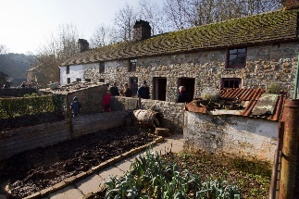
St Fagans

Use the following links to help you answer the questions below.
https://museum.wales/stfagans/castle-and-gardens/
- What type of building is St Fagans Castle?
- Who donated the manor house to the people of Wales?
- List some of the things you can find in the museum grounds.

https://museum.wales/stfagans/about/
- How many original buildings have been re-erected in the 100-acre parkland since 1948?
- What do the buildings include?

https://museum.wales/stfagans/buildings/kennixton/
- Where was the original Kennixston Farmhouse located?
- Why was the house painted red?
- When was the house moved to the museum?
- When was Kennixston Farmhouse opened to the public?

https://museum.wales/stfagans/buildings/maestir_school/
- What materials was Maestir Schoolhouse built from?
- Why was the yard behind the building divided into two?
- What used to provide drinking water for the pupils?
- Why was this stopped?
- Who was the headteacher in 1900?
- What ages were the pupils in the school at that time?
- Why and when was the school closed?
- Where was Maestir School originally located?
- When was the school moved to St Fagans?

https://museum.wales/stfagans/buildings/clogmaker/
- Who was one of the last traditional clog makers in Wales?
- Who were the cogs popular with and why?
- What led to a decline in the demand for clogs?
- How many clog workers were there in 1918?
- Why were there only six in the early 1960s?

https://museum.wales/stfagans/buildings/rhydycar/

- Why was the small terrace of houses built and by who?
- What do the six houses show?
- Why did one of the houses have an Anderson Shelter?
- What were the Anderson Shelters later used for?

