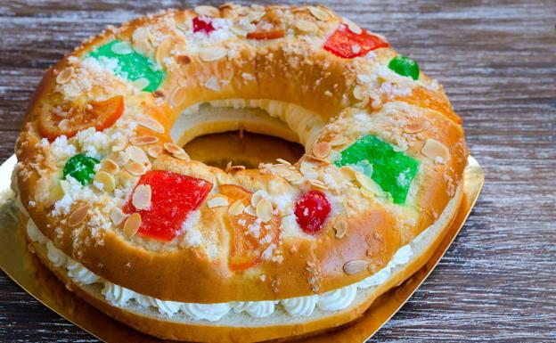

Roscón de Reyes recipe by Claudia Pastor Cruz
The easiest Roscón de Reyes recipe, perfect for beginners and for those who don´t have much time.
It is one of the most typical recipes in Spain when Christmas arrives and has its origin in the 2nd century BC. when "Las Saturnales" were celebrated, a pagan celebration in honor of Saturn, the god of crops.
However, the tradition did not last long because when the Christian religion assumed power and pagan celebrations such as Saturnalia gradually disappeared, the custom of eating bean cake also disappeared, although not for long.
Some centuries later, the traditional cake with beans returned, but this time to Spain, by Felipe V. However, it was no longer the same cake of the Saturnalia festivities because instead of including only beans, gold coins were also incorporated. Thus, whoever found the coins won the prize, while whoever found the bean was considered a loser and, therefore, was predicted bad luck throughout the year. It is claimed that the idea of introducing a coin came from a French court cook, who at that time wanted to surprise Louis XV.
Take note of this recipe for Easy Roscón de Reyes and that you can finish as you like, without filling and with a good cup of hot chocolate, or with a rich filling of cream, cream, chocolate ... I'll explain how to make the dough with a kitchen robot and by hand so that you can do it all.

Ingredients ( 2 small or 1 large roscones)

For the mass
150 grams of icing sugar skin of 1 orange
skin of 1 lemon
130 grams of whole milk
25 grams of fresh baker's yeast
30 grams of orange blossom water 2 eggs (L)
a pinch of salt
500-550 grams of bread flour
80 grams of butter at room temperature.

Decoration
c / n of candied orange
c / n of almond stick or laminated c / n of sugar
a few drops of orange blossom water.

Elaboration
The amount of flour can vary, not all strength flours are the same nor do they need the same amount of liquid for hydration. It is preferable to stay short and to be able to add (that's why we start with 500 grams of flour, being able to add up to 50 grams more, depending on the dough is seen), but without forgetting that this dough must be quite moist.

Dough with food processor
Prepare the orange and lemon peel, peel or grate it and put it in the glass of the food processor with the sugar. In Thermomix, program 30 seconds, progressive speed 5-7-10 to turn it into powder, if you use another kitchen robot, carry out the same process with its functionalities. Then add the milk and fresh yeast, to dissolve it, program 1 minute, 37º C, Speed 2.
Add the orange blossom water, the eggs and a pinch of salt. Mix 1 minute, Speed 5. Then add the strength flour and program 3 minutes, closed glass, Speed spike. After this time, add the butter at room temperature, and reprogram 3 minutes, glass closed, Spike speed. The dough obtained will be thin, elastic and somewhat sticky.
Remove the Roscón dough from the glass, put it in a large bowl sprinkled with a little flour or spread with a little extra virgin olive oil (or butter). The bowl should be two to three times the size of the dumpling, so it has room to grow. Cover the dough with a cloth (which you usually use for dough fermentation, do not wash with strong soaps or fabric softener) and let it rest until the next day, about 10-12 hours, at a temperature between 17-20º C, in a place without drafts.

How to make the dough by hand
Grate the orange and lemon peel and mix them with the sugar. Put the milk in a glass and heat it (it should not be very hot) in the microwave, dissolve the fresh yeast in it by stirring with a spoon, it has to be completely dissolved.
Put the strength flour in the shape of a volcano in a large bowl, add the milk with the dissolved yeast and the sugar with the orange and lemon peel in the center. Also add the orange blossom water, the eggs and a pinch of salt. Beat the butter with a spatula until smooth and add it to the bowl.
Begin to integrate the ingredients by pouring the flour over the liquids and mixing. When you can make a ball, lightly grease the work table and hands with oil and pour the dough to continue kneading until you get a homogeneous dough. Roll into a ball and put it in a large bowl, two to three times larger than the ball of dough, lightly floured. Cover the dough with a cloth (which you usually use for dough fermentation, do not wash with strong soaps or fabric softener) and let it rest until the next day, about 10-12 hours, at a temperature between 17-20º C, in a place without drafts.

To make the shape
Divide the dough into two portions if you want to make two small roscones (they are not very small, each one can serve about six servings), form a ball with each portion and let them rest for five minutes so that they lose tension. Prepare two baking sheets (the roscones will be baked separately), cover them with greaseproof paper, and place the ball of dough on top. With your fingers, make a hole in the center of the dough and carefully open it.
If the dough shrinks after stretching it to make the donut, let it rest for a few minutes, it will have lost tension and can be easily stretched. Open the hole by taking the dough around its contour with both hands, so that it remains with the same thickness, being a small dough it will be easy. Don't forget to add the 'king' and the 'bean'.
The hole must be twice as large as what is expected later in a Roscón de Reyes, as it will grow back with the second rise and bake, and will not close. Cover the dough again with the cloth to let it ferment again, leave it for about two hours or until it doubles in volume, in a warm place without drafts.
Turn the oven to 200º C with heat up and down. Paint the dough with the beaten egg and a few drops of milk, and decorate with the candied orange and almond. Dip the sugar with the orange blossom water and spread the small rocks that form on the roscón.
Put the roscón in the oven at medium height or a lower point, and lower the temperature to 180º C. Bake for 15-20 minutes, but watch after 10 minutes in case it gets too brown, each oven is different. If it takes on color too soon, cover the roscón with aluminum foil and continue baking for a few more minutes, without spending more than 20 minutes so that it does not remain dry.
Remove the Roscón de Reyes from the oven and let it rest for 10 minutes, then transfer it to a rack to cool and the bottom is not damp.

Presentation of the dish
Once the Roscón de Reyes is cold, you can fill it with cream, truffle, chocolate, pastry cream ... But without filling it is also to repeat, you can serve it with a cup of hot chocolate, a coffee, or an infusion.
To preserve the Roscón de Reyes without the dough drying out, cover it with plastic wrap covering it well. There are also those who put it in a bag because the plastic does not let air pass. In any case, from one day to the next it will be equally rich, so much so that it will end and some will have to be done before next Christmas.

Abbreviations
c / s = Soup spoon
c / p = Dessert spoon c / c = Coffee spoon
c / n = Required quantity

