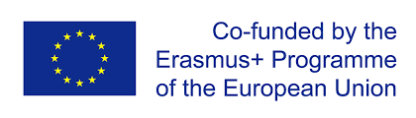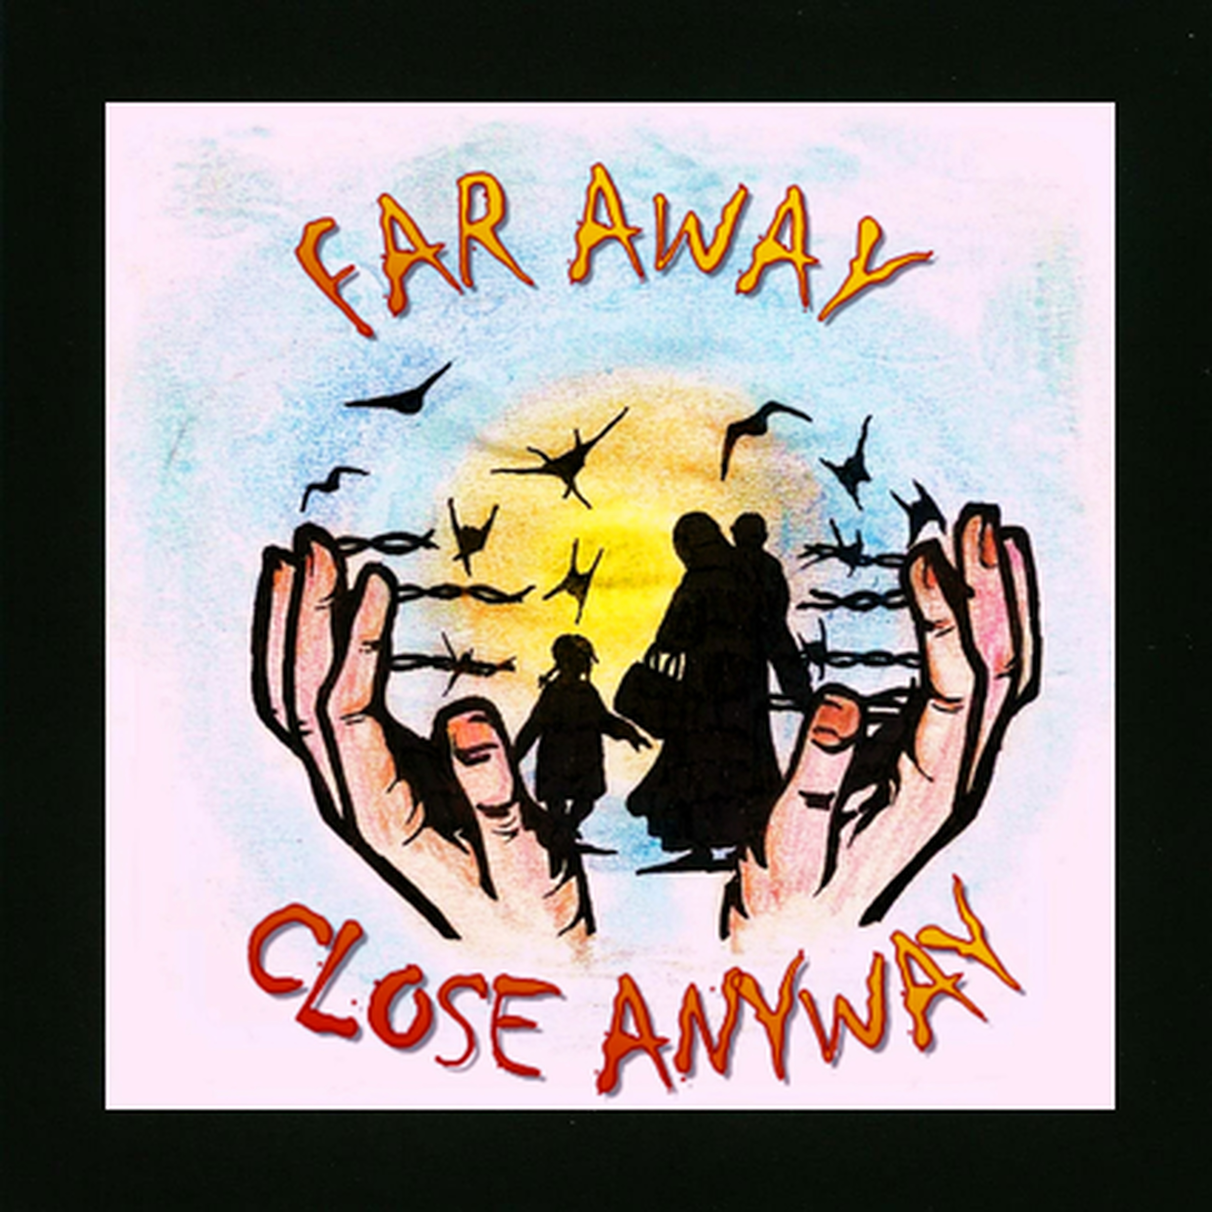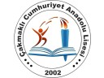

2016-1-TR01-KA219-033904 ERASMUS+ ‘IN A FAR AWAY LAND: REFUGEE CHILDREN’ PROJECT ‘HOME IS WHERE THE HEART IS’ THEME BASED LITERATURE AND ART WORKS CONTEST TERMS & CONDITIONS

- This is a competition for the Erasmus + project of the participant schools. It consists of two main categories and four sub-categories.
- It is open to every students of the coordinator and partner schools and the students who are connected to the project.
- The competition opens on 17th January 2018 and closes on 17th March 2018. Any entries received outside these specified dates will not be eligible for entry into the competition.
- To enter, please send the original of the literature works and the scanned works of arts to refugeechildren1@gmail.com. The body of the email must include:
• The competitors name
• School, class and school number of the competitor
• Title and line counts of your work of literature or title of the artworks
All entries must be forwarded as an attachment and not in the body of the email.
- By sending the entries, the competitors agree and warrant that the work has not been published before, it is entirely the contestants’ own original work, and nothing in it is defamatory, private or an infringement of copyright; other intellectual property right or in any way a breach of another’s rights or illegal, unlawful, obscene, offensive or any other unsuitable material. Any entry in breach of this clause will be disqualified from participating in and winning the competition.
- All works must refer to the theme. All entries must be original and submitted digitally as high resolution files.
- There must be provided information of the competitors at the back of the works. This information should include the name, age, class, school number and email address of the competitors.
- Each sub-category has its own terms and conditions and they will be provided seperately.
- One winner will be selected from the entries received in accordance with these terms and conditions for each category based on the following criteria: originality, relevance to the theme, writing skill and strength of character depiction, drawing & painting, creativity and designing skill.
- The coordinator teachers of the project will choose the best 3 works for each category, then come together in Italy meeting with the original works and will read and inspect the entries for the final decision. The winner will be chosen by then. The judges’ decisions are final, and no correspondence will be entered into.
- The winners’ names will be announced by 26 March 2018 on the project’s website, project’s twinspace and facebook page.
- The winners will be awarded according to the decision to be taken in Italy meeting and they will get their awards after the Italy meeting. The winners will be offered the opportunity to have their winning entries published in the project book to be prepared at the end of the project process, on twinspace and also on the social media accounts of the project. The original entries will not be returned to the competitors.
- Only one entry per person is allowed. Second or subsquent entries will be disqualified. Entries will not be accepted in bulk or on behalf of someone else.
- The coordinator reserves the right to alter the prizes, these terms and conditions or cancel the competition.
- The emailing addresses of participants will only be used for the purpose of contacting the winners and administering the competition.
- By entering the competition, the competitors agree to be bound by these terms and conditions.
- This compatition is organised by the coordinator and partner schools of the Erasmus+ project called ‘In A Far Away Land: Refugee Children’. The European Comission and National Agencies can not be held responsible for the inaccurate content.

PAINTING: This is the painting competition terms and conditions. To enter, please send the photograph of the original, unpublished, drawn on 350mm x 500mm drawing paper, in frame, by freehand technical (excluding oil paint) , on the theme to refugeechildren1@gmail.com after taken a photograph of the original. Digital or computer generated artworks created on Computer, Smartphone, Tablet, or similar are eligible. Digital artworks will be formatted by TIFF and one TIFF file will be minimum 15MB for high resolution. Please include the contestant’s full name, age, class, number and email address at the back of the work and also the email body.

POETRY: Poetry entries must be a PDF document and the maximum allowed file size is 1-2MB. Poems must not exceed 24 lines and must be printed on one side of A4 white paper. It should be sent the typed text with Times New Roman and in 12 point type. It should have a title. Please include the contestant’s full name, age, class, number and email address at the back of the work and also the email body.

SHORT STORY: This is the short story writing category terms and conditions. To enter, please send your original, unpublished, fictional short story, in English, of between 5,000 and 10,000 words and 5 pages at most on the theme to refugeechildren1@gmail.com of PDF file max. 1-2 MB. It should be sent the typed text, double spaced, in Times New Roman, in 12 point type. It should be provided a title for the story. Please include the contestant’s full name, age, class, number and email address at the back of the work and also the email body.

POSTER: Poster entries must be accompanied by a description of 5 words or less. Poster files must be in TIFF format with more than 10MB in size.(at least 10 MB) Participants are to submit works, which visualize the proposed project in accordance with the described conditions in the following formats. Official poster size (400mm x 600mm) (1417 px X 1984 px) - Resolution: 600 dpi - Color Mode: RGB or CMYK - Any design shall have a title. - Please include the contestant’s full name, age, class, number and email address at the back of the work and also the email body.

ÖZGÜ ÖZTÜRK
THE COORDINATOR- TURKEY

