Child exploitation
Definition:
With child exploitation we mean the violation of rights of the child by encountering a form of slavery, this is due to the fact that the school loses value, while work is more important. This causes damage to a nation, which renounces to intellectual and professional wealth, so causing illiteracy. Going back to historic events,the exploitation began to increase during the industrial revlution, where the child worked up to 15 hours a day,receiving in return a poor wage that didn't even allow him to by a piece of bread. The child, however, wasn't only exploited in industries or factories, or in other fields, for example making football balloons or shoes, but also in family sectors related to production. It is important to underline that helping parents with housekeeping isn't exploitation, but collaboration.
Another form of exploitation is child prostitution which sees more than a million girls as victms every year,
This is because many families are forced to deliver
their children because of their debts or poverty.

Convention on the right of the child:
The convention on the right of the child was approved at the United Nations General Assembly on 20th November 1898.
The proposal enunciated for te first time the fundamental rights that should be guaranteed to all children and girls of the world. Today there are 196 states that are part of the Convention. It is composed of 54 articles,the must fundamental are 5:

Art. n 2: Each child should be respected without discrimination of any kind: race, colour, sex, language, religion, political or other opinion, national, ethnic or social origin, property, disability, birth or other status.
Art. n3: All actions concerning the child must be based on his or her best interests.

Art. n 4: Each child has the right to life, survival, and development. The States must commit to the utmost to protect the lives and healthy development of children.

Art. n 12: The child has the right to express an opinion, and to have that opinion taken into account, in any matter or procedure affecting the child, in accordance with his or her age and maturity

But the most important article is Article 32. It states that a minimmum age for admission to employment should be established so as an adequate regulation of working hours and conditions of use to avoid negative impacts on children’s health, education or development.

Italy has ratified the Covention with the Law n.176 of 27 May 1991 and has untill now presented 4 reports of the Rights of the Child. Before then, he child was perceived in a state of inferiority, who became a person-subject of rights only after being educated and molded.
As for the exploitation of minors in factories we can identify various types of industries, such as Nike, Adidas and H&M, but also multinationals who produce chocolate like: Mars and Nestlè.

The Convention is also defined as the convention of the three Ps:

Protection:
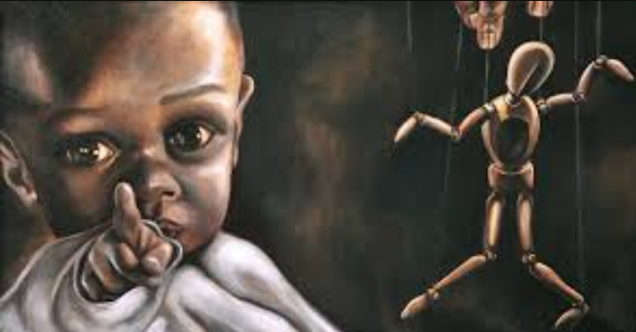
The article 19 provides that the child mustn’t be mistreated. Adults need to protect their children from abuses, violence and neglect. This article we can link to article 34, it emphasizes that the child must be protected from sexual abuse, so no one can use his body against his will.

With article 24, the child has the right to enjoy good health.

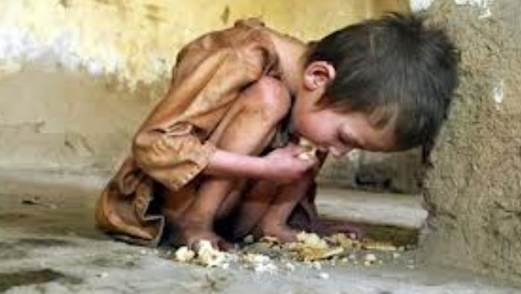
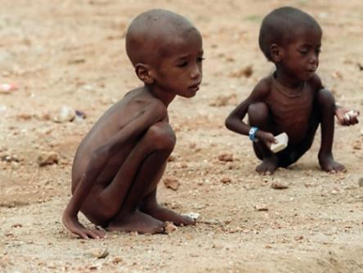

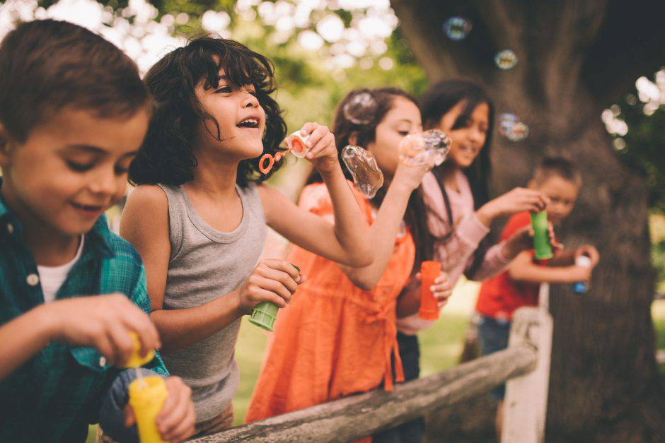
Partecipation:

The child has many rights that protect him and his childhood, the most important is the right to life. The child also has the right to rest and leisure, that can engage as best he thinks, for example attending sports association, as football, volleyball, rugby, or parish association.

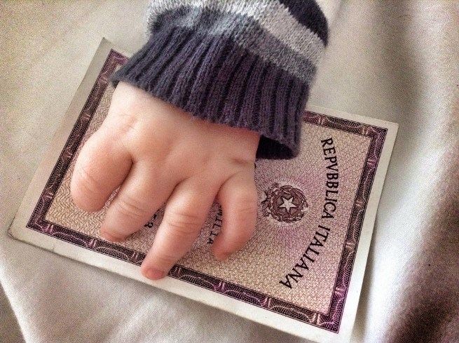
Provition:

Clearly the child MUST have an identity, so a name, a surname, a nationality, a home and a family who takes care of him, helping him growing to become the man who will be.

Reflections:

Very often we don't undrestand completely a child, as we don't understand his wishes and needs. For example, the main character of the book “The little Prince” says that “the big ones alone never undrestand, and it is weary, for a chilf, always having to explain everything...”.
Children represent “Innocence” as William Blake said. They are the purity and also the fragility. The children are so fragile creatures and adults very often are the incarnation of wickness, some more wick than others, with their ideas of perversion that destroy, quickly, the intimacy and the purity of the child.
There are many forms of violence, just as exploitation. We understimate the fact that those children, whose childhood has been torn, they will be our future. We wonder how the future will be, colored or all black? We forget that children are our greatest supporters and that we are, for them, an example to follow, but what example do we want to be for them?
We apologize to children from all over the world.
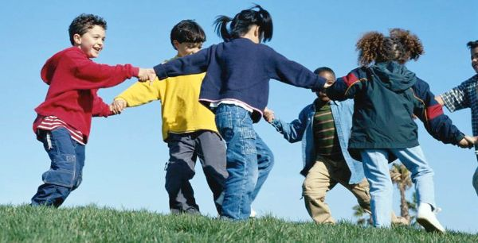

Written by: Arianna Bottalico, Maria Antonietta Arena, Damiana Campanile.

