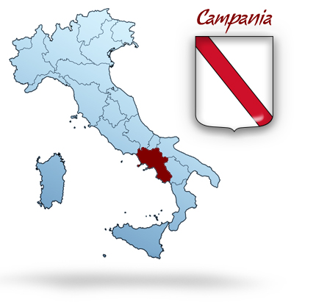

Monday 25th February 2019
10:00 Official reception at the Town Hall
The Major and the headmistress’ welcome speech.
12:00 Welcoming buffet lunch at school
14:30 Visit to the Royal Palace and its park, Unesco World Heritage Site
17:30 Visit to the nursing home NonnAnna.
Activity: reading legends from the multilingual story-book.
20:00 Welcome dinner for teachers at a local restaurant in Caserta.
Students with host families

Tuesday 26th February
8:30 Departure for the Amalfi Coast
10:30: Guided tour of Amalfi and entrance to the Duomo
13:00 Departure for Ravello, City of Music and cultural heritage of Unesco.
14:30 Guided visit of the old town with entrance to Villa Rufolo.
Packed lunch
16:30 Departure for Caserta
20:00 Optional Dinner for teachers
Students at host families

Wednesday 27th February
8:30 Departure for Piana di Monteverna
9:00 Piana di Monteverna:
Students and teachers will be received by the Major at the City Hall.
Visit to the medieval church of S. Maria a Marciano and its frescos
10:00 Departure for Alvignano.
Guided tour through the historical and ancient tradition and the secrets of mozzarella making with tasting of this unique and delicious food,one of the most typical products of the Mediterranean diet .
13:00 Lunch at restaurant for teachers
Students with host families
15:00 Meeting at school:
Activities for students and teachers’ meeting
17:30 The Royal Site of San Leucio
Visit to La Casa del Tessitore for teachers : a view of the textile tradition and silk factory. Tasting of “Pallottole”, the typical local food dating back to 1800
Students with host friends
20:00 Optional Dinner: Pizza at the restaurant “I Borbone”

Thursday 28th February
8:30 Departure for Pompeii,
Guided visit of the archaeological site
13:30 Departure for Caserta
Buffet lunch at school for teachers and students
Activities at school for students
Teachers’ meeting: Monitoring and Assessment
Display of tasks
Coffee break
Certificates’ Cerimony
20:00: Dinner at restaurant for teachers
Students at host families

Friday 1stMarch -
8:00 Departure for Naples
9:15: Arrival in Naples
Guided walking tour of the historic centre with entrance to S. Chiara, Chiesa del Gesù Nuovo, Cappella S. Severo, Duomo
13:00 Packet lunch or “Pizza a portafoglio” (it is folded and looks like a wallet)
15:00: Visit to Pasticceria Scaturchio, one of the most famous brand in Neapolitan confectionery. Workshop and Neapolitan traditional pastry tasting in laboratory of pastry chefs
16:30: Entrance to Zevallos Stigliano Palace to admire the last masterpiece of Caravaggio
18:00 : Departure for Caserta
Free time for teachers and students
20:30: Farewell dinner for teachers
Students at host families

