And the Oscar goes to ….Austria!
Liebe – Amour

The film was released in 2013 by the Austrian director Michael Haneke. The German title for the film is “Liebe”, the original language of this film is French. The film “Amour” is about an old couple called Anne and Georges where the old woman suffers from an apoplectic stroke. It is a big challenge for them both. The film is set in Paris. Anne was a piano teacher once. Now she is in a wheelchair. So Georges has to nurse her. One day George gives Anne a slap in the face. A few days later he tells Anne a sad story and after the story he chokes Anne with a pillow. It is a very sad, romantic and drama film.
Official trailer: https://www.youtube.com/watch?v=6Tuc3zjvJU8&t=6s
German trailer: https://www.youtube.com/watch?v=opmFGRQ6RFE

Awards:
- 85th Academy Awards – Best Foreign Language Film
7th Alliance of Women Film Journalists Award – Top 10 Film, Best Non-English-Language-Film
- 66th Bodil Awards – Best Non-American Film
- 33rd Boston Society of Film Critics Award – Best Foreign Film
- 2012 British Film Institute – Top 10 Films
- 38th César Awards – Best Film
- 2013 Oscar – Best Foreign Language Film
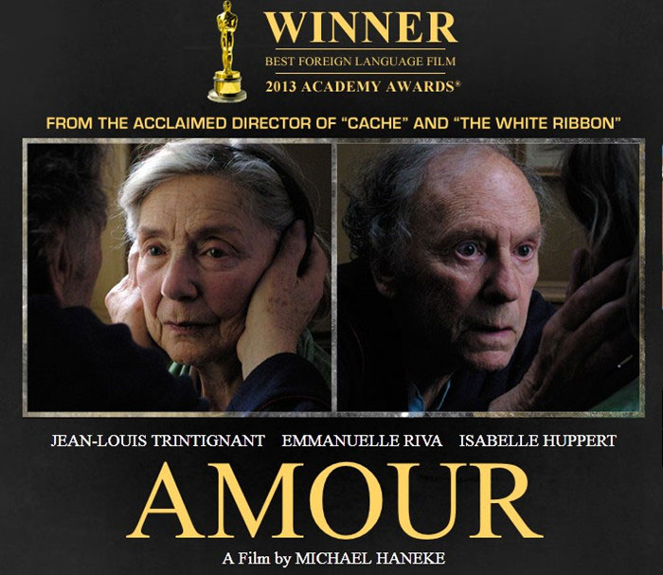
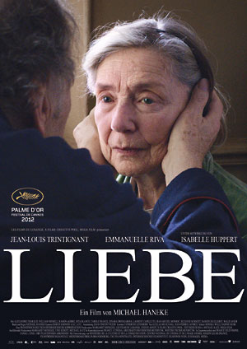

Die Fälscher – The Counterfeiters

The forger is an Austrian-German film. The director is Stefan Ruzowitzky (Austrian)and this film was released in 2007. The original language is German.
The film is set in the Second World War.
An unusual man rents a room in a luxury hotel in Monte Carlo. In the afternoon, he goes to the Casino. There he meets a woman and they spend the night together. Suddenly the woman sees a tattoo with numbers on the man`s underarm. The tattoo was a symbol for the prisoner in the concentrate camp.
The background: In Berlin, in the year 1936 Salomon Sorowitch got his money and documents from a forger. One day he was arrested by the criminal officer called Herzog. Sorowith came to the concentration camp in Mauthausen. There he was a portrayer. Five years later he came to Sachsenhausen another concentration camp. In Sachsenhausen, Sorowith and other prisoners come in a big hall. Herzog had an order that the prisoners should make fake foreign money. They had a better life than the other prisoners in the concentration camp. The next mission was to produce fake US-Dollars. First it seemed that they wouldn’t succeed. But they did.
Back in Monte Carlo: Sorowith is sitting at the table and wins a card game. He stands up and takes the money. He goes to the Roulette-table. There he spends all his money. But he loses all his money and he has only one chip left.
Trailer: https://www.youtube.com/watch?v=qwr9nCurEEQ

Awards:
- 2007 Academy Awards – Best Foreign Language Film
- 2008 Oscar – Best Foreign Language Film

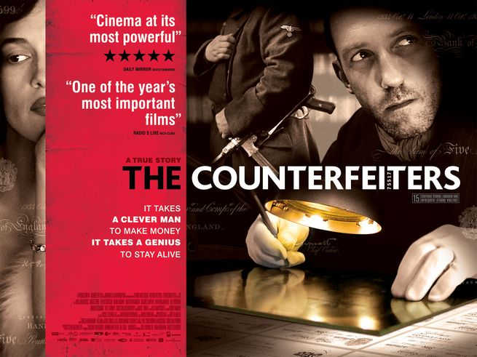
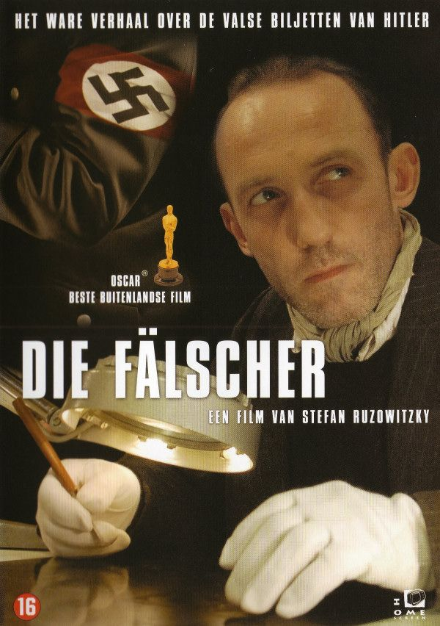

Ein Mann zu jeder Jahreszeit - A Man For All Seasons

The film „A man for all seasons was produced in England and it`s based on Robert Bolt`s play. The film is a British biographical drama and came out 1966. It was directed by Fred Zinnemann (Austrian born American film director)
A man for all seasons was a critical and box office success. The film ranked number 43 on the British film institute’s list of the top 100 British films. The film won 6 Oscars at the 39th academy awards, including best picture, best director and best actor. The film was also entered into the 5th Moscow international film festival where Scofield won the award for the best actor.
Plot: The film tells the story of Thomas More, who stood up to King Henry VIII, because the king rejected the roman catholic church to obtain a divorce and a remarriage. He worked as a chancellor. But then he cancels his job because the king voted himself as the head of the church so he is allowed for a divorce. Thomas More is deeply loved by his family and respected by the common people. But in the end More is condemned to death, because Rich Richard betrayed him.
Trailer German: https://www.youtube.com/watch?v=6Zinx0uQb0M
Awards:
Academy Awards
- Best Actor (Paul Scofield) – won
- Best Picture (Fred Zinnemann) – won
- Best Cinematography (Ted Moore) – won
British Academy Film Awards
- Best British Film (Fred Zinnemann) – won
- Best Actor in a leading Role (Paul Cofield) – won

Golden Globe Awards
- Best Screenplay (Robert Bolt)
- Best Director (Fred Zinnemann)

