Michael Haneke
Michael Haneke is one of the most famous Austrian directors.
His movies: ”Die Klavierspielerin”,(THE PIANO PLAYER) “Caché”, “Das weiße Band“(THE WHITE RIBBON) and „Liebe“( AMOUR)have alle won an Oscar.

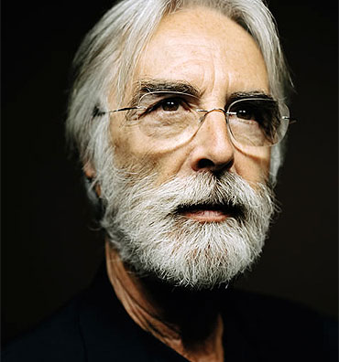
He was born in 1942 in Germany but moved to Austria as a child. His father was also a director and his mother was an actress, so he came in contact with films in his very early days.

Since his childhood his dream was to become actor.
After school he studied theater science.
Later on he became more interested in directing than acting.
He also liked classic music and he could imagine being a composer.

But through the good contacts of his father he finally worked his way as a director.

Now he is 74 years old. Since 1983 he has been married but he has no children.

