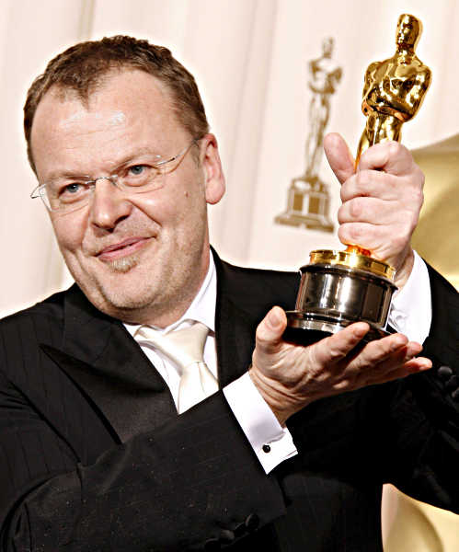
Stefan Ruzowitzky

Stefan Ruzowitzky was born in Vienna in the year 1961.
Ruzowitzky is a famous Austrian director and writer. He got an Oscar for the best foreign language film ,,Die Fälscher‘‘ or “The Counterfeiters”, in the year 2008.
Stefan has been married to Birgit Sturm since 1999. They also have two children.
He studied drama and history at the university of Vienna and started directing music videos for example for N Sync and commercials.

In 1961 Ruzowitzky presented his first feature film called “tempo”.
In 2000 he directed the successful German Horror film “Anatomy”.
In 2007 the Film ,,The Counterfeiters‘‘ premiered at the Berlin International Film Festival and was nominated for a Golden Bear award and in 2013. He directed a 90 -minute non fiction drama ,,Das radikal Böse‘‘.

He directed his first Opera production in 2010 “Der Freischütz” or “The Freeshooter”)

