Once upon a time, there was a little girl called Mary Lennox, who lived in India with her rich family. She was a selfish child, vitiated by her servants and neglected by her parents. After a cholera epidemic, she was orphaned and was entrusted to her uncle Mr Craven who lived in England. In her new house she was locked up in a room so she wouldn’t explore it. However she became friends with the servant Martha who told her various stories also about a secret garden whose access was forbidden since Mrs Craven’s death. Mary planned to find it and began to explore the various parts of the house.

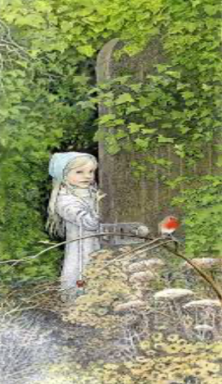
One day she found a key that causally opened the door of the majestic secret garden covered by rose bushes and vines. Mary started taking care of the garden at the same time becoming more kind and careful, also thanks to the help of Dickson, Martha’s brother. Later he met his cousin Colin, confined to his room because of his illness and apparent paralysis. Mary understood that he was the source of the strange sounds that she heard in the house.
Dickon, Martha and Colin became friends and spent their days taking care of the secret garden. At the end through their friendship and their relationship with nature the three children became healthier and happier