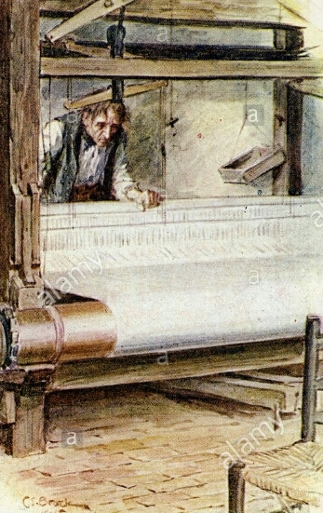
Silas marner
Once upon a time there was a linen weaver.
His name was Silas and he was a good and kind man .
He lived in a big city and was happy, but one day he was wrongly accused of killing a person.
So Silas left and arrived in a small village :Reveloe.
Here he walked away from everyone for fear of being disappointed again.
He thought only of his shiny money.
The most important people in the village were Squire Cass and his two sons:
Dustan who had a gambling vice and Godfrey who had a secret.
He had married a poor girl, Molly, despite being in love with Miss Nancy.
Dustan wanted more money so he stole it from Silas.
When Silas returned home and saw what had happened he ran to the village crying and told his story.
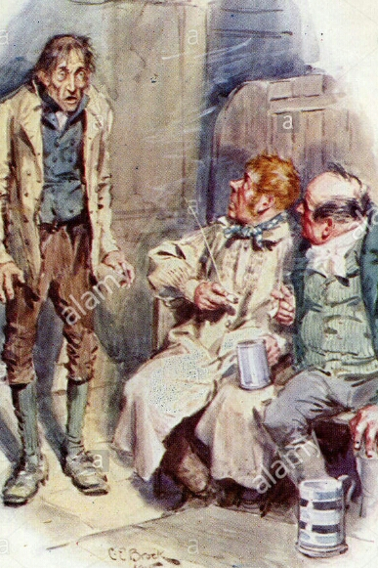
The people understood that he was a good man and they tried to help him, yet his money was never found again and Dustan never returned home.
The new year arrived and, as usual, everyone was celebrating at Squire House ,except Silas who was sleeping in his house.
When he opened his eyes he saw a little girl asleep in front of his fire place.
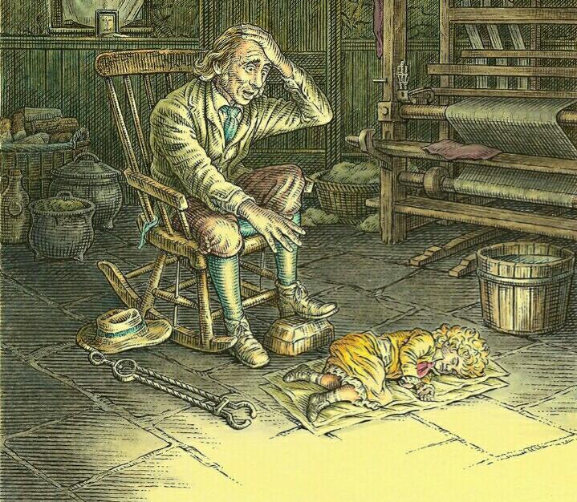
He opened the door and not far away found her mother dead due to the cold in the snow.
No one recognized the woman except Godfrey; she was Molly.
Godfrey married Nancy and Silas kept the baby, who was called Eppie.
The life of the weaver changed and he started again to go to church and to stay with his neighbours.
Now he had someone to love and who loved him.
The years passed.
Nancy and Godfrey were happily married but they didn’t have children and Eppie had grown up.
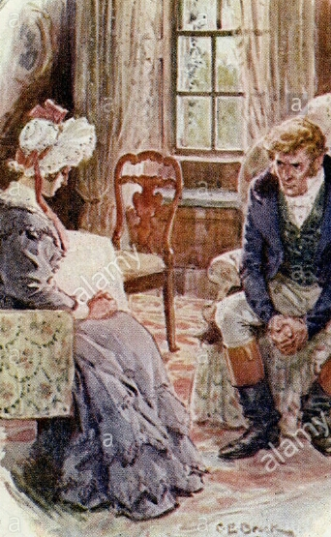
One day digging in the quarry the body of Dustan was found with the money of Silas.
Godfrey understood that all lies would be discovered sooner or later ,so he decided to tell everything to Nancy.
His wife forgave him and together they decided to return the money to Silas and adopt Eppie.
But Silas refused the money and Eppie replied that he would never abandon his father because without him she would have no one .
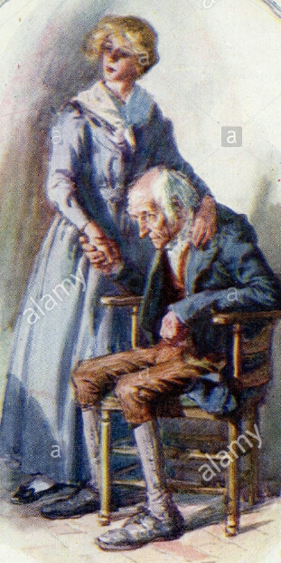
Eppie preferred love to money and to a luxurious life.

