
This project has been funded with support from the European Commission.
Visible Teaching4Performance 2017-2020

The second international meeting of the 'Visible Teaching4Performance' project took place in Moers, Germany, on 21-26.04.2018. The meeting was attended by representatives of all 9 partner schools, i.e. Bulgaria, Finland, France, Germany, Greece, Italy, Poland, Portugal and Turkey. It was a short term teacher training event (C1) with the objective of teacher professionalization with Europass Mobility Certification validated by National Europass Centres.
The classes that the teachers took part in concerned the analysis of Hattie's concept as to the factors affecting the improvement of the quality of teaching and learning. There were also workshops during which participants in mixed international groups chose the most important factors that positively influence the quality of teaching and learning.

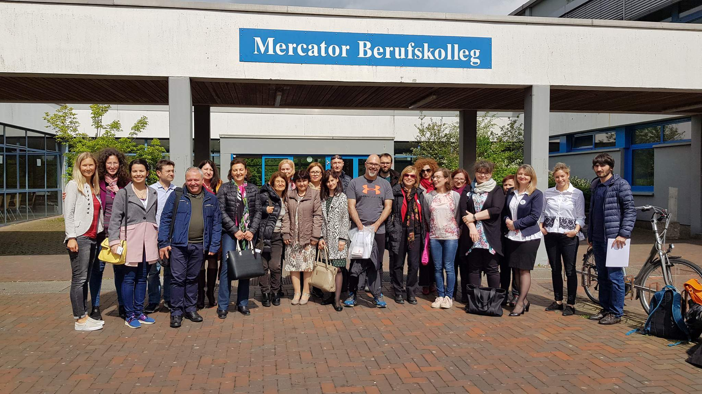

21.04.2018
After the arrival in Moers, the group began a series of meetings with festive dinner at the 'Mondrian' restaurant in the city center. The guests were welcomed warmly by the hosts and organizers: Mrs. Ramona Poley (deputy director in the department for design and development of the school) and Mr. Christian Graack (director of the above-mentioned faculty).

22.04.2018
The day began with a walking tour of the city of Moers. Pupils of the Mercator Berufskolleg school, Mrs. Ramona Poley and Mr. Christian Graack guided the participants of the project along the most known and popular spots of the area, telling interesting stories about the life of its inhabitants. A walk along the picturesque streets of Moers as well as dinner at the 'Ciao ciao' restaurant let everyone break the first ice and exchange teacher's experiences.
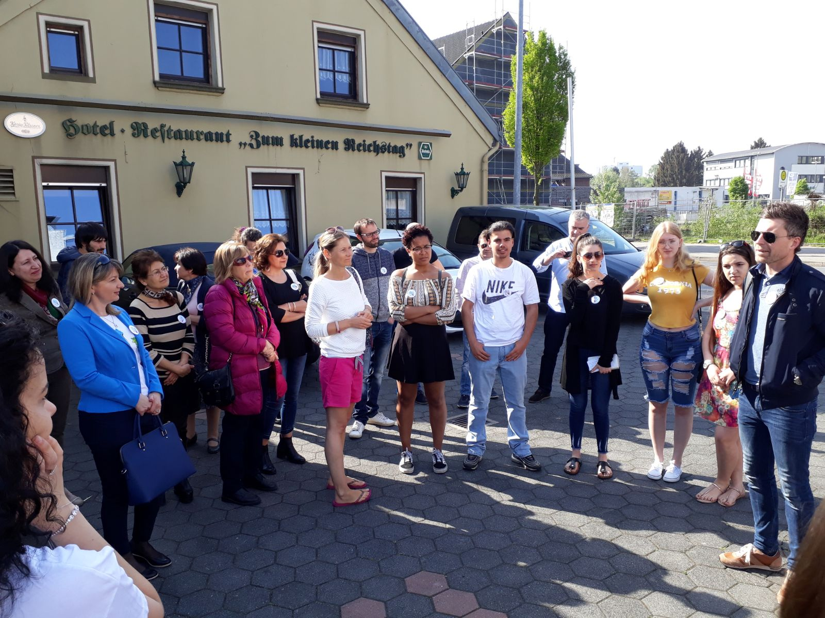

23.04.2018
The following day was spent expanding the knowledge of Hattie's concept of effective teaching from the student's perspective. The moderator - Mr Detlev Lindau-Bank, lecturer in social sciences at universities in Dortmund, Vienna and Berlin, as well as a co-founder of the training company 'Respekti:ve' was introduced to the group of participants. The lecturer introduced in detail the subject of research on key factors affecting the quality of the teaching process in schools to the teachers. Participants of a few-hour lecture were eager to ask questions, and the moderator profoundly answered. The classes were diversified by transparent slides.
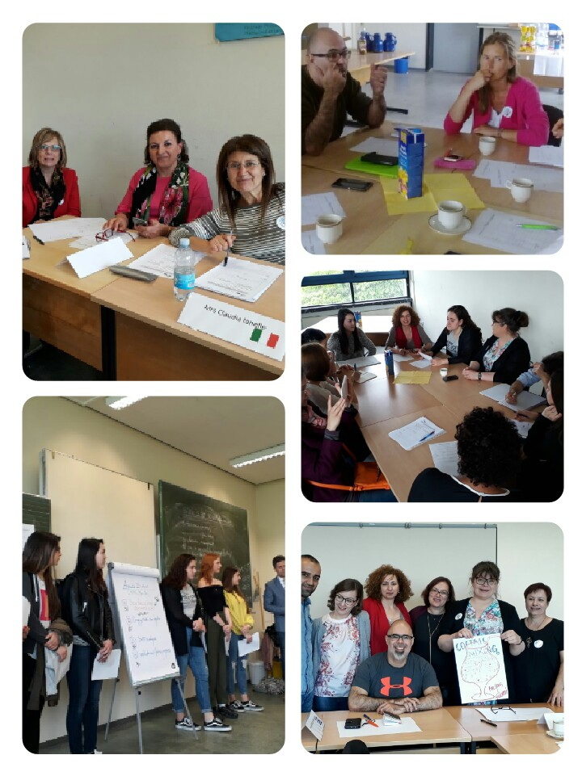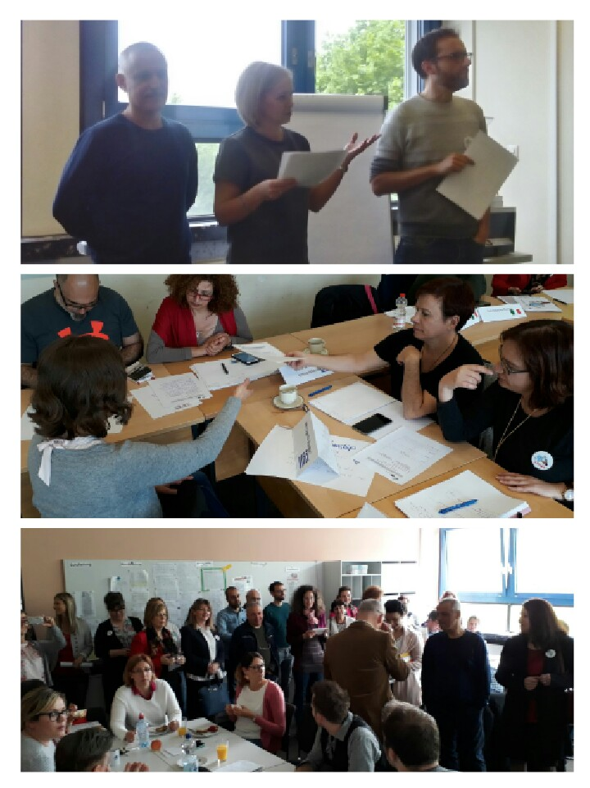

24.04.2018r.
Referring to the lecture from the previous day, Mr. Detlev Lindau-Bank invited the project participants to take part in workshops. In mixed groups, the 9 countries' partners carefully analyzed the Hattie questionnaire, discussed key factors affecting the quality of teaching and learning, choosing the ones that they thought are the most important. Representatives of the groups supplemented Frederica Vester's 'Paper Computer' tables with calculations of the above values and presented their results in public. The whole task was coherently summarized by the moderator and Mr. Christian Graack. In the afternoon, coordinators of 9 partner schools met to discuss activities related to the next meetings of the 'Visible Teaching4Performance' project.

25.04.2018
On this day, Mrs. Ramona Poley, Mr. Christian Graack and the director of the Mercator Berufskolleg school, presented the participants of the project to the employees of the institution. The director briefly explained the purpose of our visit to Moers and the main assumptions of the project. Afterwards, the partners were shown around the school and had the opportunity to take part in a short but very interesting economics lesson. After the warm reception there was a continuation of the workshops. Mr. Christian Graack introduced a few students of Mercator Berufskolleg, who were assigned to their groups of partner schools and responded in detail to the questions related to a previously conducted questionnaire examining the impact of various factors from the list of Hattie on the quality of learning. At the end of the day, teachers in groups prepared a SWOT analysis, which they later presented to the rest of the group. Conclusions for further work were drawn.
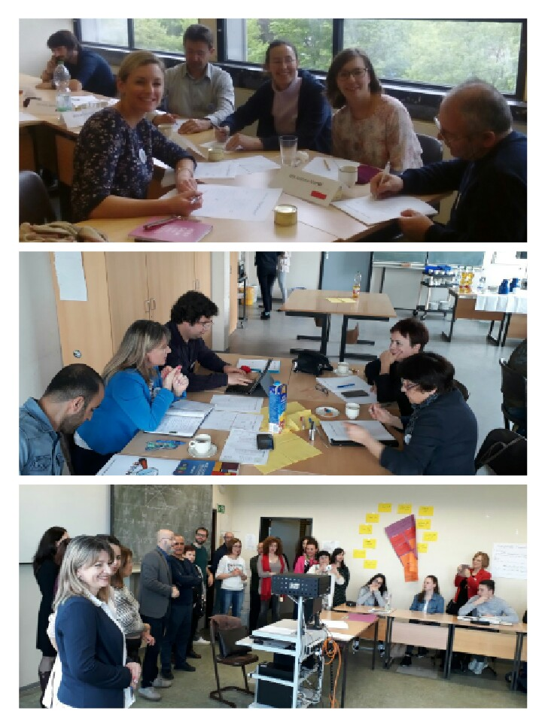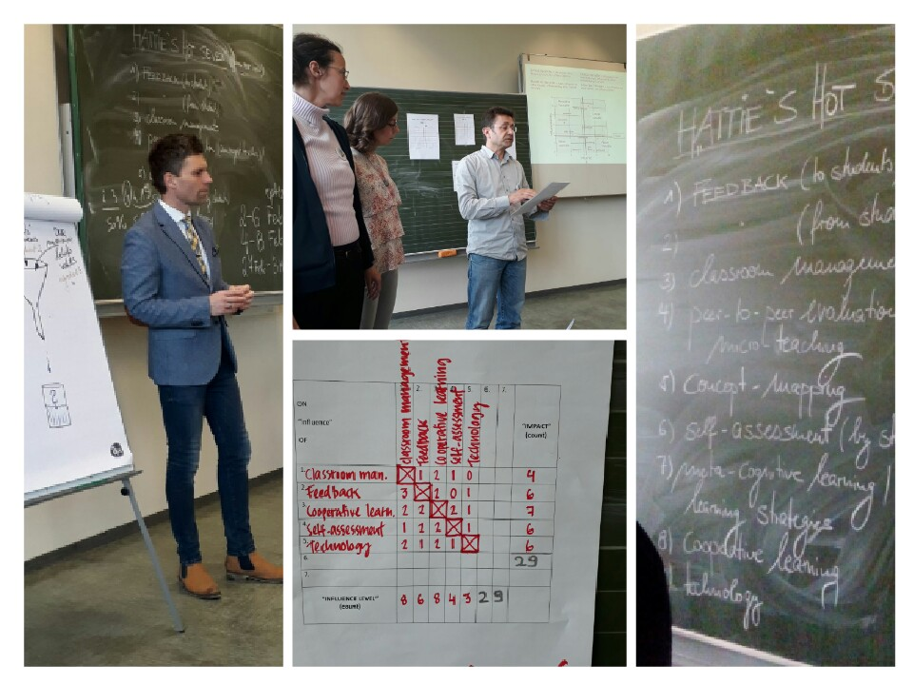

26.04.2018
This is the day when most of the project participants left the town of Moers. On my behalf and of Mrs. Hanna Skowrońska (project coordinator), Mrs. Joanna Lubańska-Pieloch and Mrs Joanna Marcol, thank you very much not only for the extremely nice reception, wonderful impressions and atmosphere, but above all for the high substantive level of the whole meeting, which definitely raised our awareness of better teaching based on the list of Hattie's factors.

Report:

Joanna Marcol and Oriana Kotajny, ZS 2 Rybnik, Poland

2017-1-PL01-KA219-038284_1

