Lesson Evaluation Sheet for Students

Classroom Management

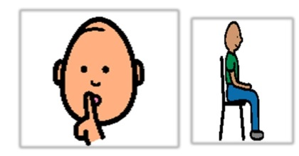
There is no noise during the lesson
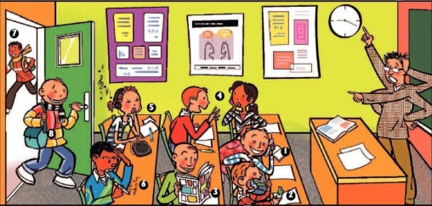
There is no wasted time before, during and after the lesson

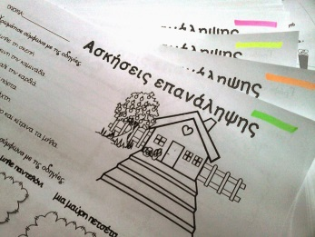
There is always available printed or other material I am confident to use.

Safe learning Environment
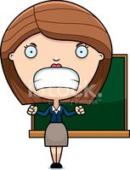
Teacher speaks kindly o students

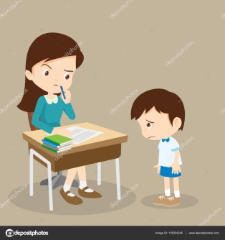
Teacher permits mistakes

Teacher helps students o respect each other

Teacher rewards students

Teacher helps students to work together

Teaching

Teacher explains well difficult subjects

Teacher encourages me to participate

Teacher finds opportunities to engage in dialogue

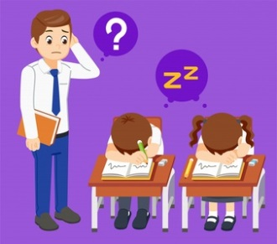
Teacher makes the lesson interesting

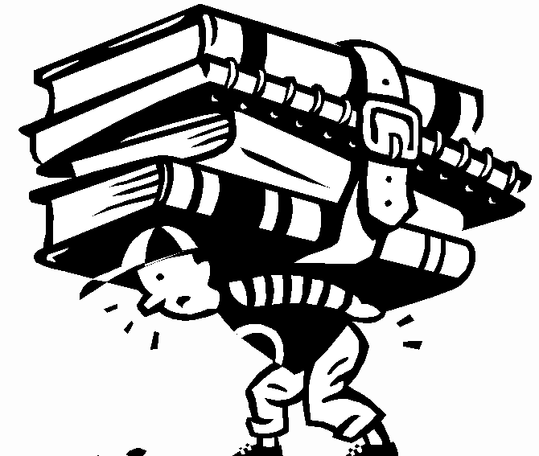
Teacher gives a lot of homework

Created by Elisabeth Ilia , E.E.E.EK of Chios

