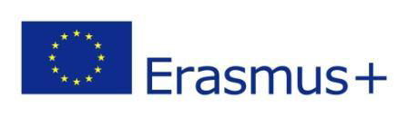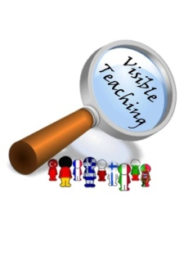
VT4P Erasmus plus 3rd TPM live online meeting Report 16th June 2020
Due to the extraordinary situation caused by the coronavirus pandemic the real meeting scheduled for March 2020 in Rybnik was transformed into collaborative online work whose part was the live online meeting with the use of the Zoom platform.
Objectives of the meeting: Realizing the objectives planned for the 3rd TPM in Rybnik:
- Teacher Empowerment Plans/ School development plans.
- Exchanging good practices. Team Empowerment.
- Final report.
- Future cooperation.
Participants of the Italian and the Polish partner schools attended the meeting.
The meeting started with the project coordinator’s official welcome, presenting the objectives of the meeting followed by the official statement of the Italian school Principal Mrs. Ida Sisca expressing gratitude for the long-term fruitful cooperation and hope for the future collaboration of our schools in the challenging new reality. The statement was presented by Mrs. Ornella Pegoraro, the Italian partner school project coordinator.
Partners exchanged information about the current situation in their local schools, the region and their countries with the predictions for the future school activities based on the government statements.
With the use of “mentimeter” participants were asked to write down words/expressions to empower the team also with this tool ideas supporting online teaching were collected ( ideas published here: https://twinspace.etwinning.net/50561/pages/page/922806 and in the following presentation: https://twinspace.etwinning.net/files/collabspace/1/61/561/50561/files/bea8f7d34.pptx
Final products ( Teacher Empowerment Plans) were presented by both partners. The next presentation about Google Classroom was given by Mrs. Saverina Ferraro. The presenation was also supported by Mr. Alberto Curcio and google meet modules were discussed.
The presentations were followed by a discussion about assessment and dealing with evaluation. Mrs. Claudia Ianello refered to learning integration plans supporting students and induvidualized learning plans as well as competence-based methodology. Such ideas as human growth of the given student, autonomy, responsibility and flexibility were brought up as crucial factors indispensable not only in the new reality.
Free webinars by Osiris Educational were recomended. Information and useful tips from the webinars already held and attended by the project coordinator were disseminated.
At the end of the meeting crucial points about the final products and report were discussed.
It was a great pleasure to meet online, see one another and be able to shape the so far unknown new, with great support of each participant sharing good practices and empowering our team.
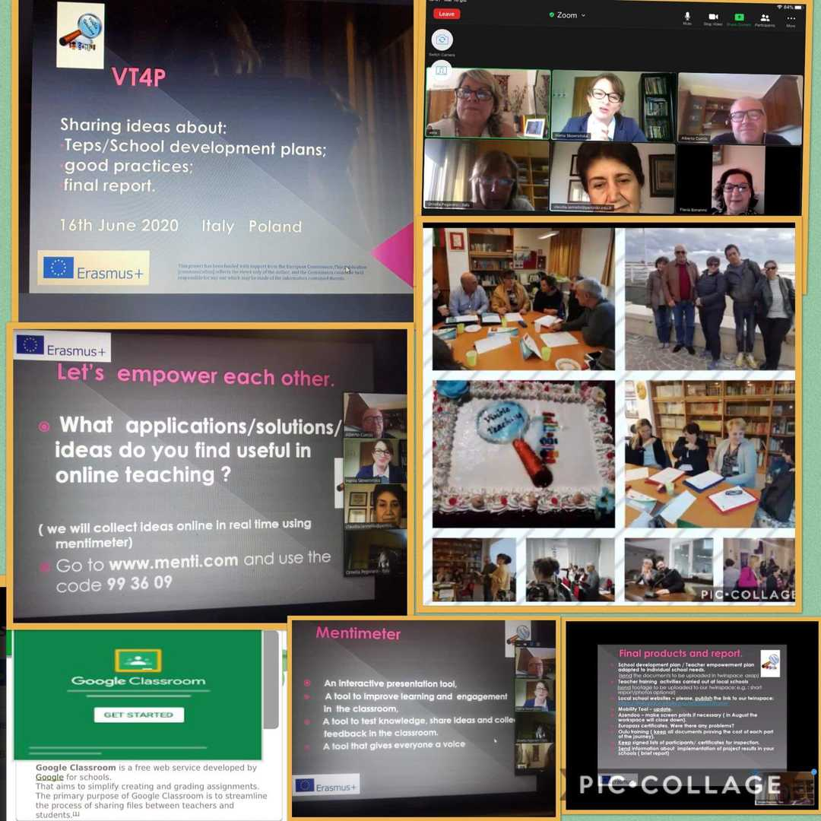
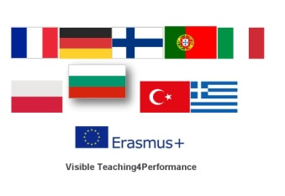
Project coordinator: Hanna Skowrońska

2017-1-PL01-KA219-038284_1

