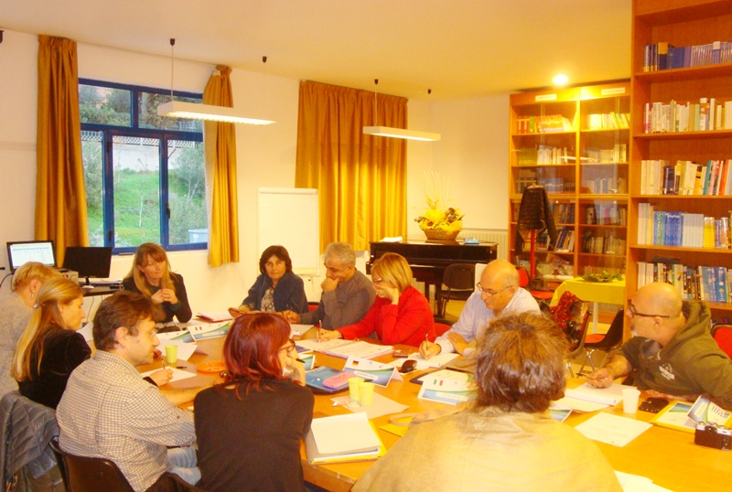
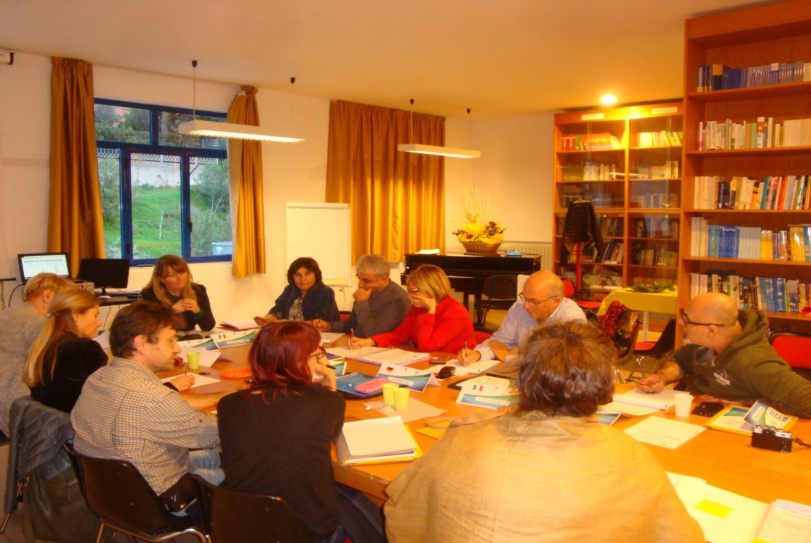

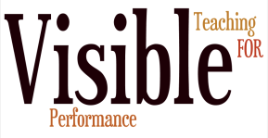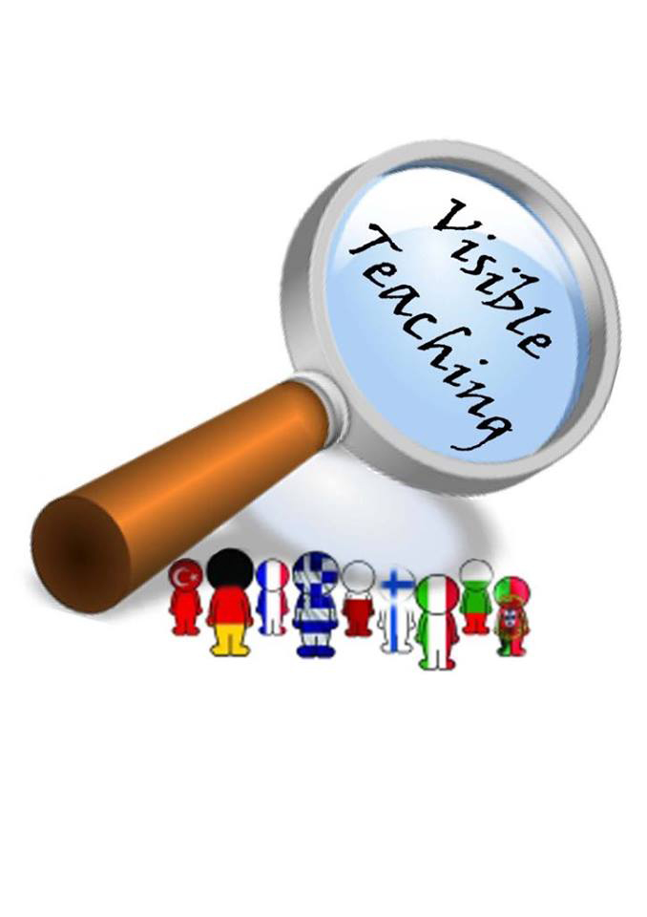

Brochure preparation and design: Visible Teaching4Performance Team 2017/2020
Language School “Frederic Joliot-Curie”, Varna


“This project has been funded with support from the European Commission. This publication [communication] reflects the views only of the author, and the Commission cannot be held responsible for any use which may be made of the information contained there

